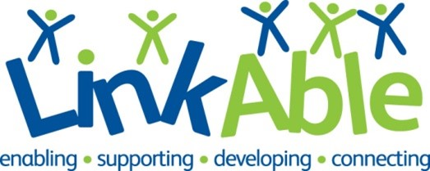

Minibus Volunteer Role Profile
The Organisation
LinkAble is a Woking based charity that has been supporting children, teens and adults with learning disabilities for over 30 years. We are passionate about supporting people with learning disabilities and/or autism to live joyful and purpose-driven lives. The LinkAble community enjoys activities every day of the week and during school holidays in our fully accessible and inclusive centre in Woking.
Aims of the Role
To support the running of our busy play and activity sessions for children, young people and adults with learning disabilities by driving 1 of our 3 minibuses. Sessions run during the day, in the evenings, at weekends and in school holidays. We are looking for a team of drivers with varying availability but particular school holidays.

Key Tasks
- Drive one of our minibuses to various local community venues such as Bocketts Farm where are children, young people and adults are visiting.
- Wait at the venue and drive the minibus back to The Link where it will be parked.
- Report any issues with the vehicle or the journey to the Group Leader for the session.
- Complete vehicle checks.

Required Skills
- Physically fit and a careful driver who is confident in driving larger vehicles.
- Volunteer drivers do not need to have completed Midas Minibus training but do need to be over 21, have been driving for 3 years and have a clean driving license. Some vehicles require a D1 license.
- Be confident interacting with children, young people and adults who have learning disabilities, with support.
- Committed to safeguarding principles and reporting and to following the Safeguarding Policy.
- Commitment to equality and diversity and following policies and procedures
Benefits to you
- Work as part of a friendly and welcoming team.
- Gain experience of minibus driving.
- Reference provided for all volunteers who have been in post for 6 months.
- Satisfaction from knowing supporting people with learning disabilities to live fulfilling lives.
- Paid DBS check, induction and training.
- Expenses paid according to our volunteer policy.
Next Steps
- Send us your CV or email us detailing your skills and experience.
- We’ll conduct an informal interview to find out about your skills and reasons for volunteering.
- We’ll ask you to come along to one of our sessions and meet the people we support.
- We’ll support you to apply for a DBS which is required for this role.
Location
2 Board School Road, Woking GU21 5HE. A short walk from the town centre. Limited parking available. Please note that our offices do have some stairs.
Email: Sandra.Nixey@linkable.org.uk

