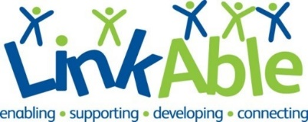

Office Volunteer Role Profile
The Organisation
LinkAble is a Woking based charity that has been supporting children, teens and adults with learning disabilities for over 30 years. We are passionate about supporting people with learning disabilities and/or autism to live joyful and purpose-driven lives. The LinkAble community enjoys activities every day of the week and during school holidays in our fully accessible and inclusive centre in Woking.
Aims of the Role
To support the running of our busy office, helping increase our efficiency and adding valuable extra resource to enhance our services. Office hours are 9-5pm weekdays, and we require a minimum commitment for one regular day a week.
Key Tasks
- Answer telephone calls from parents and respond to general enquiries.
- Welcoming visitors and ensuring sign in processes are followed.
- Supporting the team with particular projects such as creating documents or spreadsheets or researching venues to hire.
- Database management and data entry.
- General office admin such as printing, photocopying, filing paperwork and shredding.
- Specialist projects relating to volunteer’s skills and experience e.g., IT projects, fundraising.
Required Skills
- Confident in using Microsoft 365 products (Word, Excel, Outlook, Sharepoint).
- Personable manner with good verbal and written communication skills.
- Commitment to equality and diversity and following policies and procedures.
Benefits to you
- Work as part of a friendly and welcoming team.
- Gain skills in areas that interest you and progress you in your chosen career.
- Reference provided for all volunteers who have been in post for six months.
- Satisfaction from knowing you are supporting people with learning disabilities to live fulfilling lives.
- Paid DBS check, induction and training.
- Expenses paid according to our volunteer policy.
Next Steps
- Send us your CV or email us detailing your skills and experience.
- We’ll get in touch and arrange a time to meet with you and tell you about our charity.
- We’ll conduct an informal interview to find out about your skills and reasons for volunteering.
- We’ll support you to apply for a DBS which is required for this role.
Location
2 Board School Road, Woking GU21. A short walk from the town centre. Limited parking available. Please note that our offices do have some stairs.
Email: Sandra.Nixey@linkable.org.uk

