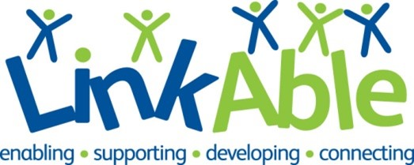

Children and Young People’s Activity Sessions Volunteer Role Profile
The Organisation
LinkAble is a Woking based charity that has been supporting children, teens and adults with learning disabilities for over 30 years. We are passionate about supporting people with learning disabilities and/or autism to live joyful and purpose-driven lives. The LinkAble community enjoys activities every day of the week and during school holidays in our fully accessible and inclusive centre in Woking.
Aims of the Role
To support the running of our busy play and activity sessions for children, young people and adults with learning disabilities. Sessions run during the day, in the evenings, at weekends and in school holidays. We are seeking a team of volunteers with availability at different times.

Key Tasks
- Take part in session briefings so you know what is expected and know how best to get involved.
- Help set up sessions, ensuring the environment is safe and clean, setting up toys and equipment.
- Welcome children, young people and adults to the session and ensure they feel welcome.
- Interact with children, young people and adults as directed by the Group Leaders and sessional staff to enhance their experience.
- Support with getting drinks and snacks ready for children and young people’s breaks.
- Support groups who are going out to community activities or day trips.
- Clearing away toys and equipment and ensuring the environment is safe.
- Driving one of our charity vehicles if you’re happy to do so and meet our insurance requirements.
Required Skills
- Committed to empowering children, young people and adults who have learning disabilities to enjoy play, activity or social sessions.
- Keen to learn about communication, sensory or calming strategies that support people we support to get the most out of sessions.
- Committed to safeguarding principles and reporting and to following the Safeguarding Policy.
- Commitment to equality and diversity and following policies and procedures
Benefits to you
- Work as part of a friendly and welcoming team
- Gain skills in supporting children, young people and adults with learning disabilities.
- Reference provided for all volunteers who have been in post for 6 months.
- Satisfaction from supporting people with learning disabilities to live fulfilling lives.
- Paid DBS check, induction and training.
- Expenses paid according to our volunteer policy.
Next Steps
- Send us your CV or email us detailing your skills and experience.
- We’ll conduct an informal interview to find out about your skills and reasons for volunteering.
- We’ll ask you to come along to one of our sessions and meet the people we support.
- We’ll support you to apply for a DBS which is required for this role.
Location
2 Board School Road, Woking GU21 5HE. A short walk from the town centre. Limited parking available. Please note that our offices do have some stairs. Email: Sandra.Nixey@linkable.org.uk

