Marfan Trust Charity: Donation Form

Name:

Address:

Postcode

Telephone

Email

I wish to donate £10 |  | Or my preferred amount of £___________________

I enclose my cheque/postal order payable to the Marfan Trust
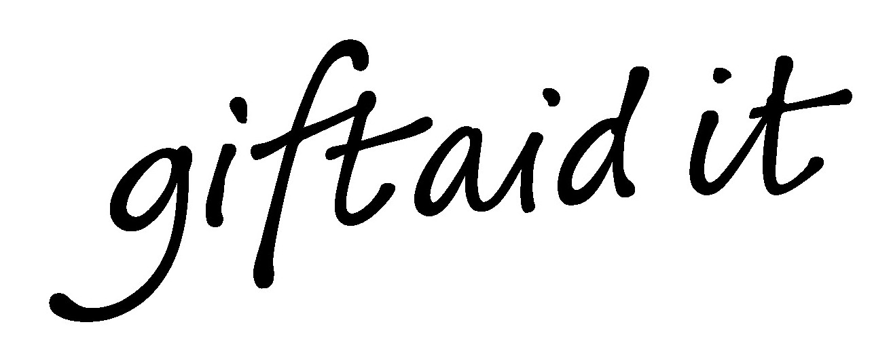
If you are a UK taxpayer*, under the Government’s Gift Aid scheme the Marfan Trust can reclaim the tax you have already paid on your gift. This means that your donation can increase in value by nearly a third at no extra cost to you. Please tick the box below if you would like the Marfan Trust to reclaim the tax on your gift.

Please treat this and any future donations I make to the Marfan Trust and all payments I have made to the Marfan Trust from 6 April 2000 as Gift Aid donations.

*It doesn’t matter what rate of tax you pay as long as you pay an amount of income or capital gains tax equal to the tax we reclaim on your donations in that financial year. Please remember to inform us of any changes in your tax status.

Signature(s) ____________________________________ Date ______________________

Please return signed and scanned form to info@marfantrust.org

