

|  |
| --- |
| **July and August 2023**  **Services 10:45am Sunday mornings** **ALL ARE WELCOME****WITHIN THE CIRCLE OF LOVE** |
| Unitarians are a religious denomination that believe in a united world community, justice, peace and compassion. |

**Monton Unitarian Church**

**Monton Green, Monton, Eccles, M30 9NX**

**Charity Reg 1199569MINISTER’S LETTER**

Dear friends

Sometimes things bear repeating. Either because they don’t get heard (or read!) the first time around, or because people might find something different the next time around – or because you believe something so strongly you need to keep on saying it.

That sounds really philosophical (or at least given a pinch of salt it could be). It is actually more practical right now. For a number of reasons, it’s been a chaotic month or two – so chaotic that in fact June got entirely missed out of the calendar cycle! As in, this newsletter is a month late.

And as it’s due out today, but today is also Monton Festival, I will own up to not having enough brain cells functioning to write a brand-new minister’s letter, as well as tomorrow’s service. So I’m going to restate some of what I said in the April/May newsletter. But I hope you will still re-read it – and maybe hear something different, or hear it properly, or decide this time to actually do something about what you’ve read. Because I’m hoping that you may feel that you can identify with some of what we stand for, and some of what we are wanting to do – and that you may feel stirred to come and join us in our work.

Our community isn’t perfect, by any stretch – we have the same ups and downs, malfunctions, disagreements, worries about finances or buildings etc that most organisations have. But it’s the reason we exist, and the way in which we gather, that makes us, drives us, enthuses us to keep moving forward, trying to get better, be better, give better.

Our church, our community, is nothing at all if it is not serving the people around it – is not living its faith if it does not work to support those who need help, to comfort those who are hurting, to celebrate those who have something to celebrate. And we know that many of you share those values with us.

And that’s actually all you need to share to be a part of our community at Monton Unitarian Church. There is no test of faith or creed, no insistence that you must believe A, B or C, or X, Y and Z. Your faith is your own: all we ask is that you come with an open mind, an open heart and open hands, ready to explore, to share, to discover, and to be part of the magical mystery that means that no matter who we are when we gather, we are changed, a little or a lot, by that gathering.

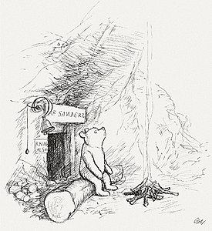

Our services are not pronouncements of “thou shalt believe”, but celebrations of life, expressions of concern, even outbursts of anger against the injustices of the world. You might hear a reading from the bible – there are some interesting, meaningful stories to be found in it. You might equally hear from Winnie the Pooh, or a local news story. We often sing traditional hymns, or traditional tunes with new words, but we’ve also played Wrabel, Abba, Bach, Pink, Arvo Part, Sweet Honey in the Rock, Ed Sheeran and so many others.

If you want to know more about membership, or just about the church and the movement in general, please do look us up on line. Our own website is [www.montonunitarianchurch.co.uk](http://www.montonunitarianchurch.co.uk), or our national body, The General Assembly of Unitarian and Free Christian Churches, can be found at [www.unitarian.org.uk](http://www.unitarian.org.uk). And if you fancy a chat about it all – or anything else, for that matter – do give me a call. I only work 20 hours a week at the moment, so it might take me a little while to get back to you but I’d love to hear from you!

I, like most of us in our congregation, am still working out what my faith is, and what it asks of me – and will keep on questioning and exploring till the day I die. But there’s a couple of things that I believe completely - one is that, as MP Jo Cox said, “While we celebrate our diversity, what surprises me time and time again … is that we are far more united and have far more in common with each other than things that divide us.” The other thing is that we are stronger together than we are apart (Walter Payton), or, to unashamedly misquote Aristotle, “the whole is greater than the sum of its parts”. By ourselves we are amazing and can achieve many things – but together, we both are, and can do, so much more.

I’d love you to come and join us – to help each of us do more, serve more, give more, create more – even enjoy more! The world is better for you being in it, and so is our community!

Sending you all many blessings, Rev Anna



**TUESDAY COFFEE MORNING CONTINUES!**

Coffee morning continues, every Tuesday morning 10am till 12pm, in Monton Memorial Hall, with tea and coffee, biscuits and cakes on offer, and of course, plenty of fellowship and a good natter! Do come along and join us. We do ask for a donation for the refreshments, where possible, but we never turn anyone away!

**BODDAN LODGE**

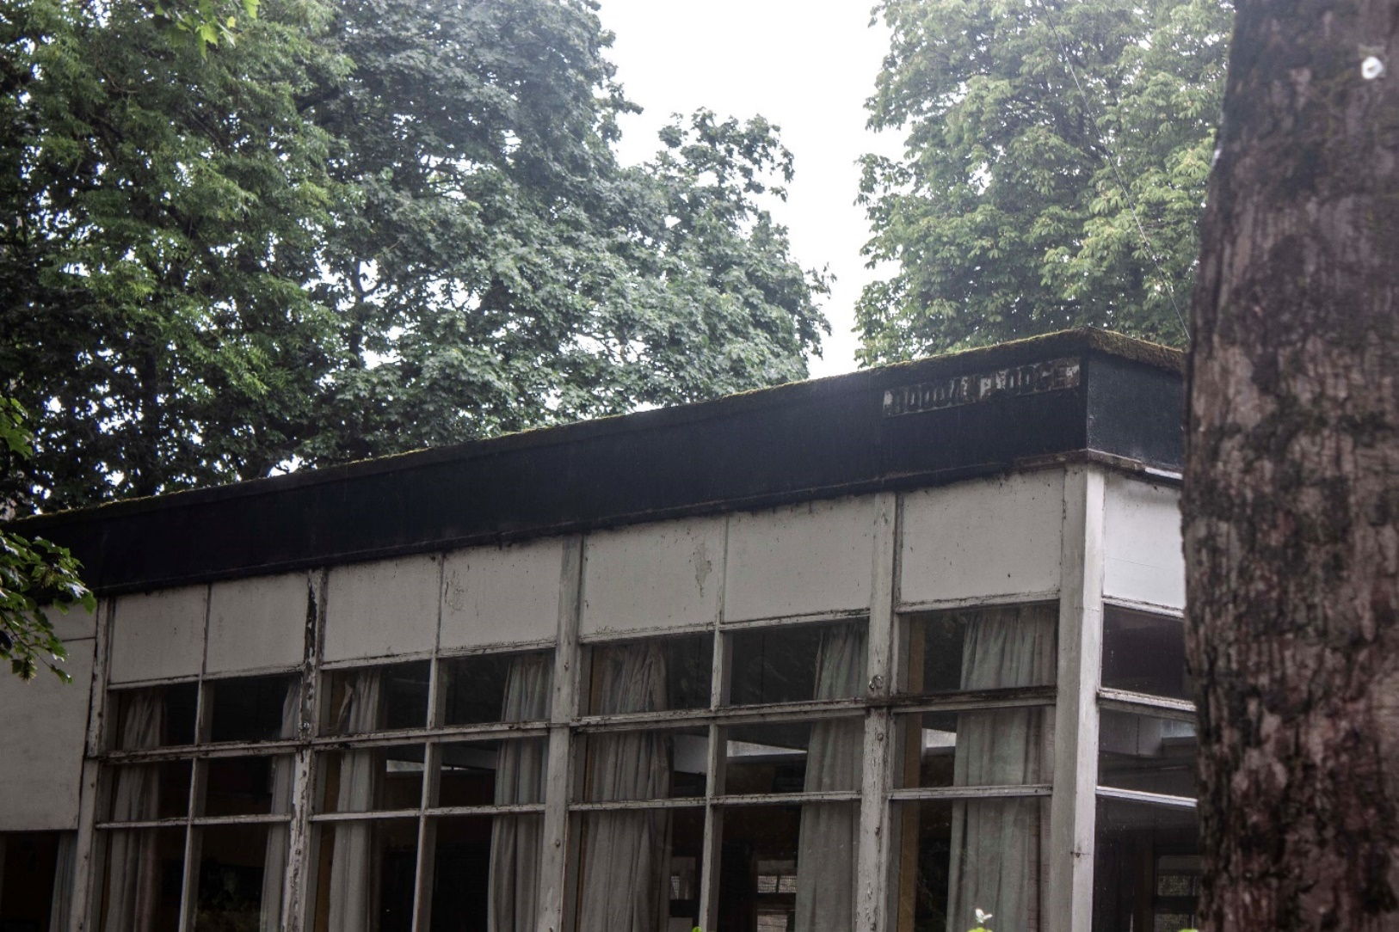

Boddan Lodge is the glass fronted building next to the Monton Unitarian church hall. The land it resides on was leased by Monton Unitarian Church to the council over 50 years ago and the council built the structure known today as Boddan Lodge.

The council has withdrawn from their lease and the physical structure is no longer viable or repairable, has been closed for safety reasons and is awaiting demolition. The church is beginning the process of consultation to find out from potential users what they would like from the new space. The church wants to construct a new multi-purpose and eco-friendly community building that retains all existing trees and is in keeping with the surrounding area.

For more information visit montonunitarianchurch.co.uk/boddan-lodge.

As part of this consultation, there is a questionnaire that we would love as many local people as possible to complete and return to us by 8th July. This can be completed online using Microsoft Forms, and can be accessed via the QR code here.



Please do complete the form, and have your say!

**MONTON UNITARIAN CHURCH’S CHARITY OF THE YEAR**



Age UK Salford has been chosen as our Charity of the Year 2023. While we will still have to do some fundraising for our own purposes, we will also be running a number of activities to help raise money for Age UK Salford, and all their amazing activities, culminating in the Christmas Tree Festival 2023. There shall be more information coming out soon as to our fundraising efforts for them, so do keep an eye out for emails from us, or posters, and come along and support us as we support Age UK Salford.

**WAYS TO GET INVOLVED IN MONTON UNITARIAN CHURCH**

We’ve got various projects either on the go or needing to get started, here at Monton Unitarian Church. Whether or not you are a member, if you support what we stand for and our place in the community, and would like to lend a hand, do get in touch with Rev Anna and let her know how you’d like to help. Many hands make light work, after all! So here’s some ideas as to the things you could get involved in.

Marketing and visibility – we are looking to arrange a bright banner for outside church, letting people know who and what we are, a clear demonstration of our commitment and welcome to LGBTQ+ people, improved leaflets and much improved social media.

Textile projects – Children’s Corner panels creating a collage about the church and its history, particularly with reference to the cotton industry, and a new church banner celebrating the chalice and particular Monton themes.

Fundraising and planning e.g. for a proper catering station within the children’s corner, to enable us to manage events within the church better.

Christmas Tree Festival – last year was fab, this year needs to be even better! Come and be part of the team!

Spiritual growth / discussion – an interest was expressed in learning more about the Unitarian journey, both historically and for individuals, and exploring our individual faiths and spirituality. This could be done both through programmed courses (Building Your Own Theology, or Spirituality in Everyday Life), but also through freer-structured discussion groups. Keep an eye out for announcements!

150 years Anniversary – the church building turns 150 in 2025, and we would love to have a really special celebration of this. If you would like to be involved in planning this and bringing it into being, whatever it might look like, please do speak to Rev Anna.

**FOLLOW OUR SOCIALS AND SPREAD THE WORD!**

Help us spread the word of what’s going on, by sharing our Facebook posts, Instagram posts and don’t forget the best form of advertising ever – word of mouth!

**COMMITTEE MEETINGS**

July Committee meeting Sun 9th July

Please do speak to any member of our committee if you wish something to be raised at these meetings. Our committee members are currently:

Irene Hitchcock, Rennie McFarlane (Treasurer), Colin Morse, Lynne Stopani, Gloria Taylor, Dave Ward-Speers and Pam Ward-Speers (Secretary).

**FILM CLUB**



**Sun 2nd July 6pm – Nomadland**

**Sat 5th Aug 2pm – Holiday Special –**

**Sun 6th Aug 6pm – Murder on the Orient Express**

Holiday specials are aimed particularly at children during the school holidays – but adults will enjoy these movies too! Children must be accompanied by a responsible adult.

Suggested donation of £5.00 entry (£2.00 children)

**OPEN MIC NIGHTS 2023 – 7.30pm in the Church**



**21st July**

**18th August**

Whatever your talent, whether you are a professional or a first timer, come and share your creativity with us –

or just enjoy supporting others!

Suggested donation of £2.50 entry (children free)

Refreshments available

**MEMBERSHIP / SUPPORT OF MONTON UNITARIAN CHURCH**

According to our constitution, any person aged 18 years and upwards and who is in sympathy with the purpose and principles of this Church, may be enrolled as a Church Member. It also states that no rule or regulation shall at any time be made whereby the acceptance of any Creed, Article of Religion or Confession of Faith shall be established as a condition of membership. This is because we believe that each person has both the right and the responsibility to discern their faith for themselves, to maintain an open mind and open heart, and continue exploring your beliefs and values, and sharing your discoveries with others.

Unitarians have always combined reason and science with spirituality and faith, with a strong commitment to using our power to create a more just and fair society. We are committed to approaching all of the world’s religions and belief systems with an attitude of tolerance, open-mindedness and respect. We are grounded in our current reality, and this drives our evolution, while our radical spirituality calls us to take a stand on the big questions and challenges facing our world. If you are in agreement with the ethos of this Church and would like to become a member to support its aims and be involved in its activities, please contact Rev Anna for a membership form.

We do, of course, also need financial support, as well as practical, “people-energy” support. It costs well over £1000 per week to maintain our church and pay all the relevant bills, and enable us to provide the sacred space for baptisms, weddings and funerals, the care and support for people going through difficult times (and exciting times!), and all the other work that we do in the community – and for this we need your support. If you would like to contribute financially as a member, you can join our envelope gift scheme. Alternatively, you can make either one-off or regular payments via BACS or Standing Order direct to our bank account:

Monton Unitarian Church

Sort code 01 05 75

Account no. 45951756

We are so grateful for any help that you might be able to give.

|  |  |  |
| --- | --- | --- |
| **MINISTER** | Rev Anna Jarvis | 07769 038 773 |
| **CHAIR** | TBD |  |
| **TREASURER** | Rennie McFarlane | 07846 634361 |
| **SECRETARY** | Pam Ward-Speers | 07976 971234 |
| **PUBLICITY**  **OFFICER** | Dave Ward-Speers | 07934 649727 |
| **ORGANIST** | Peter Collier | 0161 281 2502 |
| **LETTINGS** OFFICER | Rev Anna Jarvis | 07769 038 773 |
| **MAGAZINE**  **EDITOR** | Debbie Hulme | 0161 707 1921 |
| **WEDDINGS &**  **BAPTISMS** | All enquiries | 07769 038 773 |

**MAGAZINE**

If anyone would like to contribute any articles for the magazine, please send them to the editor by the second weekend of the month by post or by email. Please contact me by phone for email address. Thank you. Debbie.

MONTON UNITARIAN CHURCH is open to all who wish to worship with an open mind, in a spirit of freedom, reason and tolerance. No doctrinal tests are imposed on anyone. Rather, each person is encouraged to develop their own faith. Our Congregation is affiliated to the General Assembly of Unitarian and Free Christian Churches.