**SCHEDULE 4**

**PARTIES AND SIGNATORIES TO THE AGREEMENT**

1. This Agreement is made on the       day of       20      between:

|  |  |
| --- | --- |
| **Name of Provider:**  *(Registered Legal Entity)* |  |
| **Registered business**  **address** |  |
| **Registered Company**  **Number / Registered Charity Number:** |  |

**And**

|  |  |
| --- | --- |
| **Name of Contracting Authority:** |  |
| **Local Authority / Children’s Trust / Other** |  |
| **Address:** |  |

1. Signatories to the Agreement

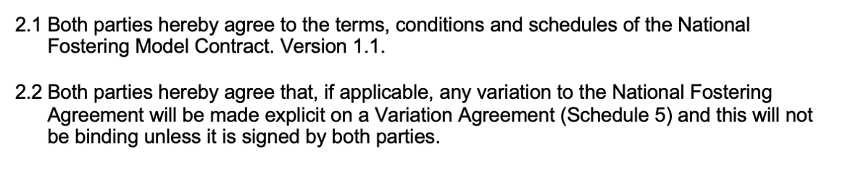

**Duly Authorised Signatory on behalf of the Provider**

Signed by: (PLEASE PRINT NAME)

|  |
| --- |
|  |

Designation: (PLEASE PRINT)

|  |
| --- |
|  |

Signature: Dated:

|  |  |
| --- | --- |
|  |  |

In the presence of: (PLEASE PRINT NAME)

|  |
| --- |
|  |

Designation: (PLEASE PRINT)

|  |
| --- |
|  |

Signature: Dated:

|  |  |
| --- | --- |
|  |  |

**Duly Authorised Signatory on behalf of the Contracting Authority**

Signed by: (PLEASE PRINT NAME)

|  |
| --- |
|  |

Designation: (PLEASE PRINT)

|  |
| --- |
|  |

Signature: Dated:

|  |  |
| --- | --- |
|  |  |

In the presence of: (PLEASE PRINT NAME)

|  |
| --- |
|  |

Designation: (PLEASE PRINT)

|  |
| --- |
|  |

Signature: Dated:

|  |  |
| --- | --- |
|  |  |