Application form to have a Gig Buddy

 | Your name:
Do you have a learning disability and/or autism?

 Yes  No

 | Your date of birth:
Layout in table cell | Your address:
Your telephone numbers:

Home:

Mobile:

 | Your email address:
What is the best way for us to contact you?

 Phone

 Email

 Speak to my family, support worker or carer

Please tell us the contact details for your family, support worker or carer:

Name………………………………………………………………………………..

Phone……………………………………………………………………………….
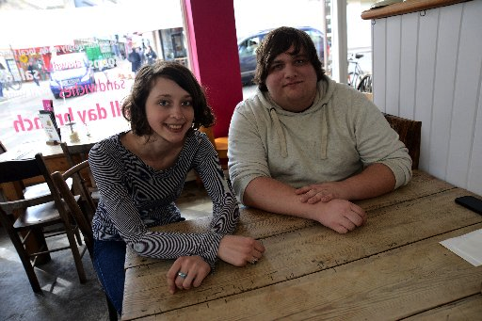 | What do you hope to get out of having a gig buddy?
 | What music are you into? (this could be types of music, like ‘rock’ or bands / singers)
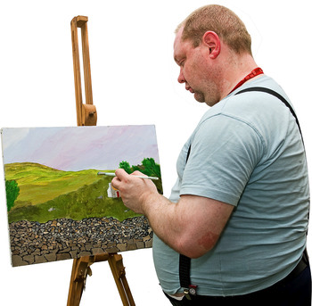 | What are your hobbies?
 | Do you have any preferences about the person you are matched with (age, gender, interests)?
Please tell us about your home. Please tick the box next to where you live.

- I live in my own home
- I live with my family
- I live in supported living or
residential care
 | Do you have any specific health needs (for example, epilepsy)? Would your buddy need any special training to help you with this?
 | Is there anything else that your buddy will need to know about support that you need?
Please send this form to:
Let’s Go Out @ Northdale
Yafforth Road
Northallerton
DL7 0LQ
Or email: breathingspace@northdale.org.uk

