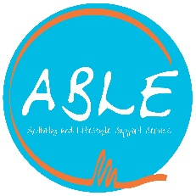

Northdale

Social Media Policy

General policy
Social Media is an essential part of Northdale’s work in promoting our work and collaborating with likeminded people.
Staff and volunteers need to ensure that any posts do not tarnish the reputation of the charity, do not discriminate and do not contain language may offend or discriminate.
Staff are encouraged to engage with relevant social media platforms as part of their day to day duties, or provide content as requested.
Normal courtesies should be observed and staff and volunteers posting up libellous content will be subject to the charity’s disciplinary policy.
Staff and volunteers are also bound by Data Protection laws.
Expectations
Staff who use social media are encouraged to positively engage in promoting the charity’s work through its various social media platforms.
Staff must be responsible for what they communicate either directly, or personally, about the work of the charity.
Communication with clients, volunteers, or work groups should not be exclusively on social media and staff should be mindful of those who do not have access.
Communications on social media which raise concern should be dealt with through the usual safeguarding procedure.
Related Policies and Procedures
Disciplinary Procedure
Data Protection
Code of Conduct

