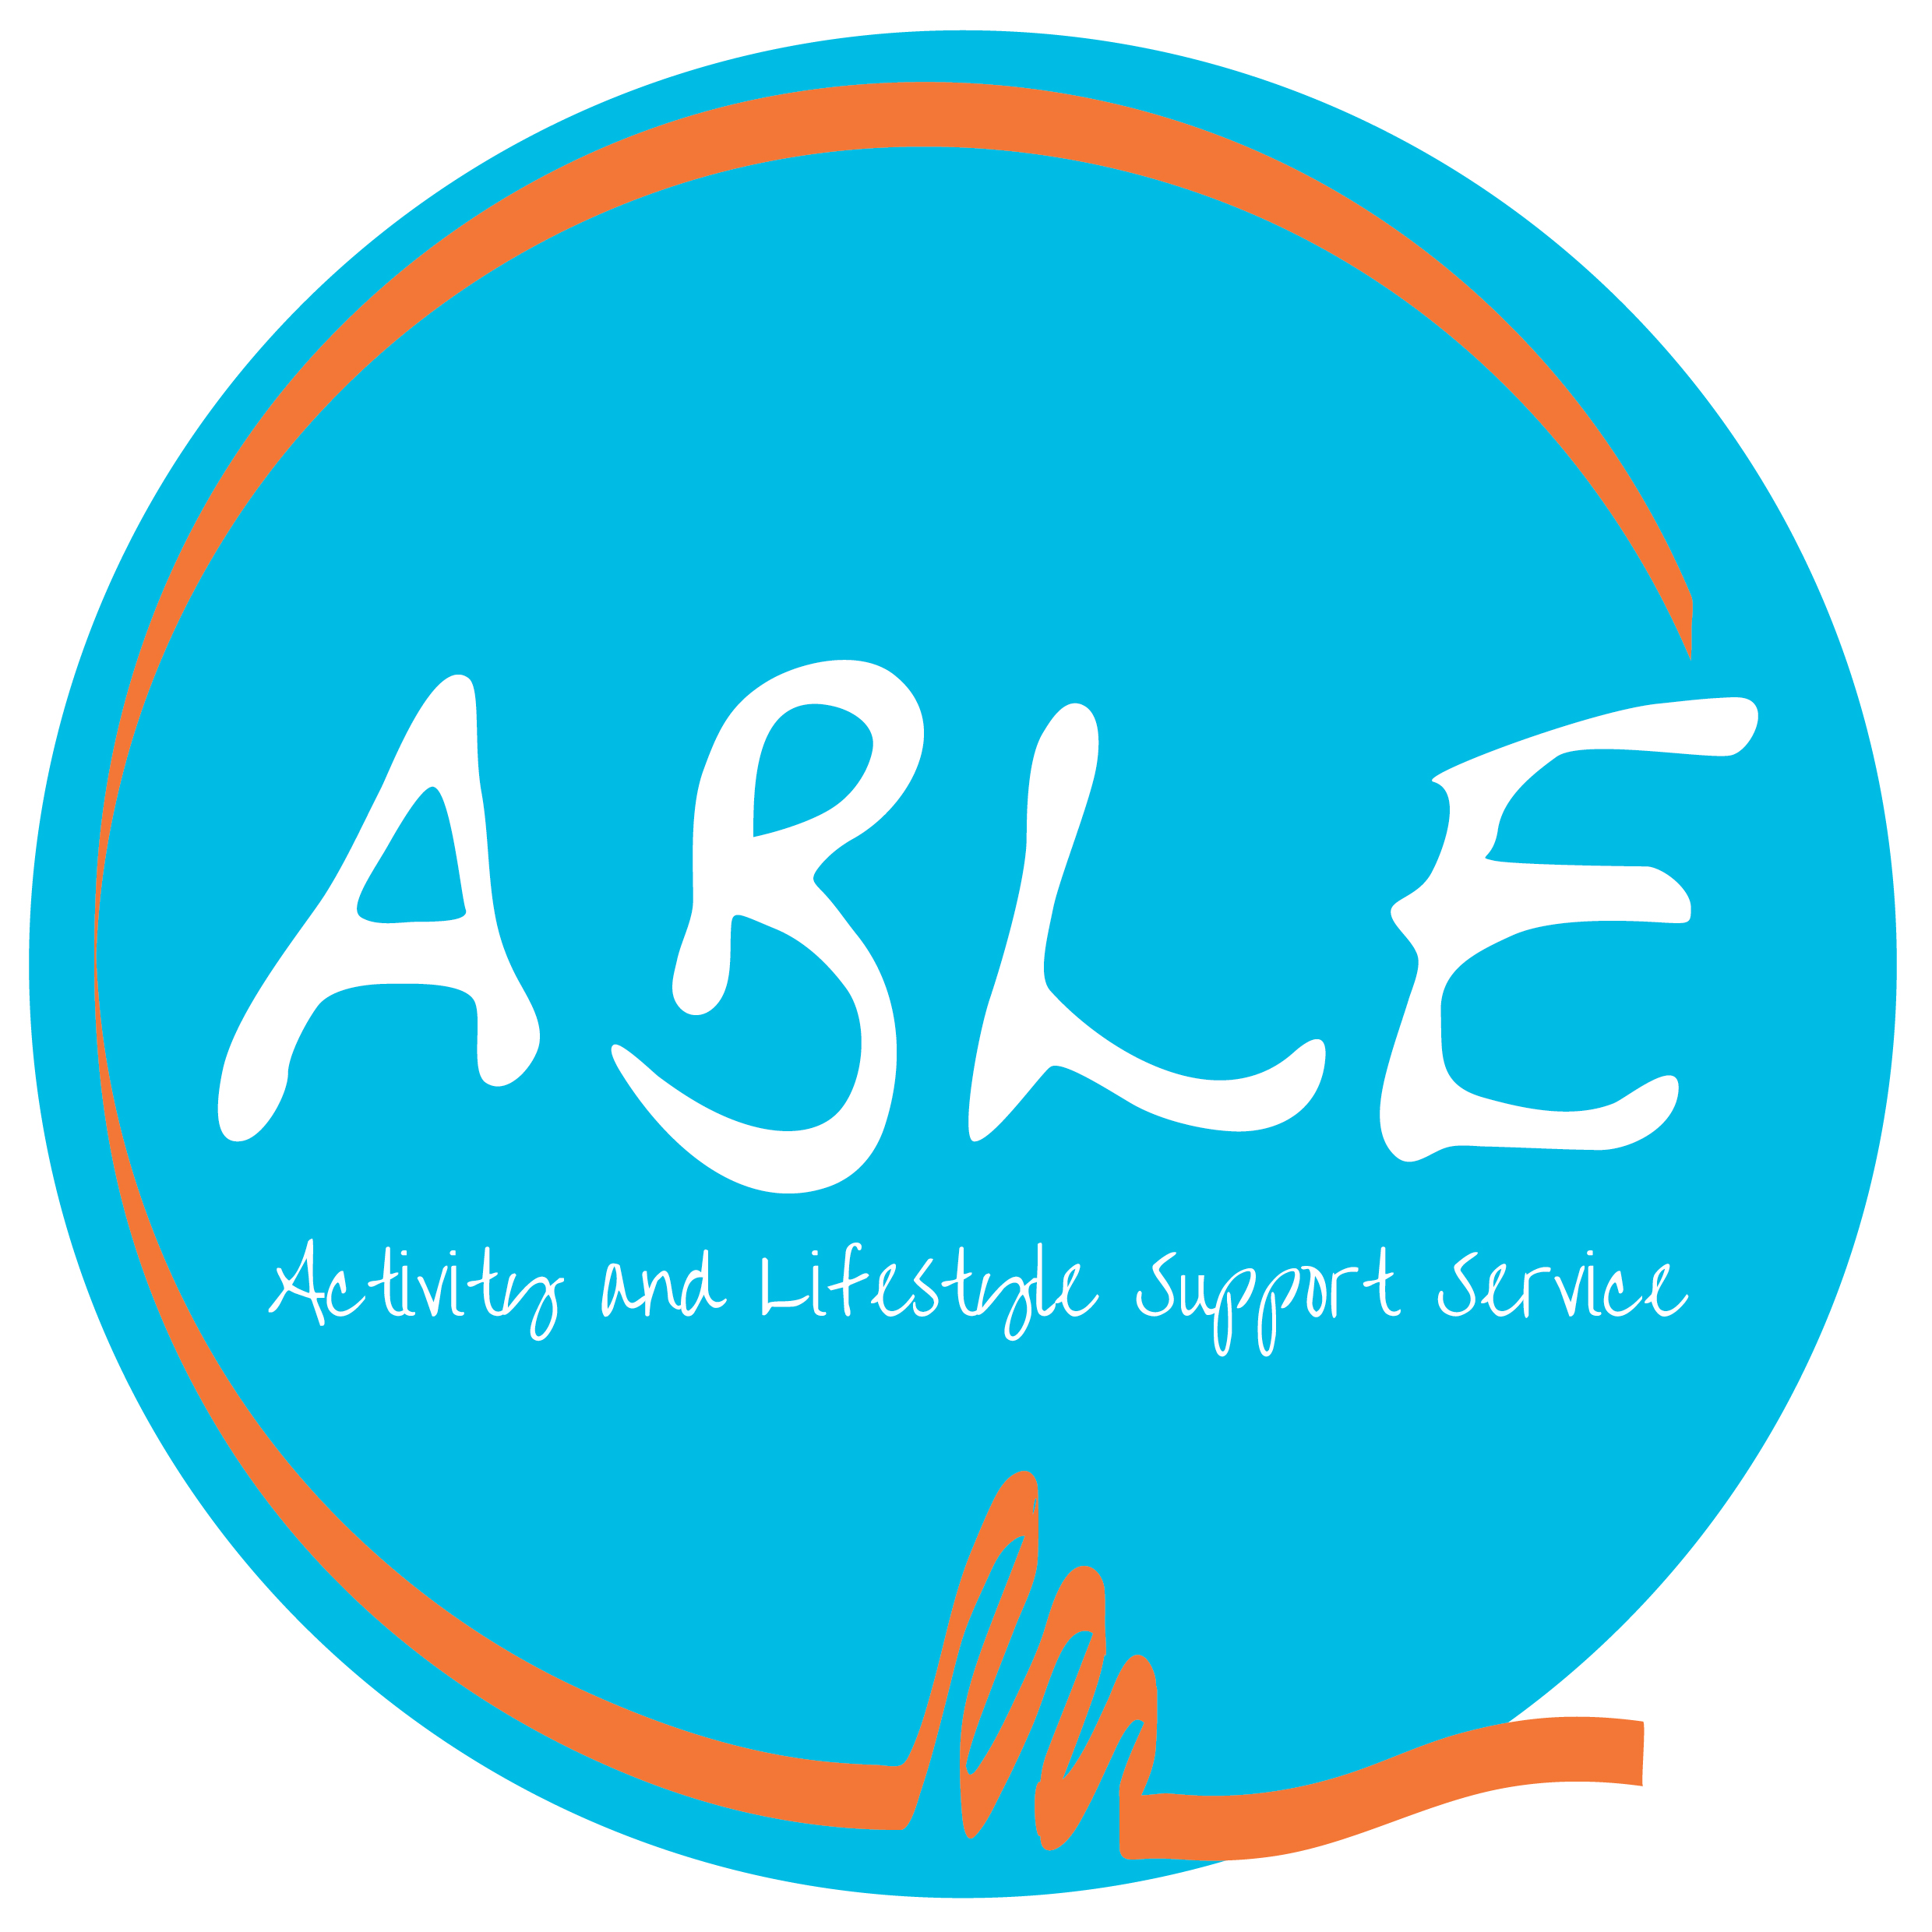

NORTHDALE HORTICULTURE
POLICIES AND PROCEDURES

VOLUNTEER POLICY

Introduction

Northdale Horticulture’s Volunteer policy aims to reflect the high esteem in which the Charity holds its Volunteers and the valuable experience of life they bring to the work of the Charity. They often champion the Northdale Horticulture cause and add value to the work the Charity undertakes with the many adults with learning disabilities and or physical disabilities that use the service each year. The contribution that Volunteers make spans the work of the Charity. The Board of Trustees, which controls the strategic direction of the Charity and its financial accountability, is made up entirely of Volunteers and the bed rock of our service, also our work based activities are supported by a loyal and committed band of regular Volunteers.

This policy sets out the broad principles for volunteering with Northdale Horticulture and has been produced in consultation with the Volunteers. The policy is relevant to everyone involved with the recruitment, development and coordination of Volunteers as well as Volunteers themselves.

Policy Statement

Volunteers are an established, valued and integral part of Northdale Horticulture and the work and support provided by Volunteers is crucial to the ongoing work of the Charity. Northdale Horticulture is committed to continually developing and maintaining the dynamic and mutually beneficial relationships between its Volunteers and the Charity.

Equal Opportunities and Equality and Diversity

Northdale Horticulture operates both an Equal Opportunities and Equality and Diversity Policy for Staff, Volunteers and Service Users alike and believes that no one should be treated less favourably than anyone else because of their gender, marital status, age, sexual orientation, social class, race, ethnic origin, religious belief or disability. The Charity is committed to diversity in all areas of its work and believe that it can learn from diverse cultures and perspectives.

Who is a Volunteer?

A Volunteer is someone who does not receive financial compensation beyond the reimbursement of expenses and who performs a task at the request of, or on behalf of, Northdale Horticulture.
The Volunteer relationship is binding in honour, trust and mutual understanding. No enforceable obligation, contractual or otherwise can be imposed on Volunteers to attend. Likewise the Charity does not undertake to provide regular Volunteering opportunities, payment or other benefits for any activity undertaken.

What does a Volunteer do?

The Volunteer Role Descriptions are at Annex A, B & C

Scope of Volunteering

The Charity acknowledges it has responsibilities to its Volunteers and similarly has expectations of its Volunteers.

Northdale Horticulture has the responsibilities to:

- Match the needs of the Charity with the skills, knowledge, experience and motivation of the Volunteer
- Recognise that successful Volunteer involvement incorporates the individual’s motivations, aspirations and choices.
- Ensure that paid staffs are trained to work with Volunteers.
- Ensure Volunteers receive appropriate training and support to help them deliver in their roles.
- Respect Volunteers, listen and learn from what they have to say, and encourage two way communications.
- Provide timely and accurate information about the Charity’s policies and procedures.
- Foster a friendly and supportive atmosphere.
- Make financial and other provisions in management plans for the needs of Volunteers.
- Try and resolve fairly any complaints or grievances.
- Ensure the health, safety and welfare of all Northdale Horticulture Volunteers whilst undertaking their Volunteering activities.

Northdale Horticulture expects its Volunteers to:

- Maintain and uphold the good name and reputation of the Charity.
- Co-operate with paid members of staff.
- Aim for a high standards of efficiency, reliability and quality in all aspects of their work.
- Encourage two-way communication with other Volunteers and encourage a pleasant and friendly atmosphere.
- Support the Charity’s Equal Opportunities and Equality and Diversity policies.
- Work within the law.
- Respect the need for confidentiality.
- Take reasonable care of their own health and safety whilst volunteering and that of others who may be affected by their acts or omissions.
- Operate within Northdale Horticulture’s Code of Conduct, Health and Safety, Safeguarding Vulnerable Adults and Abuse of Clients Policies. These policies will be read as part of the induction process and re-issued to each volunteer every 3 years as a refresher.

Recruitment

The Charity:

- Encourages involvement by Volunteers from all sections of the community and will not discriminate against any Volunteers in the selection procedure.
- Welcomes Volunteers of all ages. We do not specify an upper age limit and Northdale Horticulture recognises the valuable contribution made by older Volunteers in terms of knowledge and experience.
- Would be irresponsible if it permitted Volunteers to continue to volunteer if their involvement would be detrimental to their own or other people’s health and safety and may decide it is appropriate for the Volunteer to reduce or cease their voluntary contribution.
- Selection procedures for individual Volunteers must protect the Charity’s interests and the health and wellbeing of the vulnerable adults using the service.
- Must be satisfied that the Volunteer possesses the appropriate personal qualities e.g. responsible, reliable and considerate of those around them.

Recruitment Procedure

The recruitment process for potential Volunteers for the Day Service will involve:

- Being invited to visit Northdale and meet senior members of staff and at least one member of the instructing team.
- Completing an Application form.
- The completed Application form is returned to Northdale Horticulture, including the details of two personal referees. (References will be sought in all cases and a Volunteer application will not be advanced until two satisfactory references have been received).
- A Disclosure and Barring Service (DBS) check being undertaken and resulting in no reasons for concern.
- Being invited to negotiate hours of attendance and a start date.

The recruitment process for potential Volunteers for the Leisure Service will involve:

- Being invited to visit Northdale and meet the Leisure Services Coordinator to discuss the role or if not practical then the coordinator will travel to meet the volunteer in a public place.
- Completing an Application form.
- The completed Application form is returned to Northdale Horticulture, including the details of two personal referees. (References will be sought in all cases and a Volunteer application will not be advanced until two satisfactory references have been received).
- A Disclosure and Barring Service (DBS) check being undertaken and resulting in no reasons for concern.
- For Breathing Space you will be invited to attend and observe a trip and meet the paid support staff. Attendance will then be arranged as each programme of events is published.
- A Gig Buddy volunteer will be provided with induction training. Prior to a match being made they will receive information regarding their buddy. The first meeting will be supported by the coordinator and is made under no obligation to continue if the match is unsuccessful.

Training and Development

New Volunteers will be made to feel welcome and will be provided with relevant information, training and induction as appropriate to their role. Volunteers may wish to develop their skills whilst helping the Charity and where appropriate will be encouraged to undertake training where it is possible for the Charity to support it.
It is recommended that the progress and contribution of Volunteers is discussed regularly to provide an opportunity for each Volunteer and the Charity to identify and clarify any areas of concern.

Conduct and Grievance Issues

If there are concerns around a Volunteer’s behaviour or contribution, the matter will be discussed amicably and steps agreed to address it. These may include additional training or mentoring. However, if these areas of concern cannot be resolved after more formal discussions, their Volunteering relationship with the Charity may have to cease.

Northdale Horticulture must protect its reputation in all circumstances and where a Volunteer takes actions that may bring the Charity’s name into disrepute, the Volunteer’s involvement with the Charity will be stopped immediately. This also applies to any financial irregularity or violent conduct towards Staff, Service Users, other Volunteers or members of the public.

If a Volunteer has a grievance they will be expected to follow the Grievance Policy and Procedure.

Moving On

The Charity recognises that Volunteers may cease their involvement at any time. If circumstances allow when a Volunteer chooses to cease their link with the Charity that their reasons for doing so are sought, any learning points are shared and it is established whether they might wish to be involved again in the future.

Expenses

Northdale Horticulture will reimburse any out of pocket expenses incurred whilst volunteering for the Charity. However they must be agreed in advance by either the Chairman of the Board of Trustees, the Service Manager or the Operational Manager and may include travel and training expenses. It should be noted that the Charity will not reimburse travel expenses incurred whilst travelling to and from Northdale or for the reimbursement of refreshment expenses. Please see separate policy for leisure services volunteers.

Health and Safety

The Charity is committed to providing a healthy and safe environment for all Volunteers on its premises and whilst undertaking Charity business when off site. Where applicable appropriate instruction, training and supervision will be provided. All Volunteers will be expected to familiarise themselves with the Charity’s Health and Safety at Work (HASAW) Policy and to conduct themselves in accordance with that policy.

Supervision and Support

In most circumstances, Volunteers will be directly or indirectly supervised or supported by a paid member of staff. If a Volunteer would like to discuss any issue related to their volunteering or has a more general observation to make about the work of the Charity they are invited to talk to their direct work team instructor for day services, or the leisure services coordinator, or alternatively either the Service or Operational Manager.

Insurance

The scope of the Charity’s insurance is extremely wide with the policy documents being available for inspection in the Charity’s office. The Charity has a specific Social Welfare Insurance policy and the activities of Volunteers are specifically covered under its terms.

Data Protection and the Law

Personal information about Volunteers is stored and maintained with appropriate safeguards for confidentiality. The Charity abides by all provisions of the Data Protection Act of 2018.

Training Requirements

All members of Staff and Volunteers will be briefed on this policy as part of their Induction.

Related Policies and Procedures

Abuse of Clients
Code of Conduct
Confidentiality, Record Keeping & Access to Information
Equal Opportunities
Equality and Diversity
Grievance
Health & Safety
Risk Assessment
Safeguarding Vulnerable People.
Breathing Space Expenses Policy
Gig Buddies Expenses Policy
Data Protection

Annex

- Day Services Volunteer Role Description.
- Breathing Space volunteer role description
- Gig Buddies volunteer role description
- Induction Form
- Policy Review Details

Annex A to
Volunteer Policy

NORTHDALE HORTICULTURE
POLICIES AND PROCEDURES

DAY SERVICES VOLUNTEER ROLE DESCRIPTION

Role: To provide support for adults with learning disabilities and or physical disabilities so that the individual being supported might take part in valued occupations and work-based activities.

Where: Northdale Horticulture.

When: To be arranged.

What we would like you to do: Northdale Horticulture volunteers are asked to support adults with learning disabilities and or physical disabilities so that they might take part in a range of work-based activities. The primary role of a volunteer is to bring added value to the service users experience and help the instructor support a work-group of up to six individuals. A volunteer will be asked to support individuals on a one to one basis or at most support a small group of individuals to complete a task in one of Northdale work areas.

What you will not be asked to do: At no time will a volunteer be asked to supervise an individual or work-group without the support and guidance of a work-team supervisor/instructor being present in the immediate work environment. At no time will a volunteer be asked to operate equipment on which they have not been trained.

Personal requirements: We require individuals of good character who can provide two personal references and are happy to successfully undertake an enhanced Disclosure and Barring Service (DBS) check.

Training: Northdale Horticulture is happy to support volunteer training and will support individuals to undertake Safeguarding, Makaton Level 1, Epilepsy Awareness and Mental Health Awareness training.

A copy of Northdale Horticulture’s volunteering policy is available on request.

The official stuff: Volunteering is deemed to be a relationship binding in honour, trust and mutual understanding. No enforceable obligation, contractual or otherwise can be imposed on the volunteer to attend. Likewise the Northdale Horticulture does not undertake to provide regular volunteering opportunities, payments or other benefits for activities undertaken.

Annex B to
Volunteer Policy

NORTHDALE HORTICULTURE
POLICIES AND PROCEDURES

BREATHING SPACE VOLUNTEER ROLE DESCRIPTION

Role: To provide support for adults with learning disabilities and or physical disabilities so that the individual being supported might take part in a group leisure activity

Where: Multiple leisure venues

When: To be arranged, all either evening or weekends

What we would like you to do: Northdale Horticulture Breathing Space volunteers are asked to support adults with learning disabilities and or physical disabilities so that they might take part in pre- arranged group leisure activities. The primary role of a volunteer is to bring added value to the member’s experience under the guidance of the Group leader. A volunteer may be asked to support individuals on a one to one basis or at most support a small group of individuals during the event. We will arrange with you whether you travel with the group or meet them at the venue.

What you will not be asked to do: At no time will a volunteer be asked to supervise an individual or group without the support and guidance of a Group Leader being present in the immediate environment. At no time will a volunteer be asked to deliver personal care.

Personal requirements: We require individuals of good character who can provide two personal references and are happy to successfully undertake an enhanced Disclosure and Barring Service (DBS) check.

Training: Northdale Horticulture is happy to support volunteer training and will support individuals to undertake Safeguarding , Makaton Level 1, Epilepsy Awareness and Mental Health Awareness training.

A copy of Northdale Horticulture’s volunteering policy is available on request.

The official stuff: Volunteering is deemed to be a relationship binding in honour, trust and mutual understanding. No enforceable obligation, contractual or otherwise can be imposed on the volunteer to attend. Likewise the Northdale Horticulture does not undertake to provide regular volunteering opportunities, payments or other benefits for activities undertaken.

Annex C to
Volunteer Policy

NORTHDALE HORTICULTURE
POLICIES AND PROCEDURES

GIG BUDDIES VOLUNTEER ROLE DESCRIPTION

Role: To provide support for adults with learning disabilities and or physical disabilities so that the individual being supported might take part in valued occupations and work-based activities.

Where: Multiple leisure venues to be arranged

When: Commitment to an average of one trip per month to be arranged between volunteer and buddy

What we would like you to do: Gig Buddies is a volunteer befriending scheme for adults with learning disabilities and autism, matching them with a volunteer who shares the same interests. We will pair you with someone with similar interests and we would like you to arrange to go out with them an average of once a month. You will be a lone worker and you will receive training and support and will be asked to submit paperwork so the level of service can be recorded. You will receive expenses in accordance with our policy.

What you will not be asked to do: At no time will you be asked to support with medication or personal care.

Personal requirements: We require individuals of good character who can provide two personal references and are happy to successfully undertake an enhanced Disclosure and Barring Service (DBS) check.

Training: Northdale Horticulture is happy to support volunteer training and will provide induction training plus there will be support for individuals to undertake Safeguarding , Makaton Level 1, Epilepsy Awareness and Mental Health Awareness training.

A copy of Northdale Horticulture’s volunteering policy is available on request.

The official stuff: Volunteering is deemed to be a relationship binding in honour, trust and mutual understanding. No enforceable obligation, contractual or otherwise can be imposed on the volunteer to attend. Likewise the Northdale Horticulture does not undertake to provide regular volunteering opportunities, payments or other benefits for activities undertaken.

Annex D to
Volunteer Policy

Induction Form

Name

Volunteer Start Date

Northdale Staff Member
Management has volunteer been: - | Yes/No | Initials
Management has volunteer been: - | Yes/No | Northdale | Volunteer

Given a tour & overview of Northdale

Advised of where to sign in/out

Introduced to all Staff

Introduced to Service Users

Advised of Fire Procedure

Advised of Fire Assembly Point

Advised of who are the First Aiders and their location

Provided with a copy of the appropriate volunteer role description

Read Northdale’s Safeguarding Policy

Read Northdale’s Code of Conduct Policy

Read Northdale’s Abuse of Clients Policy

Read Northdale’s Health & Safety Policy

Provided with a copy of Northdale’s volunteer Policy

Annex E
Volunteer Policy

3 Yearly Volunteer Policy Review Form

Name

Date
Management has volunteer: | Yes/No | Initials
Management has volunteer: | Yes/No | Northdale | Volunteer

Read Northdale’s Safeguarding Policy

Read Northdale’s Code of Conduct Policy

Read Northdale’s Abuse of Clients Policy

Read Northdale’s Health & Safety Policy

Provided with a copy of Northdale’s volunteer Policy

