THE NATIONAL VEGETABLE SOCIETY  Northern Branch Championships 2025 | Registered Charity 1088979  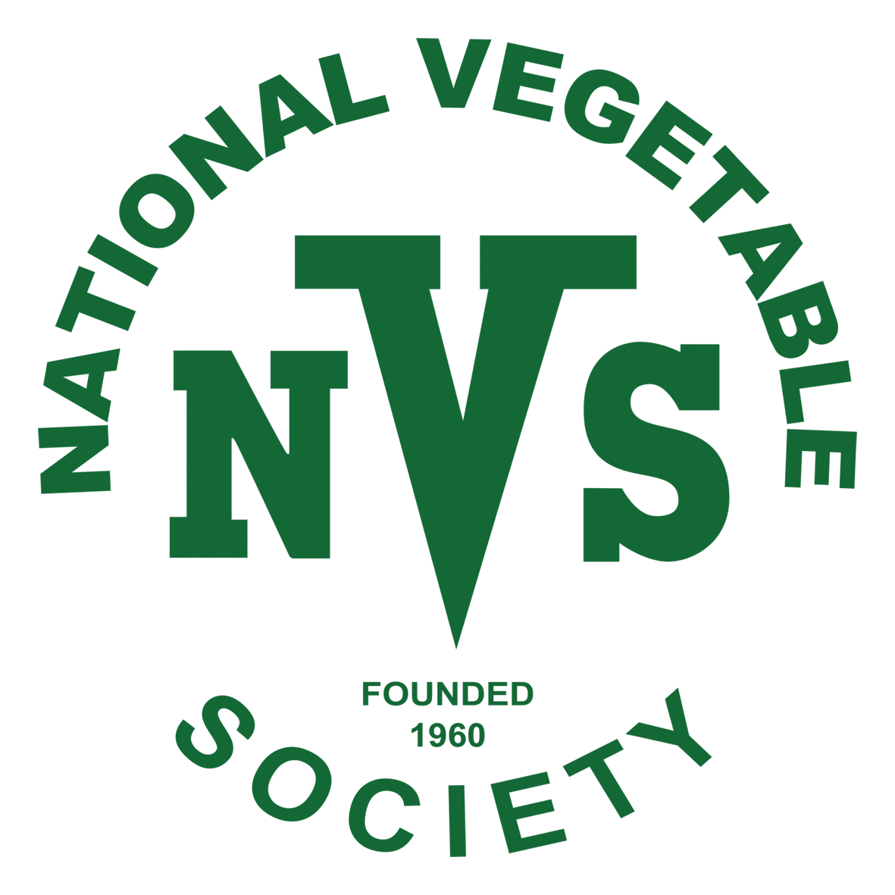
The National Vegetable Society wishes to thank The Harrogate Flower Shows for hosting the 2025 Northern Branch Championships.
Judges
David Allison FNVS Burley in Wharfedale
Graeme Watson Egton , North Yorkshire
Derek Bath Cawood, North Yorkshire
Paul Neve FNVS Swanland, Hull, E Yorks

Friday 19th September 2025 (0900 – 1700)
Saturday 20th September 2025(0900 – 1700)
Sunday 21st September 2025 (0900 – 1645)

Harrogate Autumn Flower Show
Newby Hall
Ripon
North Yorkshire
HG4 5AE
www.nvsuk.org.uk

Rules and Regulations
- The NVS Northern Branch Championships is free to enter for all current members of the National Vegetable Society and any one current member of an Affiliated Society.
- Each exhibitor can only enter one exhibit per class, which must be the property of and be grown by the exhibitor.
- All Entry Forms must reach the Show Secretary no later than the stated time and may be emailed (preferable) or posted. Late entries will be considered but may be refused
- Judges officiating at an NVS Northern Branch Championship Show are permitted to enter a maximum of two exhibits into any Class at this Show.
- The Show Secretary reserves the right to refuse any entry. In the event of such a refusal, an explanation will be given.
- FNVS Judging will be in accordance with the rules as laid down in the 2017 NVS Judges and Exhibitors Guide as amended 2018.
- Entry to the show is free to all exhibitors.
- Staging of exhibits will begin at 4.00pm on Thursday 18th September and will continue until 6.00am on Friday 19th September.- There will be limited over-night assistance after 2100hrs
- The handling of all exhibits once judged is strictly forbidden.
- It is the responsibility of the Exhibitor to place the correct staging and cultivar cards as supplied alongside each exhibit. All exhibits will be judged.
- Judging will commence promptly at 6.30am on Friday 19th September. Only Show Officials, Judges and Stewards are permitted to remain in the marque during judging.
- The judge’s decision is final. Protests and appeals may be raised and must be handed to the Show Manager / Secretary in writing, together with a deposit of £10, within one hour of the show hall opening to the public. The deposit will only be refunded if the objection is upheld.
- All top foliage on root vegetables to be trimmed to approximately 75mm and all cabbages to be shown with approximately 75mm stalk and cauliflowers with approximately 75mm stalk.
- Only natural raffia may be used for the tying of onions and shallots. All shallots to have been grown from sets.
- The use of any foreign substance on the exhibit is strictly forbidden as described in the 2017 NVS Judges and Exhibitors Guide and as amended 2018.
- Only plates and boards supplied by the Show Organisers will be used unless stated otherwise in the Schedule of Classes.
- Exhibitors may use their own staging materials and / or black cloth but NOT as an addition to the staging supplied, except where stated in the Schedule.
- In onion classes not shown on a plate, the base of each onion must be no greater than 150mm above the table.
- Under no circumstances may any exhibit be removed from the tables, once staged, until 4.45pm on Sunday, 21st September, except by the Show Manager / Show Secretary.
- The show organisers cannot accept responsibility for any loss or damage whatsoever, however all reasonable care will be taken.
- All personal data submitted will be treated in accordance with the National Vegetable Society Privacy Notice, a copy of which is available on the NVS website.
www.nvsuk.org.uk...

Schedule of Classes
- A collection of 6 kinds of vegetables, one of each kind, to be laid flat (Staging allowed).
- Celery one dish of two heads.
- Cauliflowers, one dish of two.
- Onions, one dish of five, each onion to weigh a minimum of 1kg, but not more than 1.5kg (Staging allowed)
- Tomatoes medium, one dish of Nine (Plate provided)
- Mini-Collection, three kinds of vegetables, two of each kind (Staging allowed).
- Carrots – stump rooted, one dish of three
- Potatoes – White, one dish of five, (Plate provided)
- Beetroot – Globe, one dish of five (Plate provided)
- Onions, one dish of five, each onion must not weigh more than 250gms (Plate provided).
- Potatoes-Coloured, one dish of five (Plate provided)
- Shallots-Large exhibition, one dish of twelve (plate provided)
- Parsnips, one dish of three.
- Carrots-Long pointed, one dish of three.
- Tap Root Collection, one of each of three from the following:
Carrot – Long pointed
Carrot – stump rooted
Parsnip
Beetroot – Long
Beetroot – Globe
- Peas, one dish of nine pods
- Beans French, one dish of nine pods
- Beans Runner, one dish of nine pods
- Cucumber, one dish of two
- Marrow table, one dish of two
- Shallots pickling, one dish of twelve (each shallot must pass cleanly through a 30mm ring
- Cabbage, one dish of two
- Pot Leeks, one dish of two
- Aubergines dish of three
- Millenium Class, Four of each of any four from the following:
- Potatoes (Any colour)
- Carrots Stump rooted
- Tomatoes (Medium)
- Beetroot (Globe)
- Onions (250gm)
- *Three different Vegetables
- *Small Cucumber- One dish of three
* Classes 26 & 27 are open to Novice members who have not won a first place at a Branch or National Competition.
www.nvsuk.org.uk...
Trophies and Prize Money
The Northern Branch no longer awards physical trophies for general classes
The NVS Silver medal and card will be awarded to the best exhibit in the Championship classes.
The Cockney Bowl (Photograph card) will be awarded to the exhibitor gaining the most points in the Championship classes.

Points awarded:

Class 1 & 25 1st – 8 ; 2nd – 6; 3rd – 4; 4th – 2; 5th – 1

Classes 2 to 24,26 & 27 1st – 8; 2nd – 6; 3rd – 4; 4th - 2

Prize Money:

1st 2nd 3rd 4th 5th
Classes 1 & 25 £50 £40 £30 £20 £10

Classes 2 -24 £25 £20 £15 £10

Novice Classes 26 & 27 £25 £20 £15 £10

www.nvsuk.org.uk...

Northern Branch Championships 2025

ENTRY FORM
Entry forms must reach the Show Secretary no later than Friday 12th September 2025.
1 | 2 | 3 | 4 | 5 | 6 | 7 | 8 | 9
10 | 11 | 12 | 13 | 14 | 15 | 16 | 17 | 18
19 | 20 | 21 | 22 | 23 | 24 | 25 | *26 | *27

Please tick the boxes for the class(es) you wish to enter. Only one entry per exhibitor per class allowed.

Classes 26 &27 are only for Members who have not won a 1st place at a Branch or National Competition

I hereby declare that I will strictly adhere to the rules laid down by the National Vegetable Society.

Signed: ……………………………………………………………………………………………………………………………………….……………
Name:
Address:
Post Code: |  | Tel No:
Email address:
NVS Membership No.
Prize money will be paid via bank transfer. please complete your bank details below.
Sort Code: - - | Bank Acc:
Failure to provide Bank details will result in delay in payment being made. All bank details are destroyed once payments have been made.

Closing date for entries is Monday 15th September

Please return completed entry forms either by email (preferable) geoffwilz@hotmail.co.uk
or post to:
Mr Geoff Wilson FNVS. 6, Kingcraft Road, Marton in Cleveland, MIDDLESBROUGH. TS7 8RF
Tel: 01642 279528

