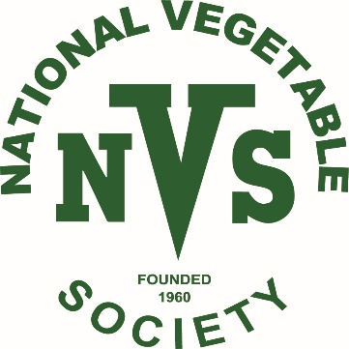

WEST MIDLANDS DA
MINI SHOW SCHEDULE FOR ANNUAL SHOW ON THE 28TH AUGUST 2025
AT
Fairfield Village Hall B61 9LZ
Entries will be accepted between 7.00pm and 8.00pm on the night. Judging will commence at 8.05 pm. and will be carried out under NVS rules. Paper plates will be provided except for class 1 where exhibits are to be placed in a seed tray provided by the exhibitor.
Class1. Tray of 4 vegetables. Potatoes, carrots, beetroot and cucumber. All vegetable varieties to be named.
Class 2. Potatoes. One dish of three white and one dish of three coloured.
Class 3. Carrots. One dish of 3 stump rooted, tops trimmed to 75mm.
Class4. Beetroot. One dish of 3 red globe, tops trimmed to 75mm.
Class 5. Tomatoes. Medium. One dish of 3, max size60mm.
Class 6. 2 Cucumbers.
Class 7. French beans. One dish of 6.
Class 8. Runner beans. On dish of 6 with stalks.
Class 9. Display of 4 herbs in bunches.
Class 10. Any other vegetable.
Class 11. 2 Courgettes
Class 12. Onions . One dish of 3, below 250 gms.
Class 13. Onions. One dish of 3, exceeding 250 gms.
Class 14. Novice class. One entry from classes 1-13. A novice being a person who has not won a prize at a NVS show.
Class 15. One dish of vegetables not mentioned in classes 1-13.
Non members class. One dish of vegetables mentioned in classes 2-13.

All vegetables to be kept fresh with water only.
Prizes in all classes. 1st £5, 2nd £3, 3rd £2. Sponsors to be confirmed.
A special prize for best exhibit in show.

Please complete the form below.
NAME:
MEMBERSHIP NUMBER:

CLASSES ENTERED

