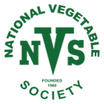 | NATIONAL VEGETABLE SOCIETY NORTHERN BRANCH

one week until your AGM and FREE seminar!
Saturday 14th March 2026
AT Horbury WMC, WF4 5DB

We reserved a few spaces for people to just turn up on the day, so don’t worry if you haven’t booked yet. The AGM will take place from 10am to 11.30am, with a free buffet lunch served from 12pm. The first speaker is on at 12:30. You’re welcome to join us for just the seminar if you can’t get to the morning meeting. There’s a raffle with prizes including two AutoPot kits generously donated by NVS sponsor AutoPot Watering Systems. The event is open to all NVS members and prospective members.

The address is Horbury Working Members Club, Cluntergate, Horbury, Wakefield WF4 5DB. Access is easy from Junctions 39 and 40 of the M1, and there’s plenty of parking. If you’ve any questions, contact geoffwilson100@gmail.com or asstsecretary@nvsuk.org.uk. Alternatively you can call or message us on 07957 214 348.

SPEAKERS

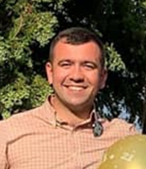 | Calum Clunie from BBC Beechgrove Garden will talk about his journey into gardening, his dabbling with showing veg, and his time presenting on Beechgrove.
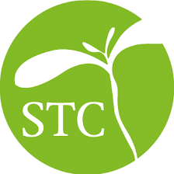 | Julian Davies of Stocksbridge Technology centre will update us on the quality and efficiency of peat-free composts available on the current market.
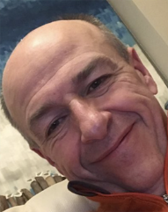 | Doug Stewart from BBC Radio Humberside’s The Great Outdoors will talk about new and sustainable ways to garden including tips for a more organic approach.

