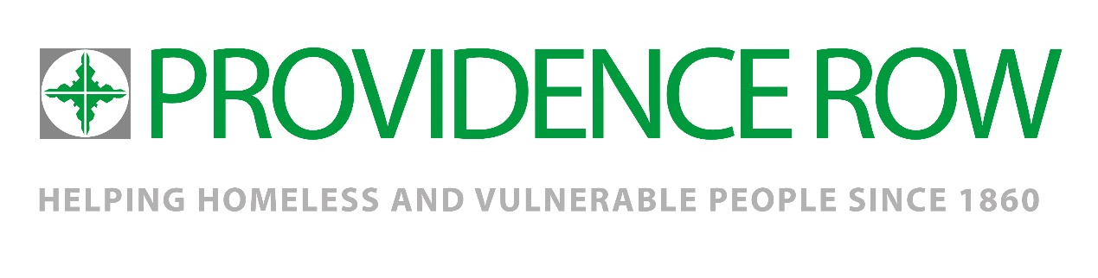

**Community Fundraising Manager**

|  |  |
| --- | --- |
| **Job title:**  **Community Fundraising Manager** | **Team:**  **Fundraising and Marketing** |
| **Accountable to:**  **Head of Partnerships** | **Line managing: N/A** |
| **Salary: c.£**£33,000 **-** £38,000  depending on experience  **Pension**: Automatic enrolment into the People’s Pension scheme after 3 months | **Hours:**  **35 hr week**  **Location:**  **Hybrid** |
| **Disclosure: Enhanced (DBS required)** | **Contract: Permanent** |

**About us:**

Providence Row has been supporting homeless and vulnerably housed people since 1860. The charity works with more than 1700 people a year in East London, offering an integrated service of crisis support and advice, recovery, learning and training programme. Sadly and inexcusably the need is growing significantly and so we are developing our services to support some of the most vulnerable people in our society.

We aim to ensure that people who are so often excluded from mainstream services gain the support and opportunities they need to create a safe, healthy and sustainable life away from the streets. Central to our work are our core values of Compassion, Respect, Inclusiveness, Empowerment and Justice, informing the content, style and delivery of all our services.



**Ideal applicant:**

Working as part of a vibrant and friendly fundraising team, you will play a key part in supporting the Head of Partnerships and the Corporate Fundraising Officer, creating a collaborative culture to ensure we succeed together. The ideal candidate will have excellent organisational skills with great attention to detail and strong communication skills. They will be confident in working with internal and external stakeholders and able to come up with innovative ideas and solutions to engage supporters.

You will bring to the role your experience of delivering income to target by building relationships and maximising community efforts. A natural communicator, you will have the ability to inspire support and action from a diverse range of volunteers and supporters. Working closely with the Corporate Fundraising team on local activities and events, you will acquire new, community support for the charity, while the Individual Giving Manager will support you to deliver Easter and Advent mailings to our church and group supporters.

You will be a team-player who wants to work with like-minded people in a fast growing, friendly and supportive team, while contributing to the success of both the fundraising department and the wider organisation to help make positive lasting changes in people’s lives

**Key responsibilities**

**Planning**

* Lead the implementation of Providence Row’s Community Fundraising strategy, to grow income by reaching new individuals, community and faith groups with a fundraising ask.
* Work strategically across the charity to build on existing networks and implement ideas from front line and senior staff, alongside your own ideas.
* Co-ordinate efforts with leadership to reach existing faithful audiences in the Catholic church.
* Collaborate with the Head of Partnerships to define ways of working that will maximise income and ensure a great supporter experience. Regularly review these ways of working and establish an approach that builds in flexibility where needed.
* Establish communication and engagement journeys that are focused on forming committed support.
* Manage and monitor income and expenditure budgets and provide internal financial reports, income analysis and forecasting and progress against monthly key performance indicators using Providence Row’s fundraising database.
* Regularly review plans to ensure the best return on investment of resources or staff time.
* Develop and maintain a good understanding of housing and homelessness issues in Tower Hamlets and remain informed on Providence Row’s activities.

**Income Delivery**

* Increase Community Fundraising income to target by representing Providence Row to potential and existing supporters, building relationships, and making asks that inspire action. The 2022/23 Community income target is £65k, rising to £80k and £120k in subsequent years.
* Develop relationships with new fundraising supporters in the target audiences of individuals, community and faith groups of all kinds.
* Gain opportunities to tell the charity’s story, and support senior staff, trustees and other volunteers to do the same.
* Meet or exceed performance indicators including active fundraising supporter volumes and successfully-filled volunteer support roles.
* Develop and deliver a programme of support for people raising money in their own way, that builds loyalty and create an excellent supporter experience.
* Motivate, recognise and reward supporters to ensure their long-term support of the charity.
* Work with Marketing and other Fundraising colleagues to create fundraising materials and collateral that are fit-for-purpose for target audiences
* Recruit, support and develop volunteers to help you achieve your targets. Clearly set expectations and actively manage these relationships. We expect that volunteers drawn from your target audiences will support you with strategic and tactical aims.
* Regularly review activity to ensure the best return on investment of resources or staff time.

**Communication and Marketing**

To assist the Marketing team on all levels community updates via website, LinkedIn, Twitter, Facebook and Instagram.

To support in the creation of fundraising resources as required for both the community and corporate fundraising programs.

**To apply**

CV and Cover letter. Deadline February 10th at 12 noon.

**Interviews**

Tuesday 14 February, PM

Wednesday 15 February, PM

***Please note that we may interview on a rolling basis and therefore encourage early applications.***