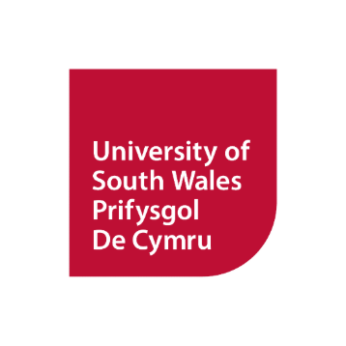
PSGB Annual Meeting
National Museum Cardiff
University of South Wales
Thursday 27th & Friday 28th November 2025
Abstract submission form

Title of Project:
Authors:
(Please underline author that will be presenting)
Affiliation:
Contact Email:
Professional Level: | Early career/student ☐ Mid-Career ☐ Senior ☐ Expert ☐ Prefer not to say ☐
Abstract (300 words max)

Key words:
Presentation Type: |  | 5-min speed talk (In person) ☐ Poster (In person) ☐  15-minute presentation (In person) ☐ Range country 15-minute talk (Online) ☐
Range country talks are designed to be delivered online from range countries by people living in these areas. If you are planning to attend in person but are presenting information/research gathered outside of the UK, please cross the box for 15-minute presentation (In person).

Abstract submissions deadline: Wednesday 15th October.

Please email this form to meetings@psgb.org with ‘PSGB Meeting Abstract Cardiff’ as the subject header. If you have not received a confirmation that your abstract has been received after 3 working days, please get in touch and please check your Junk folder.

If you have any queries, please contact meetings@psgb.com

