Report from the President (Prof. Bridget Waller) - Dec 2025
president@psbg.org
This is my first report as President after taking over from Professor Stuart Semple, and so I want to start by saying a huge thank you to Stuart for his hard work as President over the previous three years. He did fantastic work for PSGB and leaves very big shoes to fill.

As a society, we have two primary goals stated in our constitution. First, we aim to advance research in all areas of primatology (including welfare, conservation and education), and second, to help disseminate the findings of such research through our scientific meetings.

Advancing Research

Our strategy to advance research is through funding scientific grants. We continue to maintain two grant rounds per year (deadlines in March and November), and this year we again awarded a total of 12 grants. However, maintaining this level of grant activity is challenging in an increasingly difficult financial climate. Jamie will give more details in his Treasurer’s report, but I want to emphasise that we are looking closely at the PSGB finances to ensure we can continue to support our members and our goals with confidence.

Scientific Meetings

The previous meeting was held at Bristol Zoological Society in December 2025 ZSL, many thanks to all involved and for making that a success. We also ran a second PSGB Field Skills Workshop in September (led by Nicola Koyama and supported by many others) aiming to support under-represented groups in primatology. We will continue to organise a second event each year (in addition to the main meeting) so please do put forward ideas for any other types of activity you might like to see.

Other business

To try and boost our marketing income, we ran a T-shirt design competition this year. We had 14 excellent entries and picked four winners based on a public vote and council’s choice. Congratulations to winners and thank you to everyone who entered! The winning designs are available to buy at the marketing stall, and also on the online store on the website.

Finally, this year marked the loss of our patron, one of Britain’s most remarkable primatologists. Dr Jane Goodall died in October at the age of 91 after an incredible life that shaped the landscape of primatology world-wide. We published several tributes in the latest issue of Primate Eye which reflects the extent to which she impacted our members during her long career. We thank everyone who contributed, and particularly Lyndsay Murray who organised the tributes. We will continue to honour Jane Goodall’s legacy through the PSGB goals of scientific enquiry, conservation and captive care.

Report from the Secretary (Dr Pawel Fedurek, secretary@psgb.org)
PSGB Council met three times in 2025: in March, June and September. Two Council members stood down or are about to stand down at the end of January. We warmly thank Lindsay Murray and Shannon Farrington for their excellent service to PSGB.
After our call for members to put themselves forward for election to Council followed by Members’ voting, we have the following candidate:

Meeting Officer: Dr Alexander V. Georgiev (Bangor University, https://www.bangor.ac.uk/staff/sens/alexander-georgiev-125564/en).

This year, Marianne Paisley joined the PSGB Council as Student Officer.
The Society will ratify the candidates as members of Council at the Annual General Meeting held in Cardiff in November 2025.

Report from Treasurer (Dr Jamie Whitehouse, treasuer@psgb.org), for financial year 2024/2025.
I am pleased to present a report for the PSGB accounts over the last financial year starting 1st October 2024 and ending 30th September 2025. As always it has been busy. Firstly, thanks to all the people I have worked with and who have helped me settle into the new role – very much appreciated.
Our income is consistent and predictable and closely matches the previous year. Bringing in £27,336.04 from Membership, Meeting Registrations, Donations and Merch sales. This is incredibly close to our previous years’ income of £27,778. Of this year’s income, £9958 came directly from Membership subscriptions, and £5840 from Society meeting registrations.
We continue to offer two grants rounds per year, and awarded 6 research grants, 4 conservation grants and 2 captive care grants. Eight of these grants were directly funded from PSGB raised income, and 4 were funded directly from donated money. Overall, £14,451 was awarded to applicants. In addition, we facilitated an additional conservation grant (funded directly by Born Free (£1500), with no money passing through PSGB. I am also happy to report that we contributed £1320 to this year’s conservation course, SEKAKOH.
We received another generous £10,000 donation from Trentham Monkey Forest, which will fund 2 projects per grant round until 2027. In addition, we received £500 from Royal Society Publishing (for costs towards our Winter meeting) and £299 from a Just Giving fundraiser (for costs towards our field skills course).
Despite the healthy income, we unfortunately operated at a loss of £5372 this year (opening balance of main account: £15,574.54, closing balance: £10,202.26). This is in part due to the timings of some expenses associated with our society meetings. This year we settled expenses for the Winter 2024 meeting (£4970) and paid up-front costs towards the 2025 meeting (£1920) and the 2026 meeting (£2532). I believe it is unusual to contribute significantly towards three meetings expenses in one financial year, and typically much of this cost would be in subsequent years budget. However, I anticipate this will offset some significant costs in the next financial year. In terms of other notable expenses, firstly we increased our contribution to the Field Skills course. This course was incredibly successful, however accrued an additional £900 to the society (although there was great effort to secure external support and keep costs low). Finally, an additional £1200 was also accrued for the cost of an award medal for the last meeting.
I emphasise caution and think we may need to start thinking about increasing our income. Our membership £9958 almost perfectly covers our 2 grant rounds (£1250 x 8, £10,000), and our meetings mostly aim to break even. This at the moment, leaves little surplus for other on-going society costs (web and commerce fees, Primate eye, Field skills course, EPF contribution). Bearing in mind, our accounts currently include un-spent donation pre-allocated for grants.
Thanks for the support, and please find detailed expenditure on the following pages, as well as some visualisations of the flow of money through the society.
Jamie Whitehouse.

PSGB Expenditure 2024-2025 (compared with 2023-2024)
 | Year to 30th Sept 2025 |  |  | Year to 30th Sept 2024
Description | Income | Expenditure | Surplus/Loss | Income | Expenditure | Surplus/Loss
Membership + Meeting tickets | £15799.38 | - | £15799.38 | £15733.19 | - | £15733.19
Misc income | £350.19 | - | £350.19 | £16.00 | - | £16.00
Merch sales | £388.28 | - | £388.28 | £539.18 | - | £539.18
Trentham Donation | £10000.00 | - | £10000.00 | £10000.00 | - | £10000.00
Other donations | £798.19 | - | £798.19 | £1500.00 | - | £1500.00
Research grants | - | (£7441.85) | (£7441.85) | - | (5580.19) | (£5580.19)
Conservation grants | - | (£5000.00) | (£5000.00) | - | (6442.64) | (£6442.64)
Captive care grants | - | (£2510.00) | (£2510.00) | - | (2438.56) | (£2438.56)
Conservation Cause | - | (£1323.00) | (£1323.00) | - | (1019.00) | (£1019.00)
EFP contribution | - | (£432.26) | (£432.26) | - | (446.99) | (£446.99)
Winter meeting 2024 | - | (£4970.25) | (£4970.25) | - | (4231.00) | (£4231.00)
Winter meeting 2025 | - | (£1920.00) | (£1920.00) | - | - | £0.00
Winter meeting 2026 | - | (£2532.00) | (£2532.00) | - | - | £0.00
Council expenses | - | (£539.97) | (£539.97) | - | £93.70 | £93.70
Prizes and medals | - | (£1302.00) | (£1302.00) | - | £100.00 | £100.00
Whitefuse (technical fees) | - | (£2044.80) | (£2044.80) | - | (1998.00) | (1998.00)
Web fees | - | (£43.20) | (£43.20) | - | (£43.20) | (£43.20)
Primate eye | - | (£391.00) | (£391.00) | - | (£952.00) | (£952.00)
Merch cost | - | (£202.57) | (£202.57) | - | - | 0.00
Refunds | - | (£90.00) | (£90.00) | - | - | 0.00
Field skills course | - | (£1964.42) | (£1964.42) | - | (£781.95) | (£781.95)
Misc expense | - | (£1) | (£1) | - | (£977.79) | (£977.79)
Total income for year | £27336.04 | (£32708.32) | (£5372.28) | £27788.37 | (£24817.62) | £2970.75

Society assets
On the whole however, the accounts are healthy. We have £18,125.37 available in a savings account, and a further £3,398.81 in an old PSGB NatWest account. The NatWest account is still under the control of an old treasurer (Brian), and it’s proving very difficult to get the account signatory transferred, or, have the balance transferred to our main account.

Assets | 30th Sept 25 | 30th Sept 24
Coop Current Account (Main) | £10,202.26 | £15,574.54
Coop Bank Savings Account | £18,125.37 | £17,945.00
Natwest | £3,398.81 | £3,398.81
Paypal | £0.00 | £8.83
Total assets | £31,726.44 | £36,927.18

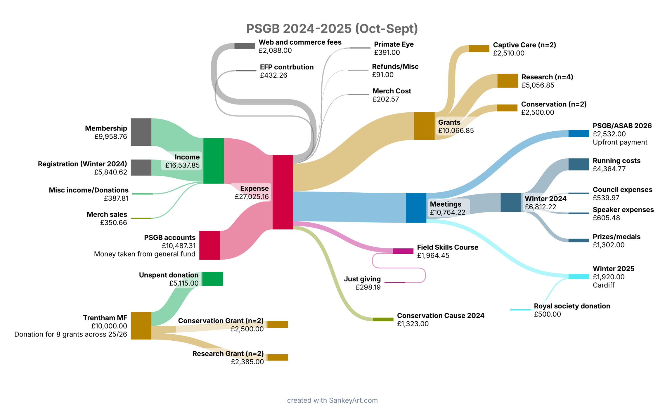
Visualisation of PSGB money flow 2024-2025.

Balance over time 2021-present.
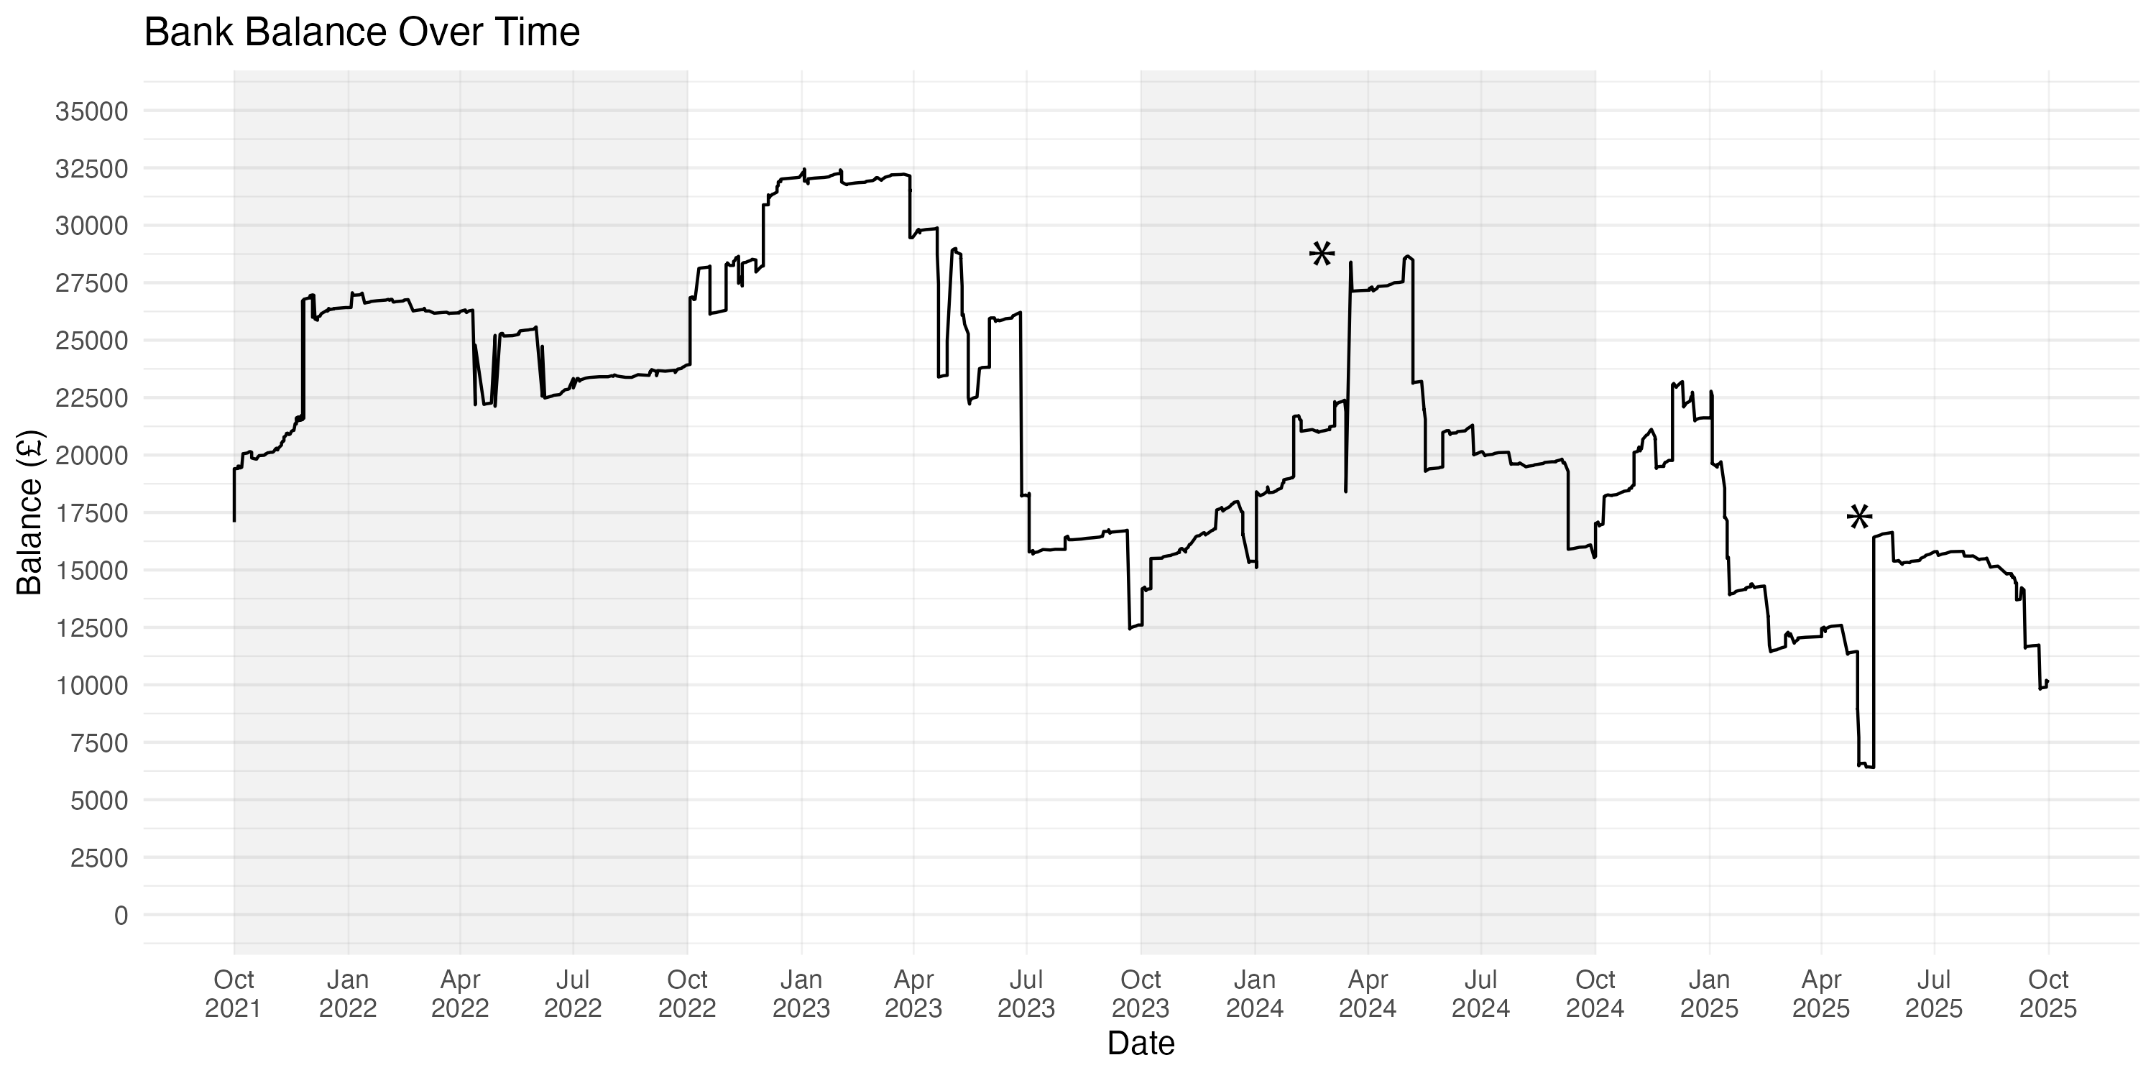
*These peaks represent the £10,000 Trentham Monkey Forest contributions. We will not receive this contribution in 2025-26 as the last donation is to cover 2 years.

