A Project Report on-
Assessing Behavioural Anxiety of Globally Threatened Capped Langurs in Bangladesh
Implementing period- May 2024 to October 2025
Submitted by- Md Mokhlesur Rahman, Department of Zoology, University of Dhaka, Bangladesh

Abstract
Anxiety is a psychological state characterized by feelings of apprehension triggered by potential threats, leading to unfavourable psychological or behavioural responses. Though non-human primates (NHPs) are highly relevant models for studying anxiety, langur species, remain significantly underrepresented in anxiety related research. This gap is particularly concerning for the capped langur (Trachypithecus pileatus), a globally vulnerable and nationally endangered NHP species in Bangladesh, which is currently facing a range of anthropogenic threats across the ranges. These anthropogenic threats may affect their health and well-being, manifesting through behavioural anxiety and physiological stress. Assessing behavioural anxiety is essential for their conservation, yet studies on how capped langurs respond psychologically to anthropogenic stressors appeared to be lacking. To address this, we aimed to assess the behavioural anxiety through measuring self-directed behaviours (SDBs, such as scratching, self-grooming, body shaking, yawning) and vigilance in capped langurs across two contrasting habitats, which were divided on the level of human disturbance. Over a year, we conducted 10-minute continuous focal animal sampling on 16 groups of langurs at Madhupur National Park, a shal-dominated deciduous forest located in north-central Bangladesh. A total of 150 hours and 40 minutes of behavioural data were collected, during which langurs engaged in SDBs and vigilance for 2.56% and 3.115% of the entire observation period, respectively. The results showed that, out of four SDB types, scratching (82.24%) and self-grooming (16.57%) were the most prominent SDBs, and routine vigilance was higher (91.33%) than induced vigilance. To examine the best predictors of SDBs and vigilance, we conducted Linear Mixed-Effect Models (LMM) in R, with SDBs and vigilance as response variables and habitat, age-sex, group size, time block, temperature, and humidity as explanatory variables. The models revealed that group size was a significant predictor of both SDBs and vigilance, with larger groups exhibiting more SDBs and vigilance than medium and small groups. SDBs also varied temporally; compared to early morning, langurs showed significantly less SDBs in subsequent time blocks. Additionally, vigilance is also predicted by the climatic variables, where langurs showed a positive relation with minimum temperature and a negative relation with maximum temperature and humidity. Notably, habitat type and age-sex class did not show any significant effect on both SDBs and vigilance. These research findings did not support the traditional many-eyes effect, which predicts reduced vigilance as group size increases. Instead, the parallel increase of both SDBs and vigilance in larger groups supports the social tension hypothesis, indicating that internal social monitoring and group composition may have an influence on anxiety rather than anti-predatory scanning. The reduced vigilance during high temperature and humidity and increased vigilance in minimum temperature demonstrate that the thermal environment may act as a powerful ecological barrier shaping vigilance activity. These results warrant long-term study with comprehensive datasets, considering other ecological parameters, to support these contrasting research findings.
Keywords: behavioural anxiety, SDBs, vigilance, non-human primates, capped langurs

Introduction
Anxiety is a psychological state in which typically harmless environmental stimuli are perceived as threatening, leading to unfavourable physiological or behavioural responses (Coleman & Pierre, 2014). It is commonly understood as a feeling of apprehension or unease triggered by the anticipation of a potential threat (Coleman & Pierre, 2014). While anxiety research has historically focused on humans, there is increasing recognition of the value of studying non-human animals, particularly non-human primates (NHPs), for understanding the evolutionary and physiological basis of emotional responses. NHPs are highly relevant models due to their close genetic, anatomical and behavioural similarities to humans (Capitanio & Emborg, 2008). Importantly, their social and ecological variability offers opportunities to explore how emotions like anxiety manifest in naturalistic settings.
The behavioural manifestation of anxiety has been extensively studied across different taxa, particularly in primates, where specific behavioural markers have been identified. One widely recognized marker is displacement behaviours that appear unrelated or incongruent with the immediate context in which they are expressed. These behaviours are thought to arise in situations involving conflicting motivations (such as fear and aggression), environmental unpredictability, inescapable stressors or thwarted goals (Maestripieri et al., 1992). Displacement behaviours include actions such as scratching, self-grooming, yawning, and body shaking, which have been consistently observed in a wide range of primate species under stress (Coleman & Pierre, 2014). Other anxiety-related indicators include piloerection, in which animals raise their fur to appear larger; fear grimaces or bared-teeth grins, which may signal submission or dread; and heightened vigilance (Hinde & Rowell, 1962; Petit & Thierry, 1992). Vigilance can also be used as an indicator of anxiety in non-human primates (Coleman & Pierre, 2014). In primates, researchers rely on behavioural and physiological proxies that reflect similar emotional states. Such observation-based studies have become a cornerstone of anxiety research in animal models.
Despite this potential, most existing studies on primate anxiety have been restricted to a narrow range of species, primarily baboons, macaques and marmosets (Ausderau et al., 2023). Within this context, macaque species, especially rhesus (Macaca mulatta) and cynomolgus (Macaca fascicularis) have historically served as key models in anxiety research.
Among NHPs, langur species, especially those belonging to the genus Trachypithecus remain significantly underrepresented in studies of emotional behaviour and anxiety. This research gap is concerning, given that langurs occupy a wide range of ecological and social environments that are likely to influence their emotional responses. Their varied habitats, ranging from dense forests to areas impacted by human activity, make them important models for understanding how environmental and anthropogenic pressures shape behavioural and psychological stress. For instance, Roth & Cords (2020) investigated the effects of human presence on captive ebony langurs (Trachypithecus auratus) and reported increased sleep disruption, aggression and displacement behaviours. However, such studies are largely confined to captive settings, and little is known about anxiety-related responses in langurs living in wild or semi-wild conditions. This lack of research is particularly striking in the case of the capped langur (Trachypithecus pileatus), a globally vulnerable species and is classified as endangered in Bangladesh (IUCN Bangladesh, 2015).
Although historically widespread throughout the deciduous forests of Bangladesh, capped langurs are now limited to fragmented pockets of habitat, including the Shal forests of Mymensingh and Tangail, and the evergreen forests of Lawachara, Satchari, and parts of the Chittagong division (Khan, 2018). This reduction in range has been driven primarily by deforestation and land-use changes that threaten not only the capped langur but many NHP species in the region. As human populations expand and forest cover diminishes, biodiversity loss accelerates, exacerbating the vulnerability of already threatened species (Khatun et al., 2013; Mukul, 2007). Despite these urgent conservation concerns, scientific studies on capped langurs remain relatively limited. Much of the existing research has focused on their distribution, feeding habits and general ecology (Islam & Husain, 1982; Kabir, 2002; Stanford, 1987). Also a number of studies have examined their activity budgets, habitat use and social organization (Green, 1978, 1981; Kabir, 2002, 2006; Mandal & Kabir, 2014; Stanford, 1987). However, detailed investigations into how capped langurs respond behaviorally or psychologically to habitat degradation and anthropogenic stressors remain almost entirely absent.
In response to this gap, the present study aimed to assess anxiety in capped langurs across two contrasting habitat types in Bangladesh: relatively undisturbed forested areas and landscapes heavily modified by human activity. In species like the capped langur, which are already struggling with population decline, habitat degradation and increased human disturbances, the ability to detect early signs of physiological and psychological disorders becomes an essential tool in conservation planning.

Methods
Study site and group
This research was conducted at Madhupur National Park (MNP) includes regions of the Tangail and Mymensingh districts in central Bangladesh. The park is located between 24°30′ and 24°50′ N latitude and 90°00′ and 90°15′ E longitude, situated on the western part of Tangail-Mymensingh highway. The temperature at the study site varies between 28°C to 32°C in summer and falls to 20°C in winter, sometimes extreme low of 10°C (Naher et al., 2017). The average rainfall of the study area is about 1000 mm to 1500 mm.
The langurs are found in MNP and the adjacent villages, and local market areas near the park. To conduct this study, a preliminary survey was conducted to identify foraging and ranging areas of different langur groups. Capped langur groups of MNP and its adjacent areas were categorized as forested groups and rural groups, based on the places where they lived and the level of human disturbance. Langur groups experiencing minimal anthropogenic disturbance were classified as forested groups, whereas langurs living in human-modified areas adjacent to the forest, with a significant level of human disturbance to their daily activities, were classified as rural groups. Forested groups were mostly dependent on natural foods such as leaves, different parts of plants and forest resources, while rural groups were mostly attracted to fruits like mango, banana, papaya, potato and other homestead vegetations.
Direct observations were used to classify all observed individuals into categories of adult male, adult female, sub-adult male, sub-adult female and infant. Age-sex classification was determined following (Gron, 2008) and age estimates are as follows: Adult Male (>5 years old), Adult Female (>2.9 years old), Sub-adult Female (2-2.9 years old), Sub-adult male (9 months- 2 years old) and Infant (<9 months). The detailed age-sex composition of the study groups is shown in Table 1.

Table 1. Detailed age-sex composition of capped langurs in MNP
Group No | Group ID | Habitat | Adult Male | Adult Female | Sub-Adult Female | Sub-Adult Male | Infant | Total
Forest-1 | Group-A | Forest | 2 |  |  |  |  | 2
Forest-2 | Group-B | Forest | 2 | 4 | 1 |  | 3 | 10
Forest -3 | Group-C | Forest | 2 | 2 |  |  | 3 | 7
Forest-4 | Group-D | Forest | 1 | 2 |  | 1 | 2 | 6
Forest-5 | Group-E | Forest | 2 | 2 | 1 |  | 3 | 8
Forest-6 | Group-F | Forest | 1 | 3 | 1 |  | 3 | 8
Forest-7 | Group-G | Forest | 1 | 1 |  |  |  | 2
Forest-8 | Group-H | Forest | 1 | 4 | 1 |  | 3 | 9
Forest-9 | Group-I | Forest | 2 | 2 | 1 |  |  | 5
Forest-10 | Group-J | Forest | 1 | 3 |  |  | 1 | 5
Forest-11 | Group-K | Forest | 2 |  |  |  |  | 2
Forest-12 | Group-L | Forest | 1 | 2 |  |  | 1 | 4
Rural-1 | Group-M | Rural | 2 | 3 | 1 |  | 3 | 9
Rural-2 | Group-N | Rural | 1 | 1 |  |  |  | 2
Rural-3 | Group-O | Rural | 2 | 5 | 2 | 1 | 3 | 13
Rural-4 | Group-P | Rural | 1 | 1 | 1 |  |  | 3

Behavioural Data Collection
Behavioural data were collected following 10-minute continuous focal animal sampling (Altmann, 1974). A time interval of 2-5 minutes was used to ensure that each focal is distinct from the previous one, which ensures that the obtained data is statistically valid (Altmann, 1974). Data were collected from June 2024 to October 2025 by a research assistant with the help of a trained field assistant. Note that due to political unrest and security reasons, we could not conduct fieldwork from July 2024 to October 2024. The group was considered habituated and the data credible when langurs did not modify their behavior or returned to their usual behavior after one minute of recognizing the observer’s presence (Williamson & Feistner, 2003). Before collecting data, individual identification and environmental condition assessment were conducted. Every study day, focal groups were searched near their pre-observed ranging areas or near previous night’s sleeping site. The langur group was searched in study sites at around 6:00 am or around sunrise (when the sunrise was later) and tracked them until 18:00 or around sunset (when the sunset was earlier). The day was divided into 4-time blocks throughout the study period to avoid over sampling at particular times of a day: early morning, late morning, early afternoon, late afternoon, which varied from a minimum of 2 hour 55 minutes to 3 hours 24 minutes. Day length varied due to sunrise and sunset hence the duration of each time block also varied in each season.
During each focal, the predominant behaviours for instance feeding, moving, resting, self-directed behaviours (scratching, self-grooming, yawning, body shaking), vigilance, aggression, and social interactions of each individual of the study group were recorded using CyberTracker (https://www.cybertracker.org/) programme installed on a portable mobile device. Data were collected from a distance of 5-10m to ensure the study subject’s behaviour remained unaffected by the presence of observers. Additionally, positional behavior was also recorded during behavioural data collection. We observed groups for three to five consecutive days every month, throughout the year (Summer: March–June; Rainy: July–October; and Winter: November–February).

Data analysis
To calculate the percentage of time spent on SDBs and vigilance per focal, the duration of the behaviour was divided by focal time (10 minutes) then multiplied by 100 for each category. A linear mixed-effect model was also constructed to test the best predictors of SDBs and vigilance. SDBs and vigilance was used as response variable, with explanatory variables such as habitat, age-sex, group size, time block, minimum temperature, maximum temperature and humidity. Focal identity was selected as random factor in the models. Temperature and humidity were collected from the local field metrology stations. All statistical analyses were completed using R, version 4.3.3 (R core team, 2024). All tests were two-tailed with a 5% level for significance (p < 0.05).

Results
In total 16 groups (Forest=12, Rural=4)) were observed for measuring behavioural anxiety of langurs. Among them 6 groups were Multi-Male Bisexual Troop (MMBS) and 8 groups were Single-Male Bisexual troop (SMB) and 2 groups was All Male Band (AMB). In this study, troop refers to bisexual groups and band refers to unisexual groups or all male parties (bachelors). All of these groups were followed and observed during the study period.
A total of 150 hours 40 minutes of data were collected for the study, during which langurs engaged in SDBs for 2.56% of the entire observation period. Out of four SDB types, scratching (82.24%) and self-grooming (16.57%) were the most prominent behaviours. Vigilance behavior accounted for 3.11% of the entire observation time. Routine vigilance was higher (91.33%) between both types of vigilance.
SDBs across group size
Figure 1 shows that the percentage of time spent in SDBs, generally increased with group size. Individuals in large groups exhibited higher median percentage of SDBs and significantly more variation in behaviour compared to those in small and medium groups (p<0.05).
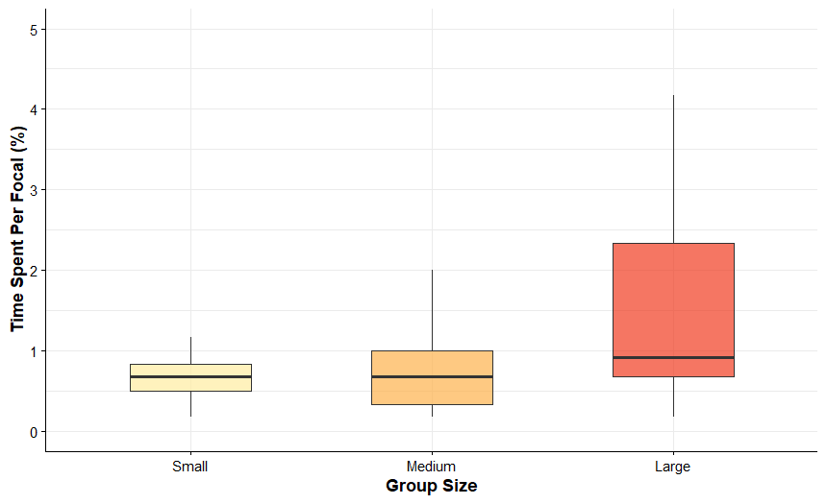
Figure 1. SDBs across different group size.
SDBs across time block
The figure 2 displays that SDBs were significantly influenced by the time of day. Using early morning as reference, model revealed that other three blocks (late morning, early afternoon, late afternoon) were negatively correlated to SDBs (p<0.05).
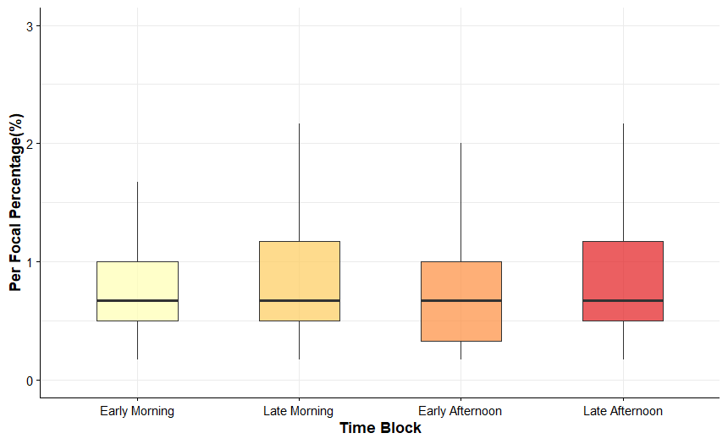
Figure 2. SDBs across different time blocks.

Factors Influencing SDBs
The LMM for SDBs revealed that group size and time block primarily influenced SDBs, whereas habitat type, age-sex class, and environmental conditions (temperature and humidity) had no significant effect. Compared to the large groups, langurs in medium and small groups exhibited significantly lower SDB (Table 2). Additionally, the time of day significantly influenced SDB levels. Using early morning as the reference period, SDBs were negatively correlated with all subsequent time blocks (Table 2). This pattern indicates that self-directed behaviours peak in the early morning and stabilize at lower levels throughout the remainder of the day.

Table 2: LMM result for total SDBs.
Reference category, #Forest; * Adult Female; **large; **** Early Morning.
Fixed Effect | Estimate | Std. Error | df | t value | P Value
Intercept | 0.8568 | 1.802 | 1271 | 0.475 | 0.634
Habitat, Rural# | 0.0877 | 0.3509 | 1236 | 0.25 | 0.802
Age-sex class*
Adult Male | -0.1574 | 0.2549 | 1229 | -0.617 | 0.537
Sub Adult Female | -0.3765 | 0.4867 | 1232 | -0.774 | 0.43
Sub Adult Male | 0.6196 | 0.716 | 1312 | 0.865 | 0.387
Group**
Medium | -1.291 | 0.3842 | 1260 | -3.36 | 0.001
Small | -1.1 | 0.4064 | 1267 | -2.706 | 0.007
Climatic factor
Maximum | 0.0526 | 0.0566 | 1325 | 0.929 | 0.352
Minimum | -0.002 | 0.0451 | 1305 | -0.045 | 0.964
Humidity | 0.0151 | 0.012 | 1316 | 1.255 | 0.209
Time Block***
Early Afternoon | -0.9364 | 0.4311 | 344.8 | -2.172 | 0.031
Late Morning | -0.8954 | 0.4013 | 451.8 | -2.231 | 0.026
Late Afternoon | -0.879 | 0.4436 | 429 | -1.982 | 0.048

Vigilance across group size
Figure 3 shows that the percentage of time spent in vigilance behaviour was highest in large groups compared to small and medium groups. While small and medium groups showed relatively similar and lower median vigilance levels, individuals in large groups exhibited much greater variation and a higher overall percentage of time spent scanning (Figure 3).
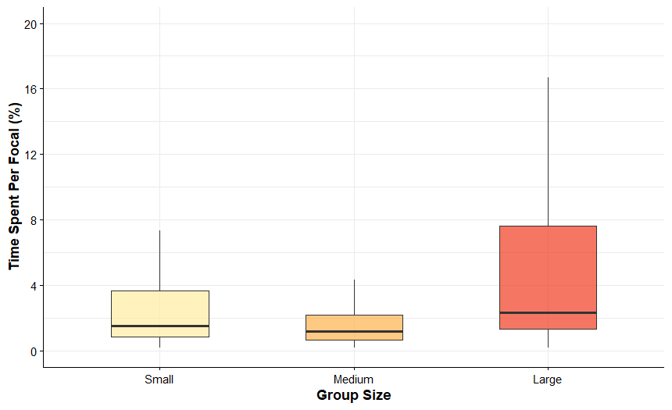
Figure 3. Vigilance across different group size categories.
Effect of minimum temperature on vigilance
Figure 4 shows that the percentage of time spent in vigilance behaviour was highest at warmer minimum temperatures compared to cooler periods. While vigilance levels at lower temperatures (10°C) remained relatively low, individuals at higher temperatures (25°C–27°C) exhibited a greater overall percentage of time spent vigilance. The model indicates a significant positive correlation between minimum temperature and vigilance activity.

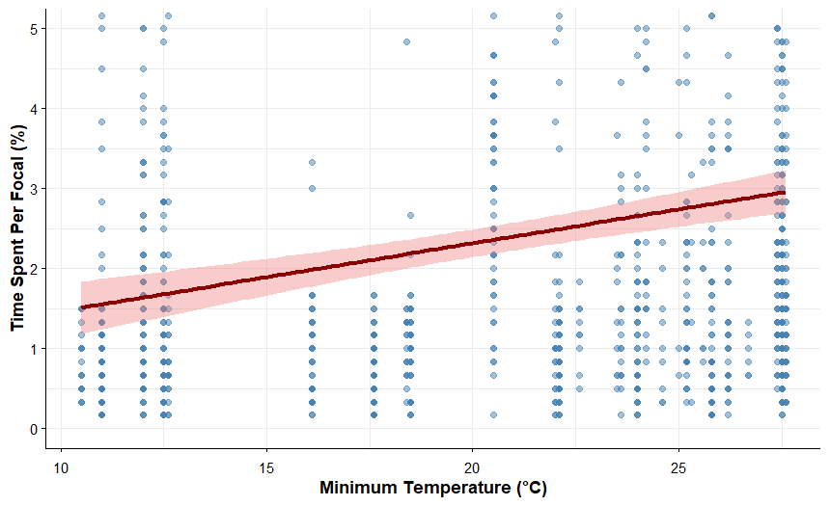
Figure 4. Effect of minimum temperature on vigilance.

Effect of maximum temperature on vigilance
Figure 5 shows that the percentage of time spent in vigilance behaviour was highest at cooler maximum temperatures compared to hotter periods. While vigilance levels at high temperatures (near 40°C) remained relatively low, individuals at lower maximum temperatures (18°C-20°C) exhibited a greater overall percentage of time spent scanning. The model indicates a significant negative correlation between maximum temperature and vigilance activity (p < 0.05).
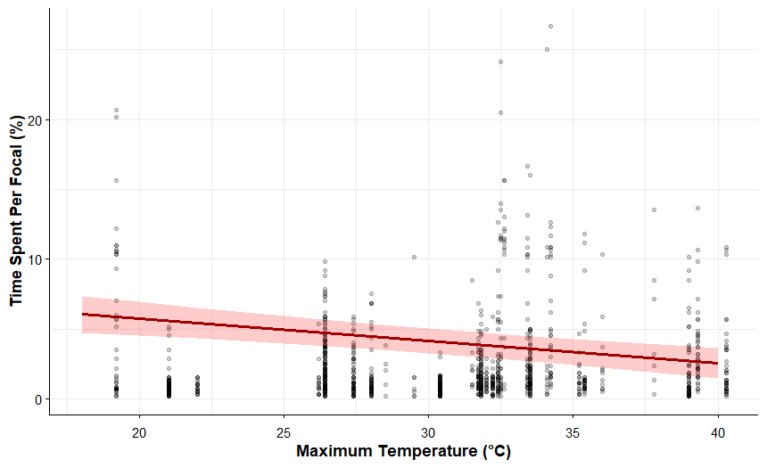
Figure 5. Effect of maximum temperature on vigilance.

Effect of humidity on vigilance
Figure 6 shows that the percentage of time spent in vigilance behaviour was highest at lower humidity levels compared to more humid conditions. While vigilance levels at high humidity (near 100%) remained relatively low, individuals at lower humidity (near 10%) exhibited a greater overall percentage of time spent scanning. The regression analysis indicates a significant negative correlation between humidity and vigilance activity (p < 0.05)

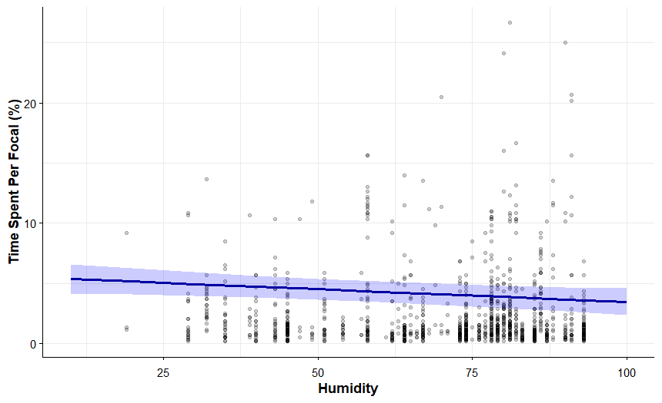
Figure 6. Effect of humidity on vigilance.
Factors Influencing Vigilance Behaviour
The LMM for vigilance revealed group size and specific climatic factors as highly significant predictors of vigilance behaviour in capped langurs. In contrast, habitat type, age-sex class, and time of day did not exert a statistically significant influence on individual vigilance levels (p > 0.05). Group size emerged as the strongest predictor in the model. Compared to large groups, individuals in medium and small groups exhibited a significantly lower vigilance levels (Table 3). These results demonstrate a clear positive correlation between group size and individual vigilance, suggesting that increased group size may elevate perceived risk or social competition within the cohort.
Vigilance patterns were significantly influenced by climatic factors. Vigilance behaviour was negatively correlated with maximum temperature, and humidity (Table 3) indicating that high temperature and humidity likely lead to restricted activities and a reduction in active vigilance. Conversely, a positive correlation with minimum temperature (Table 3) demonstrates the complex influence of microclimatic environment on daily activities. No significant effects were detected for habitat, age-sex, and time block (Table 3).

Table 3: LMM result for total Vigilance.
Reference category, #Forest; * Adult Female; **large; **** Early Morning.
Fixed Effects | Estimate | Std. Error | df | t value | P value
Intercept | 8.156 | 1.319 | 1186 | 6.186 | <0.001
Habitat, Rural# | 0.3364 | 0.2993 | 1186 | 1.124 | 0.261
Age-sex class*
Adult Male | 0.214 | 0.181 | 1186 | 1.225 | 0.221
Sub Adult Female | 0.045 | 0.418 | 1186 | 0.107 | 0.914
Sub Adult Male | 0.411 | .535 | 1186 | 0.769 | 0.442
Group**
Medium | -2.672 | 0.3446 | 1186 | -7.754 | <0.001
Small | -1.46 | 0.389 | 1186 | -3.751 | <0.001
Climatic factor***
Temperature max | -0.1594 | .0380 | 1186 | -4.194 | <0.001
Temperature min | 0.112 | .0322 | 1186 | 3.814 | <0.001
Humidity | -0.0212 | 0.009 | 1186 | -2.391 | 0.016
Time block****
Early Afternoon | 0.245 | 0.316 | 1186 | 0.775 | 0.438
Late Morning | 0.181 | 0.282 | 1186 | 0.64 | 0.522
Late Afternoon | 0.463 | 0.329 | 1186 | 1.406 | 0.159

Discussion
Primary function of vigilance behaviour is searching for potential threats (Bednekoff & Lima, 1998; Caro, 2005; Lima & Bednekoff, 1999a, 1999b; Treves, 2000). In previous studies of vigilance in mammals and birds, the group-size effect was well-supported which predicts a decline in individual vigilance as group size increases (Elgar, 1989). Contrary to the traditional many eyes hypothesis, our result revealed a significant positive correlation between group size and vigilance behaviour. This phenomenon supports the findings of previous study, suggesting that for primates in high density and stable population the primary driver of vigilance is social monitoring rather than anti-predatory scanning (Treves, 2000). In these complex social environments, individuals must constantly track the movements and intentions of group mates to avoid aggression and navigate social competition. Consequently, larger groups may increase individual anxiety and fear, manifesting as higher vigilance and SDBs. This interpretation is further supported by SDBs result. SDBs (scratching, self-grooming, body shaking, yawning) are widely accepted indicator of anxiety (Coleman & Pierre, 2014). SDBs were significantly higher in larger groups (lower in small/medium groups). This demonstrates larger groups exhibit a higher rate of anxiety. The synchronization of higher SDBs and higher vigilance in large groups strongly supports social tension hypothesis, where the internal social environment has greater influence on perceived risk than external predation (Aureli & Schino, 2019).
Additionally, anxiety in capped langurs varied temporally, with an increase in SDBs rate in the morning. With early morning as our reference, we found a significant negative correlation with all subsequent time blocks, indicating that anxiety levels are highest at the morning and stabilize thereafter. This pattern offers a contrast to wild samango monkeys, whose anxiety related behaviour, scratching increased at the late afternoon due to low light and rising predation risk (Parker et al., 2025). While samangos exhibit an evening anxiety, our langurs appear to have morning peak. Our results highlight a significant modulation of behaviour by climatic factors, supporting the thermal constraint hypothesis, which suggests that high temperatures act as a critical ecological barrier, forcing animals to prioritize thermoregulation over active behaviours. In a study of chacma baboons, it was found that as the “perceived environmental temperature” (PET) increased, individuals shifted away from feeding towards more sedentary behaviours like resting, sleeping, shade-seeking to avoid heat stress (Hill, 2006). Similarly, our findings on capped langurs support this, as the negative correlation between vigilance and high temperature/humidity. The result indicates that extreme climatic conditions restrict active scanning or other regular activities in favour of energy-conserving behaviours. We observed a temporal shift in their day; by staying at the shade during peak heat and delaying the feeding and moving (two most prominent behaviours) until the cooler evening, this effectively circumvented the physiological danger of overheating. Our results show that climate just doesn’t limit langur behaviour, it shapes their daily activities. While high temperatures act as a barrier that restricts their activity, the positive correlation between vigilance and minimum temperature tells the opposite story. It ensures that temperature is one of the primary factors for their activity budget. As temperature rise from daily lows around 12℃ to optimum range 30℃, individual vigilance level increases. This suggests that as morning chill dissipates, a real change is observed how langurs act. The warm sun usually helps them to move away from slow, resting morning mood and get back to their normal routine. Ultimately, this contraction of activity budget during extreme heats, paired with increased vigilance as minimum temperature rise, underscores that the thermal environment is a powerful driver of daily activities in primates.

Acknowledgements
This research was supported by a research grant from PSGB, Trentham Monkey Forest, and a grant from the Biotechnology Research Centre, University of Dhaka. We deeply acknowledge their financial support. We also thank the Conservator of Forests and Chief Conservator of Forests of the forest department for permits. We are grateful to all of our field assistants, Arnob, Tareq, Smoron and Joty, for their unwavering assistance in the field. Finally, we thank our local field guide, Mr Sobuj, for his hard work before and after our fieldwork.

References
Altmann, J. (1974). Observational study of behavior: Sampling methods. Behaviour, 49(3–4), 227–266.
Aureli, F., & Schino, G. (2019). Social complexity from within: How individuals experience the structure and organization of their groups. Behavioral Ecology and Sociobiology, 73(1), 6.
Ausderau, K. K., Colman, R. J., Kabakov, S., Schultz-Darken, N., & Emborg, M. E. (2023). Evaluating depression-and anxiety-like behaviors in non-human primates. Frontiers in Behavioral Neuroscience, 16, 1006065.
Bednekoff, P. A., & Lima, S. L. (1998). Randomness, chaos and confusion in the study of antipredator vigilance. Trends in Ecology & Evolution, 13(7), 284–287.
Capitanio, J. P., & Emborg, M. E. (2008). Contributions of non-human primates to neuroscience research. The Lancet, 371(9618), 1126–1135.
Caro, T. M. (2005). Antipredator defenses in birds and mammals. University of Chicago Press.
Coleman, K., & Pierre, P. J. (2014). Assessing anxiety in nonhuman primates. ILAR Journal, 55(2), 333–346.
Elgar, M. A. (1989). Predator vigilance and group size in mammals and birds: A critical review of the empirical evidence. Biological Reviews, 64(1), 13–33.
Green, K. M. (1978). Primates of Bangladesh: A preliminary survey of population and habitat. Biological Conservation, 13(2), 141–160.
Green, K. M. (1981). Preliminary observations on the ecology and behavior of the capped langur, Presbytis pileatus, in the Madhupur Forest of Bangladesh. International Journal of Primatology, 2(2), 131–151.
Gron, K. 2008. Gray langur Semnopithecus. In: Primate Info Net.
<pin.primate.wisc.edu/factsheets/entry/gray_langur>. Downloaded on 28 July 2022.
Hill, R. A. (2006). Thermal constraints on activity scheduling and habitat choice in baboons. American Journal of Physical Anthropology: The Official Publication of the American Association of Physical Anthropologists, 129(2), 242–249.
Hinde, R. A., & Rowell, T. E. (1962). Communication by postures and facial expressions in the rhesus monkey (Macaca mulatta). 138(1), 1–21.
Islam, M. A., & Husain, K. (1982). A preliminary study on the ecology of the capped langur. Folia Primatologica, 39(1–2), 145–159.
IUCN.2015, Red Book of threatened mammals of Bangladesh. IUCN Bangladesh.
Kabir, M. M. (2002). Behavioural ecology of two sympatric langur species in the semi-evergreen forest of Bangladesh.
Kabir, M. M. (2006). Activity pattern of Capped langur in the Rema-Kalenga wildlife sanctuary of Bangladesh. Bangladesh J Life Sci, 18(2), 59–69.
Khan, M. (2018). Wildlife Diversity of Madhupur National Park, Bangladesh. Jahangirnagar University Journal of Biological Sciences, 7(1), 1–13.
Khatun, U. H., Eivin, R., & M. Farid, A. (2013). Local people’s perceptions of crop damage by common langurs (Semnopithecus entellus) and human-langur conflict in Keshabpur of Bangladesh. Environment and Natural Resources Research.
Lima, S. L., & Bednekoff, P. A. (1999a). Back to the basics of antipredatory vigilance: Can nonvigilant animals detect attack? Animal Behaviour, 58(3), 537–543.
Lima, S. L., & Bednekoff, P. A. (1999b). Temporal variation in danger drives antipredator behavior: The predation risk allocation hypothesis. The American Naturalist, 153(6), 649–659.
Maestripieri, D., Schino, G., Aureli, F., & Troisi, A. (1992). A modest proposal: Displacement activities as an indicator of emotions in primates. Animal Behaviour, 44(5), 967–979.
Mandal, B., & Kabir, M. (2014). Activity patterns of Capped Langur (Trachypithecus pileatus) in a moist deciduous forest of Bangladesh. Jagannath University Journal of Science, 3(1), 65–77.
Mukul, S. (2007). Biodiversity conservation and sustainable development in Bangladesh: An overview of the present status, management problems and future prospects. A Review Report Submitted at the Department of Forestry and Environmental Science, Shahjalal University of Science and Technology, Sylhet, Bangladesh. Iv, 28.
Naher, H., Khan, S. I., & Ahmed, T. (2017). Threats and conservation problems of non-human primates in moist deciduous forest of Bangladesh. Journal of the Asiatic Society of Bangladesh, Science, 43(1), 11–22.
Parker, E. J., Hill, R. A., & Koyama, N. F. (2025). Spatial and Temporal Determinants of Anxiety in a Wild Arboreal Primate. Ecology and Evolution, 15(11), e72528.
Petit, O., & Thierry, B. (1992). Affiliative function of the silent bared-teeth display in moor macaques (Macaca maurus): Further evidence for the particular status of Sulawesi macaques. International Journal of Primatology, 13(1), 97–105.
Roth, A. M., & Cords, M. (2020). Zoo visitors affect sleep, displacement activities, and affiliative and aggressive behaviors in captive ebony langurs (Trachypithecus auratus). Acta Ethologica, 23(2), 61–68.
Stanford, C. (1987). Ecology of the capped langur (Presbytis pileata) in Bangladesh. 12(3), 373–373.
Treves, A. (2000). Theory and method in studies of vigilance and aggregation. Animal Behaviour, 60(6), 711–722.
Williamson, E. A., & Feistner, A. (2003). Habituating primates: Processes, techniques, variables and ethics.
IUCN Bangladesh. (2015). Red Book of threatened mammals of Bangladesh. IUCN Bangladesh.

Financial report
Item/s | Descriptions | Costs
Living costs in the field
Food | Food and refreshments (35£ /person/month × 2 persons × 12 months) | £840
Fieldwork
Field equipment | A portable tablet for data collection | £200
Local transports | Moving from field stations to the langurs’ sleeping site/range area (3£ per day × 72 working days) | £216
Total | One thousand two hundred and fifty-six British pounds | £1256

