Exploring how social environment moderates production and perception of facial expressions in bonobos
Rachel Robinson, Nottingham Trent University

Abstract
Facial expressions have historically been described as biologically based, hard-wired signals, which humans and animals are born understanding. More recently however, we find that human facial communication may be influenced by social and ecological factors, such as culture, family environment, and social context, shaping how facial expressions are produced and perceived. This project aimed to explore how social environment moderates the production and perception of facial expressions in our closest living relatives, bonobos (Pan paniscus). Study 1 explores the flexibility of facial expression production in individuals that migrate between different social groups during fission-fusion events. Natural social interactions were observed in a population of bonobos (n=14) at Twycross Zoo, UK and facial movements were coded from video footage using BonoboFACS. The population is managed using a zoo-assisted fission-fusion technique, resulting in continuously changing group compositions. Results of Study 1 are to be analysed. Study 2 combines eye tracking data with behavioural methods to investigate how bonobos attend to different play associated facial expressions. Eight bonobos from the population at Twycross Zoo voluntarily participated in the eye tracking study. To produce the stimuli, natural photographs of four familiar bonobos were digitally merged with an avatar, allowing us to manipulate the individual muscle movements in the face. This created 104 stimuli with six different levels of expressivity, and 581 eye tracking trials were completed. In Study 2, we found that when individuals were housed with more playful groupmates their attention to more expressive play associated facial expressions increased. These findings suggest that facial expression processing may be more plastic than previously thought and could be adaptable to our social environment and experiences. If production of signals is variable between individuals, then flexible processing of these signals may be advantageous to better navigate social interactions. Adapting your processing of facial signals depending on who you are currently surrounded by might be especially useful for species with fission-fusion dynamics and could benefit individuals migrating between social groups both in captivity and in the wild.

Introduction
Facial expressions have historically been described as biologically based, hard-wired signals, which humans and animals are born understanding and that do not adapt to change over time or across cultures (Darwin, 1872; Ekman et al., 1969; Izard, 1994; Tomkins, 1962). More recently however, we find that human facial communication may be influenced by social and ecological factors, such as culture (Camras et al., 2006; Jack, Caldara, et al., 2012), family environment (Camras et al., 2006), and the social context in which a face is presented (Wieser & Brosch, 2012), shaping how facial expressions are produced and perceived (Caldara, 2017; Geangu et al., 2016; Jack, Caldara, et al., 2012; Jack, Garrod, et al., 2012). Cultural differences have been found to correlate with differences in facial expression production in human children, such as smiling frequency, disgust-related expression frequency, and overall facial expressivity (Camras et al., 2006). This suggests that during early human development, facial expression production is influenced by the expressions we observe and the feedback that we receive on our expressions. Culture has also been found to impact which regions of the face people look at more when observing facial expressions, with Western populations looking more often at the eyebrows and mouth, and people who are born and raised in China looking more at the eye region (Jack, Caldara, et al., 2012). These differences in gaze patterns can result in labelling facial expressions with different emotions (Jack et al., 2009), suggesting that the same facial expression can have different meanings across cultures. Therefore, facial expression production and perception may not be universal and are more likely to be flexible and adaptable to our environment.

To fully understand the evolution and extent of this flexibility in facial expressions, it is informative to look at species beyond humans. Recent research has demonstrated that non-human primates’ communication signals can be influenced by their social environment. For example, chimpanzees from neighbouring populations show acoustic differences in their pant-hoots (Crockford et al., 2004) suggesting that variation in this signal has a potential adaptive function to differentiate communication between neighbours. Furthermore, whilst some gestural signals seem to be universal across bonobo populations, some gestures are only present in certain populations (Samuni et al., 2022). This suggests that non-human primates production of communication signals can be influenced by their social environment, however, it is currently unknown whether this is also true for facial expressions.

Recent technological advances have made it possible for us to comprehensively investigate the perceptual processes of non-human primates with eye tracking technology (Hopper et al., 2021). Eye tracking studies have suggested that non-human primates show a preference for looking at faces that is comparable to humans, with all great apes preferentially looking at faces over bodies or background (F. Kano et al., 2012, 2015; F. Kano & Tomonaga, 2009). Bonobos and chimpanzees have also been found to look longer at familiar faces than unfamiliar faces (Lewis et al., 2023) and can recognise the faces of groupmates they have not seen in decades (Lewis et al., 2023). Eye tracking studies have also suggested that non-human primates’ perceptions of faces (but not necessarily facial expressions) can be related to their social experience. Bonobos and chimpanzees show a looking bias for faces of former groupmates whom they had more positive social interactions with (Lewis et al., 2023). Together, these findings suggest that non-human primate’s attention to social cues can be moderated by both social experience and the identity of the signaller.

This research project aimed to investigate the social factors that moderate production (Study 1) and perception (Study 2) of facial movements in a population of captive bonobos (Pan paniscus). Bonobos provide the perfect study species to investigate the evolution of flexible facial communication as they have a complex repertoire of facial movements (De Waal, 1988), they live in continuously changing group compositions due to the fission-fusion dynamics in their societies, and are phylogenetically closely related to humans.

Study 1: How social environment impacts production of facial expressions
Research questions:
- Are there group differences in the form and function of facial movements?
- Do individuals who migrate between groups modify their facial movements to be more similar to their current group members?

Methods

Subjects and housing
Data for this project was collected from a population of 14 bonobos (8 females, 6 males, age range 3 - 48 years) at Twycross Zoo, United Kingdom, between April 2024 – May 2025. Individuals were housed in two adjacent enclosures, separated by a connecting door. Each enclosure had a heated indoor area (54.3 m² per enclosure) and a planted outdoor area (433 m² left hand side enclosure and 211 m² right hand side enclosure). Bonobos were fed several times per day and had ad libitum access to water throughout the study.

Fission-fusion dynamics
The zoo implemented a fission-fusion management technique, whereby some individuals were moved and reorganised between the two enclosures regularly (mean number of days between fission-fusion events was 5.1 days). Group sizes ranged from 3 – 11 individuals during this study. The decision to move individuals between the two enclosures was at the discretion of the care staff, usually to mitigate against conflict or tension in the group. This resulted in a continuously changing group composition throughout the observational and experimental data collection periods. This management technique is used, in part, to mimic the natural behaviour of bonobos in the wild (Badrian & Badrian, 1984; T. Kano, 1982).

Within the population, there were two family sub-groups that were separated for the duration of this study; they are referred to as fixed groups. These fixed groups have been kept in separate enclosures for 4 years prior to this study (since May 2020) due to aggressive interactions, but before this, they had spent time in the same enclosure. The two fixed groups were made up of one female and their sons (DIA Group n=2, LIN Group n=4). The remaining individuals (n=8) were made up of two family sub-groups and three unrelated females; these individuals will be referred to as migraters, as they migrated between the two fixed groups during fission-fusion events. Each family group moved between the two enclosures together as a group, and both family groups could be in the same enclosure or could be separated. The unrelated females moved between the two enclosures together or separately. All individuals were moved between the two enclosures and therefore spent some time in both enclosures.

Facial behaviour data collection
1,088 videos were collected across 33 days. Data was collected using focal animal sampling and ad-libitum sampling (Altmann, 1974) in a pseudo-random order with focals lasting 20 minutes. At the start of an observation day, the current group compositions were recorded as well as the time since the last zoo-assisted fission-fusion event. When a social interaction occurred, the focal animal's face was filmed using a Panasonic HC-V770 video camera. The prerecord feature of the camera was used, which captured video footage 3-seconds before the record button was pressed. Recordings finished at least 5 seconds after individuals moved away from each other or stopped interacting with each other. Data was collected from the visitor’s area through glass windows when individuals were in the outdoor and indoor areas of their enclosures. This resulted in 12.9 hours of codeable video footage of social interactions.

Each social interaction filmed was assigned a social context post-hoc based on the behavioural outcome of the social interaction, but not on the facial movement itself. Inter rater reliability was measured for context coding for all coders. Scan data of grooming and all individuals within 1 meter was recorded of the focal individual every two minutes during focals. Whole group ad-libitum sampling was used to record agonistic interactions. Data was recorded on an iPad using Animal Observer software ​(Caillaud, 2016)​.

Facial movement coding procedure
Individual facial movements were coded from video footage using the Bonobo Facial Action Coding System (BonoboFACS) ​(Correia-Caeiro et al., 2025)​. BonoboFACS is a reliable, objective tool, and is used to quantify individual facial movements (each underpinned by a muscle movement). Each individual facial movement is referred to as an Action Unit (AU), or Action Descriptor (AD) if the underlying muscles are unknown. Training and certification are required to use the system. FACS data allows for subtle differences in facial movements and AU configurations to be quantified and compared between individuals. Interrater reliability was measured for the two BonoboFACS coders. Facial movements were coded frame-by-frame from video footage using Behavioral Observation Research Interactive Software (BORIS) (Friard & Gamba, 2016). Each AU was coded as a state variable with a start and end time so that both duration and frequency of AUs could be measured.

Results
Data for Study 1 is yet to be analysed, with analyses planned to be complete by May 2026.

Study 2: How social environment impacts perception of facial expressions
This study combines eye tracking and behavioural measures to explore how aspects of an individual’s changing social environment affects their attention to conspecific facial expressions. Bonobos were presented with a stimulus containing two conspecific facial expressions associated with play behaviour, each of which varied in expressivity. Processing of these faces was measured by fixation duration in a preferential looking paradigm. How preferences towards different facial expressions change depending on different aspects of the subject’s current social environment was measured and evidence of a flexible response was explored. We predicted that individuals preferentially attend to more expressive play associated facial expressions when they are surrounded by groupmates that they play with and groom with more often. We also predicted that individuals preferentially attend to more expressive play associated facial expressions when they have a stronger social bond with the signaller in the stimuli. Finally, we predicted the above effects are be moderated by expressivity difference between the two faces, with great effects observed when the difference in expressivity between the faces is greater.

Methods
Eight of the bonobos from Twycross Zoo participated in the eye tracking study (5 females, 3 males, age range 3 - 31 years, Table 1) between October 2024 – May 2025. Participation in the experimental study was voluntary, and all bonobos were encouraged to participate with a reward of diluted fruit juice. Experimental data was collected on 36 days (October 2024 – May 2025) with 18 unique group compositions.

Stimuli
The stimuli consisted of bonobo faces that had been digitally manipulated to represent different facial expressions observed during natural playful interactions (De Waal, 1988; Palagi, 2006). To create the stimuli, the face of a chimpanzee avatar was manipulated to show different play-associated facial movements (Figure 1, left) using Blender (Blender Development Team, 2024); a free, open-source, 3D graphics software. Using this avatar made it possible to manipulate which individual muscles were engaged in the face. To make the faces more recognisable as conspecifics, the lower face from the avatar was then merged with natural photographs of familiar bonobos with a neutral facial expression (Figure 1, centre) using Adobe Photoshop 2025.

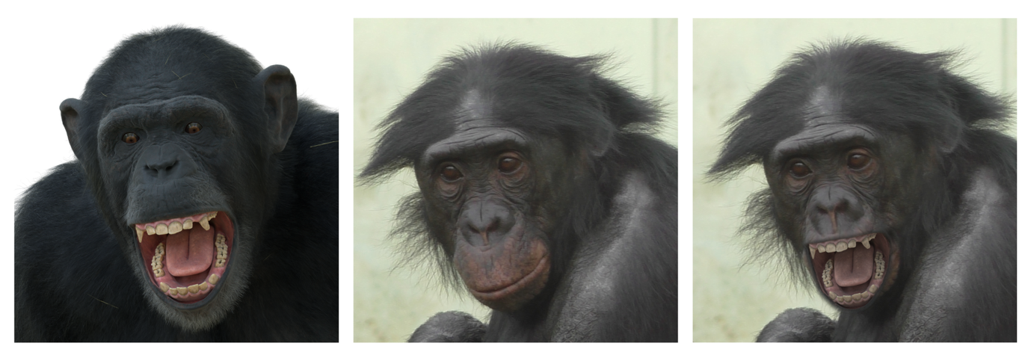
Figure 1. Avatar (Left). Photograph of a familiar bonobo producing a neutral facial expression (Middle). Stimulus produced by merging the avatar with the photograph using Adobe Photoshop 2025 (Right).
The stimuli represented six different play-associated facial expressions (Figure 2) chosen to represent natural facial expressions produced by bonobos during playful interactions (De Waal, 1988; Palagi, 2006) which varied in intensity and the number of AUs engaged. Each expression was produced using AUs from BonoboFACS (Correia-Caeiro et al., 2025).

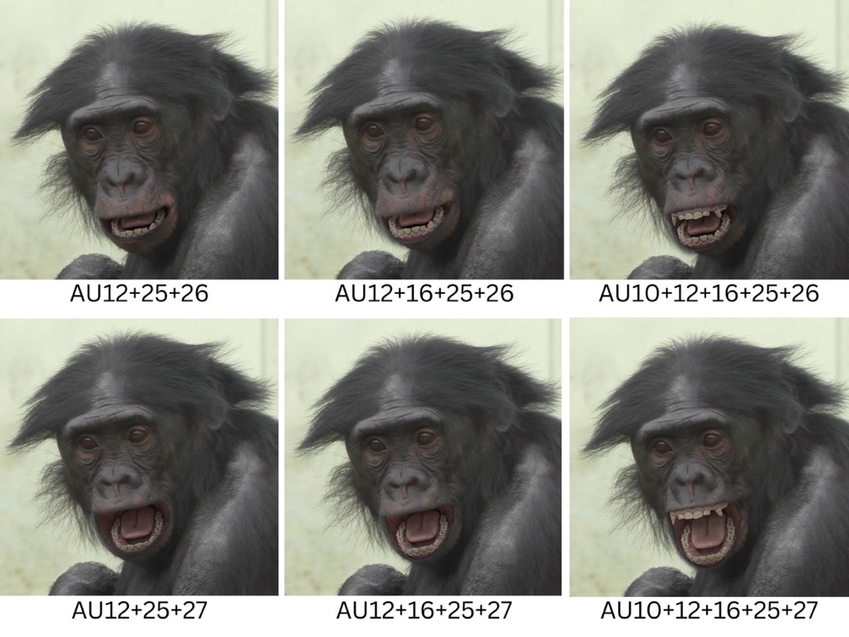
Figure 2. Stimuli set for one familiar individual showing the six different play-associated facial expressions each with a different combination of action units (AUs) engaged.
An expressivity score of each face was calculated as the number of AUs engaged in the face. For the analyses, faces were assigned as either the more or less expressive face based on their expressivity score. We then calculated the expressivity difference for each stimulus as the difference between the number of AUs engaged in the more expressive face and the less expressive face. For each of the four familiar individuals represented in the stimuli, we analysed 26 unique stimuli pairs (Figure 3) each of the six AU combinations was paired with every other AU combination of a different expressivity score, and the stimuli were counterbalanced by which side they appeared on. This provided 104 stimuli. For each subject, stimuli were presented in a random order for stimulus identity and AU combinations.

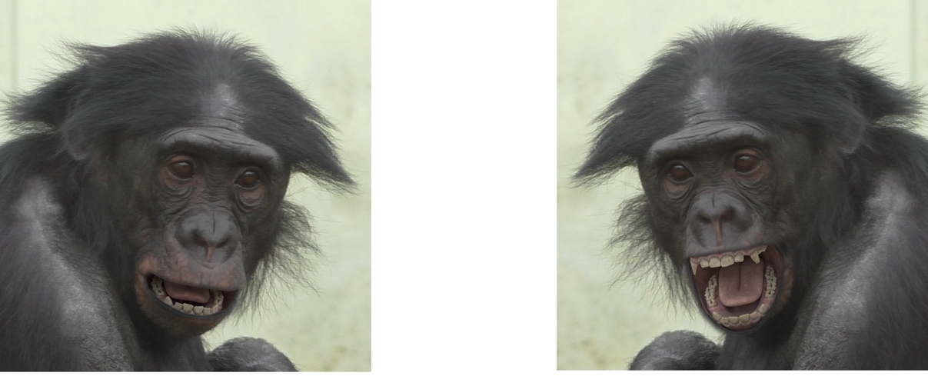
Figure 3. One of the familiar stimuli, with the less expressive face on the left (AU12+25+26) and the more expressive face on the right (AU10+12+16+25+27).

Eye tracking setup and procedure
A non-invasive remote infrared eye tracker (Tobii Pro Spectrum, sampling rate 600 Hz) was used to record bonobo eye movements when observing stimuli on a 23.8-inch screen (Figure 4). At the start of each trial, an attention grabber (a moving animated object) was presented to focus the subject’s gaze on the centre of the screen. Once the subject looked at the attention grabber for 100 milliseconds the stimulus was automatically presented. Stimuli appeared on the screen for 5 seconds, followed by another attention grabber. Stimuli were presented in blocks of 6. Each stimulus featured two areas of interest (AOI): the more expressive face and the less expressive face. Subjects viewed a maximum of 17 stimuli per day, although this was typically much less (mean = 8.6). Stimuli were presented in a random order for each subject. A total of 581 eye tracking trials were. Only one subject viewed all 104 stimuli, whilst other subjects viewed 14 - 86 stimuli (Mean = 60.2, SD = 44.3).

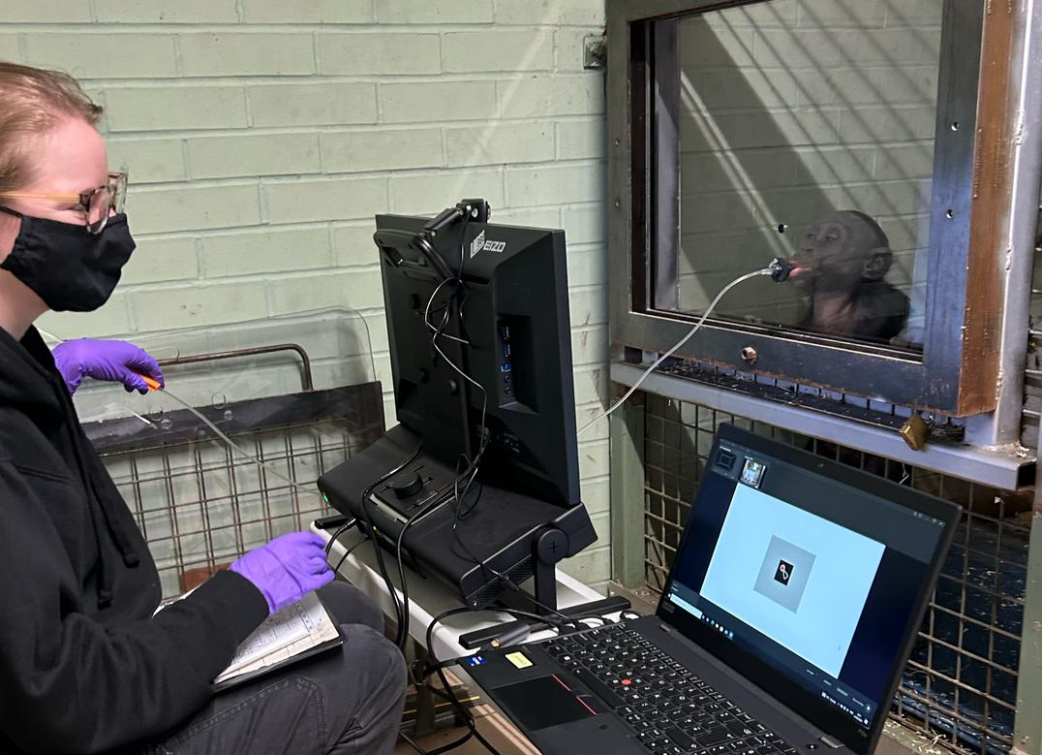
Figure 4. Experimental eye tracking set up with the bonobos at Twycross Zoo.

Attention bias data
Total fixation duration was used to measure looking time towards the two areas of interest: the more expressive face and the less expressive face. To calculate the difference in looking time between the two faces, we used attention bias to the more expressive face: the subject’s total fixation duration towards the more expressive face minus the subject’s total fixation duration towards the less expressive face.

Behavioural data collection
Behavioural observations were recorded for all individuals on 33 days over a 5-month period (April – September 2024). Social interactions between all bonobos were recorded using focal animal sampling (Altmann, 1974) in the Animal Observer app (Caillaud, 2017) on an iPad. Focals lasted 20 minutes and were completed in a pseudo-random order. Play bouts were recorded as state events, with a new play bout starting if the individuals moved away from each other and stopped making eye-contact for at least 5 seconds and then started playing again. 207 focals were recorded (65.5 hours total, mean focal hours per individual = 4.68), with 383 play bouts observed. Grooming was recorded between all individuals using scan sampling (Altmann, 1974) every 2 minutes during focal observations. 3443 scans were recorded, with 394 grooming sessions recorded. Observations were made from the visitor’s area of the zoo when individuals were in either the outdoor or indoor parts of their enclosures.

Statistical analyses
We investigated how different aspects of the subject’s social environment impacted their attention to different facial expressions. Linear mixed effects models were built in R (R Core Team, 2025), using the function ‘lmer’ in package ‘lme4’. Attention bias to the more expressive face was set as the outcome variable for all the models.

Results
A significant main effect was found for the subject’s play rate with their group on their attention bias to the more expressive face (β = 0.324, SE = 0.129, t(310) = 2.519, p = 0.012). When subjects were housed with individuals who they play with more often, their attention bias to the more expressive face increased. There was also a significant interaction effect between the subject’s play rate with their current group and the expressivity difference between the faces on attention bias to the more expressive face (β = -0.202, SE = 0.076, t(310) = -2.672, p = 0.008). As expressivity difference between the faces in the stimuli increased, the positive impact of subjects play rate with the group on attention bias became weaker. In fact, when expressivity difference was high, the subject’s play rate with their group appeared to have a negative relationship with an individual’s attention bias towards the more expressive face, whereby an increase in the subject’s play rate with their group decreased their attention bias to the more expressive face. Therefore, it appears that main effect of subject’s play rate with group was driven by those trials where expressivity difference was low, of which there were more exemplars.

We found no significant difference found for the subject’s grooming rate with group, subject’s play rate with stimulus, subject’s grooming rate with stimulus, expressivity difference as a main effect, subject age, subject sex, stimuli age, stimuli sex, or number of groupmates on attention to the more expressive face.

Discussion
This study combined eye tracking data with behavioural measures to investigate how the transient aspects of bonobos social environments influence their attention and processing of conspecific facial expressions. We predicted that by being situated in a group that you (1) play with more often and (2) groom with more often would increase an individual’s bias towards more expressive play faces. We also predicted that (3) having a stronger relationship with the individual represented in the stimulus would also increase bias towards their more expressive faces. Additionally, we expected that (4) these effects would be moderated by expressivity difference, with greater expressivity difference amplifying the observed effects. We found evidence to support our first hypothesis, with a significant increase in the subject’s attention to the more expressive face when situated in groups which they play with more often. However, this impact on attentional bias was not affected by the presence of groupmates that they groom with frequently or by the subject’s play and grooming relationship with the stimuli. Furthermore, we found that expressivity difference did moderate attention bias when situated within a playful group, but not in the direction that was predicted.

These findings show that aspects of bonobos current social environment impact their attention to facial expressions. Specifically, when surrounded by individuals they find more playful it increased their attention to more expressive play associated facial expressions, suggesting that bonobos recent social experiences may directly influence their patterns of attention. This study provides evidence that facial expression processing is not a universal, fixed system as it was historically believed to be (Darwin, 1872; Ekman et al., 1969; Izard, 1994; Tomkins, 1962) and instead may be plastic and adaptable to our social environment and experiences. If production of signals is variable between individuals, then flexible processing of these signals may be advantageous to better navigate social interactions. It has been suggested that signal repertoires might be larger in species that have fission-fusion dynamics due to the complexity of their social environment (Aureli et al., 2008). Being able to process subtle differences in facial signals and attend to these accordingly could be beneficial for individuals in complex social environments to evaluate and maintain their relationships. Adapting your processing of facial signals depending on who you are currently surrounded by might be especially useful for species with fission-fusion dynamics and could benefit individuals migrating between social groups both in captivity, and in the wild, as accurate facial expression processing is essential for successfully navigating a social world (Waller et al., 2025).

Budget breakdown
Item | PSGB Research Grant
Tripod | £40
External hard drive (1TB) | £50
Mileage (Nottingham – Twycross Zoo) | £1,160

References
Altmann, J. (1974). Observational Study of Behavior: Sampling Methods. Behaviour, 49(3–4), 227–266. https://doi.org/10.1163/156853974X00534
Aureli, F., Schaffner, C. M., Boesch, C., Bearder, S. K., Call, J., Chapman, C. A., Connor, R., Fiore, A. D., Dunbar, R. I. M., Henzi, S. P., Holekamp, K., Korstjens, A. H., Layton, R., Lee, P., Lehmann, J., Manson, J. H., Ramos‐Fernandez, G., Strier, K. B., & Schaik, C. P. van. (2008). Fission‐Fusion Dynamics: New Research Frameworks. Current Anthropology, 49(4), 627–654. https://doi.org/10.1086/586708
Badrian, A., & Badrian, N. (1984). Social Organization of Pan paniscus in the Lomako Forest, Zaire. In The Pygmy Chimpanzee (pp. 325–346). Springer US. https://doi.org/10.1007/978-1-4757-0082-4_13
Blender Development Team. (2024). Blender (Version 4.1) [Computer software]. https://www.blender.org
Caillaud, D. (2017). Animal Observer (Version 1.2.2) [iOS]. Dian Fossey Gorilla Fund. https://fosseyfund.github.io/AOToolBox/index.html
Caldara, R. (2017). Culture Reveals a Flexible System for Face Processing. Current Directions in Psychological Science, 26(3), 249–255. https://doi.org/10.1177/0963721417710036
Camras, L. A., Chen, Y., Bakeman, R., Norris, K., & Cain, T. R. (2006). Culture, Ethnicity, and Children’s Facial Expressions: A Study of European American, Mainland Chinese, Chinese American, and Adopted Chinese Girls. Emotion, 6(1), 103–114. https://doi.org/10.1037/1528-3542.6.1.103
Correia-Caeiro, C., Kuchenbuch, P. H., Oña, L. S., Wegdell, F., Leroux, M., Schuele, A., Taglialatela, J., Townsend, S., Surbeck, M., Waller, B. M., & Liebal, K. (2025). Adapting the facial action coding system for chimpanzees ( Pan troglodytes ) to bonobos ( Pan paniscus ): The ChimpFACS extension for bonobos. PeerJ (San Francisco, CA), 13, e19484-. https://doi.org/10.7717/peerj.19484
Crockford, C., Herbinger, I., Vigilant, L., & Boesch, C. (2004). Wild Chimpanzees Produce Group-Specific Calls: A Case for Vocal Learning? Ethology, 110(3), 221–243. https://doi.org/10.1111/j.1439-0310.2004.00968.x
Darwin, C. (1872). The Expression of the Emotions in Man and Animals. Cambridge University Press. https://doi.org/10.1017/CBO9781139833813
De Waal, F. B. (1988). The Communicative Repertoire of Captive Bonobos (Pan Paniscus), Compared To That of Chimpanzees. Behaviour, 106(3–4), 183–251. https://doi.org/10.1163/156853988X00269
Ekman, P., Sorenson, E. R., & Friesen, W. V. (1969). Pan-Cultural Elements in Facial Displays of Emotion. Science, 164(3875), 86–88. https://doi.org/10.1126/science.164.3875.86
Friard, O., & Gamba, M. (2016). BORIS: A free, versatile open‐source event‐logging software for video/audio coding and live observations. Methods in Ecology and Evolution, 7(11), 1325–1330. https://doi.org/10.1111/2041-210x.12584
Geangu, E., Ichikawa, H., Lao, J., Kanazawa, S., Yamaguchi, M. K., Caldara, R., & Turati, C. (2016). Culture shapes 7-month-olds’ perceptual strategies in discriminating facial expressions of emotion. Current Biology, 26(14), R663–R664. https://doi.org/10.1016/j.cub.2016.05.072
Hopper, L. M., Gulli, R. A., Howard, L. H., Kano, F., Krupenye, C., Ryan, A. M., & Paukner, A. (2021). The application of noninvasive, restraint-free eye-tracking methods for use with nonhuman primates. Behavior Research Methods, 53(3), 1003–1030. https://doi.org/10.3758/s13428-020-01465-6
Izard, C. E. (1994). Innate and Universal Facial Expressions: Evidence From Developmental and Cross-Cultural Research. Psychological Bulletin, 115(2), 288–299. https://doi.org/10.1037/0033-2909.115.2.288
Jack, R. E., Blais, C., Scheepers, C., Schyns, P. G., & Caldara, R. (2009). Cultural Confusions Show that Facial Expressions Are Not Universal. Current Biology, 19(18), 1543–1548. https://doi.org/10.1016/j.cub.2009.07.051
Jack, R. E., Caldara, R., & Schyns, P. G. (2012). Internal Representations Reveal Cultural Diversity in Expectations of Facial Expressions of Emotion. Journal of Experimental Psychology. General, 141(1), 19–25. https://doi.org/10.1037/a0023463
Jack, R. E., Garrod, O. G. B., Yu, H., Caldara, R., & Schyns, P. G. (2012). Facial expressions of emotion are not culturally universal. Proceedings of the National Academy of Sciences, 109(19), 7241–7244. https://doi.org/10.1073/pnas.1200155109
Kano, F., Call, J., & Tomonaga, M. (2012). Face and Eye Scanning in Gorillas (Gorilla gorilla), Orangutans (Pongo abelii), and Humans (Homo sapiens): Unique Eye-Viewing Patterns in Humans Among Hominids. Journal of Comparative Psychology, 126(4), 388–398. https://doi.org/10.1037/a0029615
Kano, F., Hirata, S., & Call, J. (2015). Social Attention in the Two Species of Pan: Bonobos Make More Eye Contact than Chimpanzees. PLOS ONE, 10(6), e0129684. https://doi.org/10.1371/journal.pone.0129684
Kano, F., & Tomonaga, M. (2009). How chimpanzees look at pictures: A comparative eye-tracking study. Proceedings of the Royal Society B : Biological Sciences, 276(1664), 1949–1955. https://doi.org/10.1098/rspb.2008.1811
Kano, T. (1982). The social group of pygmy chimpanzees (Pan paniscus) of Wamba. Primates, 23(2), 171–188. https://doi.org/10.1007/bf02381159
Lewis, L. S., Wessling, E. G., Kano, F., Stevens, J. M. G., Call, J., & Krupenye, C. (2023). Bonobos and chimpanzees remember familiar conspecifics for decades. Proceedings of the National Academy of Sciences, 120(52), e2304903120. https://doi.org/10.1073/pnas.2304903120
Palagi, E. (2006). Social play in bonobos (Pan paniscus) and chimpanzees (Pan troglodytes): Implications for natural social systems and interindividual relationships. American Journal of Physical Anthropology, 129(3), 418–426. https://doi.org/10.1002/ajpa.20289
R Core Team. (2025). R: A Language and Environment for Statistical Computing. [Computer software]. R Foundation for Statistical Computing. https://www.R-project.org/
Samuni, L., Lemieux, D., Lamb, A., Galdino, D., & Surbeck, M. (2022). Tool use behavior in three wild bonobo communities at Kokolopori. American Journal of Primatology, 84(1), e23342-n/a. https://doi.org/10.1002/ajp.23342
Tomkins, S. (1962). Affect imagery consciousness: Volume I: The positive affects. Springer publishing company.
Waller, B. M., O’Callaghan, O., Micheletta, J., & Whitehouse, J. (2025). Facial expression production and perception in non-human primates.
Wieser, M. J., & Brosch, T. (2012). Faces in Context: A Review and Systematization of Contextual Influences on Affective Face Processing. Frontiers in Psychology, 3, 471--. https://doi.org/10.3389/fpsyg.2012.00471

