Engaging Communities in the Conservation of Cross River gorilla and Nigeria-Cameroon Chimpanzee in Tofala Hill Wildlife Sanctuary, South-West Cameroon

Enokenwa Allen Tabi

Reporting Period: 1st January to 31st December 2025
Contact/Email: allen.tabi@abcard.org

Project Summary Report

This report provides information on conservation activities supported through a conservation grant from the Primate Society of Great Britain. The project seeks to strengthen community engagement in the conservation of Cross River gorillas and Nigeria Cameroon chimpanzees in Tofala Hill Wildlife Sanctuary through the use of camera trap technology. The approach combined local capacity building and bio-monitoring for data collection.

Five community members mobilised from the communities of Besali, Bechati and Folepi were trained in a structured two-day workshop to become active conservation actors by equipping them with skills to install, monitor and manage camera traps in gorilla and chimpanzee habitat. The training focused on installation technique, site selection, spacing, height, distance to animal trail, vegetation management, monitoring interval and downloading of data. In addition, local rangers were trained on GPS use for recording camera trap location and use of standardised data sheets for data collection. Hygiene and safety protocols were also highlighted during the training, including use of protective equipment, and disease prevention procedures to reduce the risk of pathogen transmission between humans and great apes.

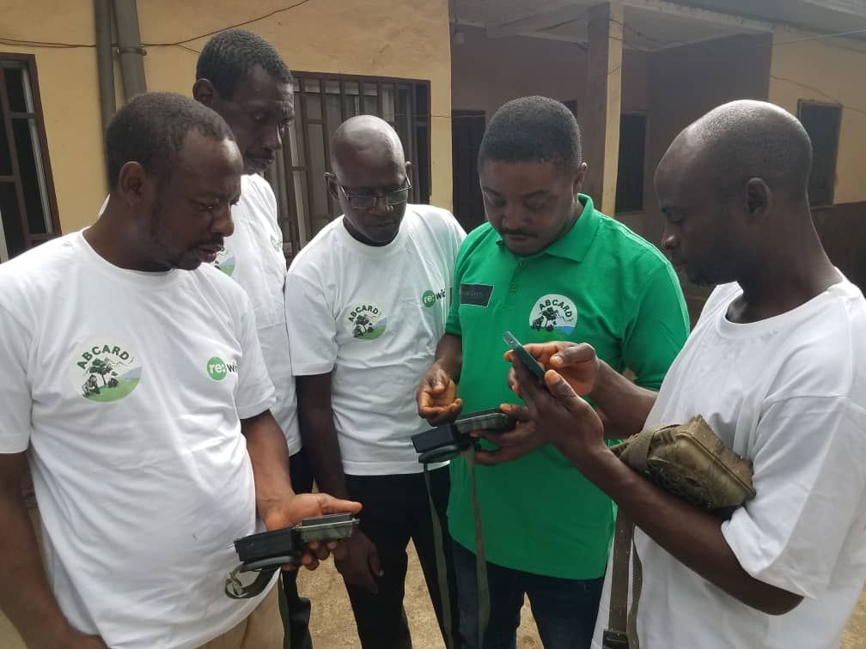
Training in camera trap use

Following these trainings, the local rangers were able to install 10 camera traps in strategic locations across the sanctuary. Monitoring of the camera traps were conducted systematically with cameras checked and repositioned every 21 days between January and April 2025, and monthly between May and June, September to December 2025. During the months of July and August camera traps were temporally removed from the field to prevent equipment damage from heavy rainfall and high humidity and were reinstalled once conditions improved. Two camera traps were lost to theft; however, eight remain functional, ensuring continuity of data gathering throughout the targeted period.

Two hundred and eighty (280) trap nights were recorded, generating photos and videos data on wildlife present as well as movement pattern of wildlife within the Tofala Hill Wildlife Sanctuary. Nine species were recorded including chimpanzee (Pan troglodytes ellioti), bay duiker (Cephalophus dorsalis), Preuss’s monkey (Cercopithecus preussi), Kusimanse (Crossarchus platycephalus), giant rat (Cricetomys sp), drill (Mandrillus leucophaeus), mongoose (unidentified species), rock hyrax (Procavia sp) and mona monkey (Cercopithecus mona). Capture rate varied significantly among species. Chimpanzees had the highest capture rate, meanwhile drill had the lowest.

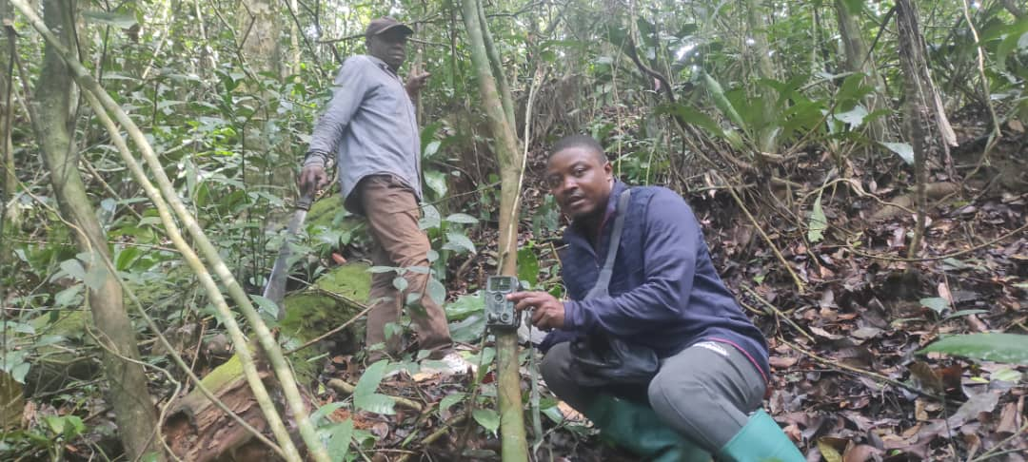
Checking camera traps in the field

Chimpanzee were the most frequently recorded species, representing 60% of all the animal species recorded by camera traps. Group size ranged from 1 to 26 chimpanzees, reflecting complex social structure. The population structure analyses of the chimpanzees indicate a healthy demographic composition with adults forming the majority of the population with strong representation of juveniles and presence of infants. The frequent photographs of infant chimpanzees support evidence of population stability and reproductive successes.

Table 1. Relative Abundance based on the number of individuals*
Species | Individuals | Relative Abundance (%)
Chimpanzee | 250 | 62.7%
Rock Hyrax | 45 | 11.3%
Mongoose | 30 | 7.5%
Kusimanse | 23 | 5.8%
Preuss’s Monkey | 20 | 5.0%
Giant Rat | 15 | 3.8%
Bay Duiker | 10 | 2.5%
Mona Monkey | 5 | 1.3%
Drill | 1 | 0.3%

*Note these are not necessarily different individuals

Table 2. Population structure of chimpanzees
Age Class | Number | % Structure
Adults | 140 | 56%
Juveniles | 70 | 28%
Infants | 40 | 16%

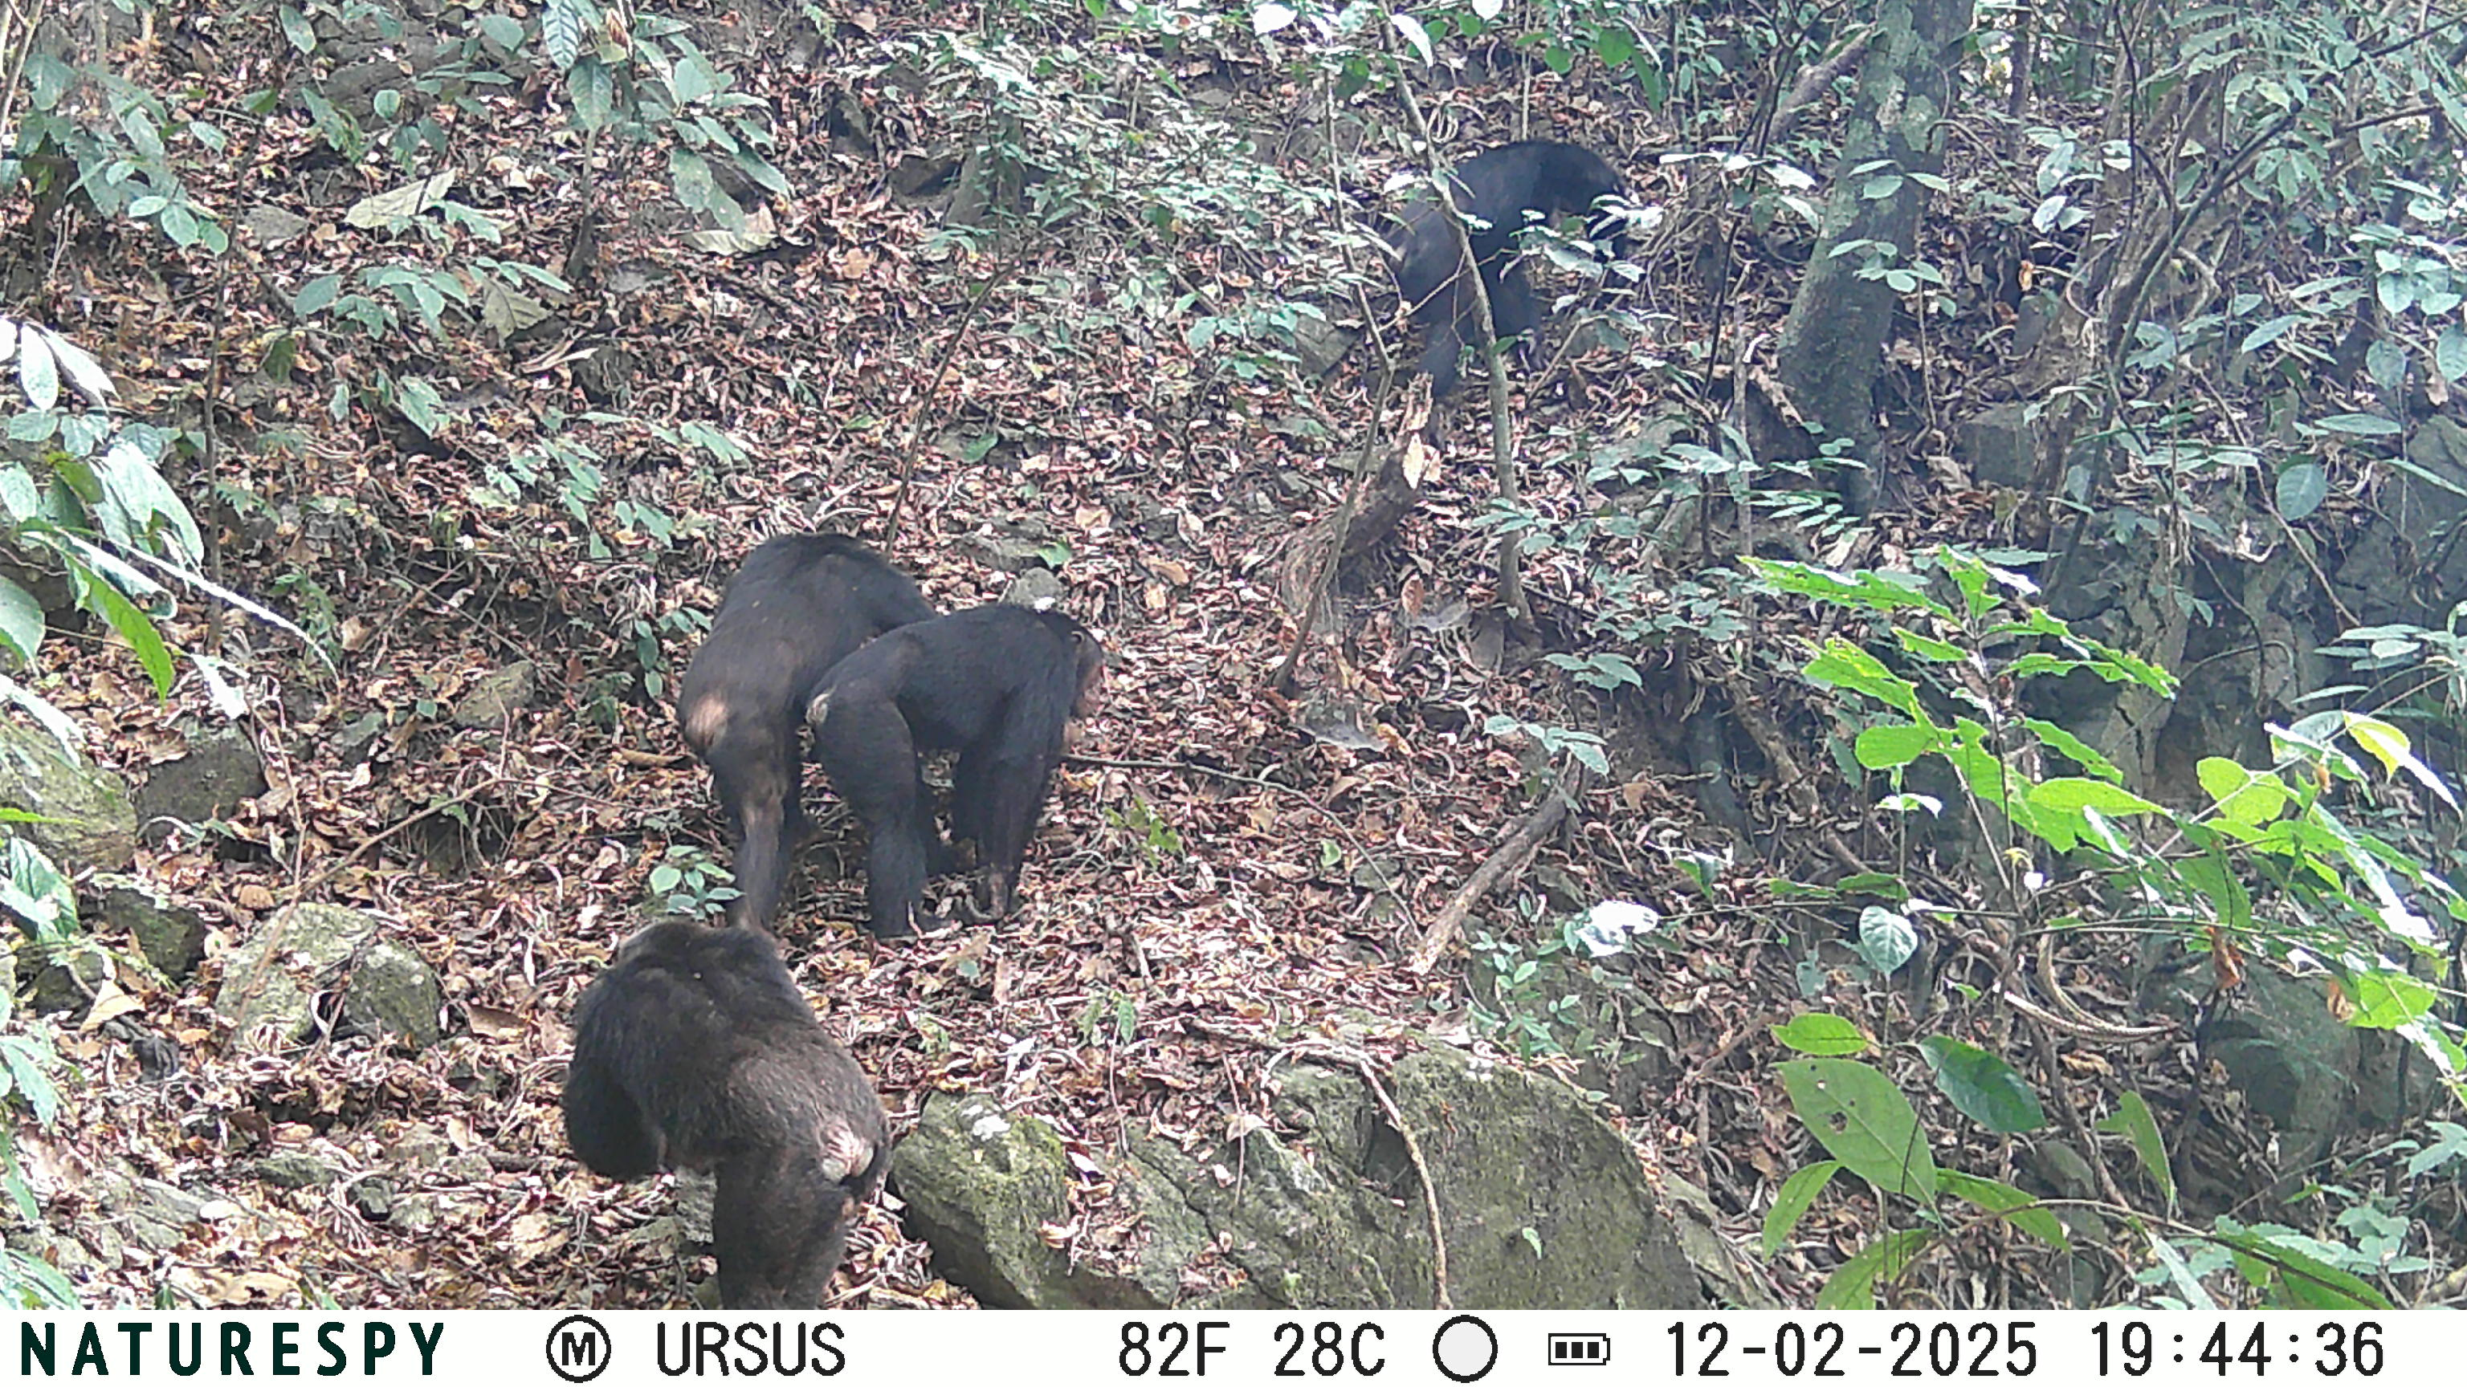
A chimpanzee subgroup recorded by camera trap

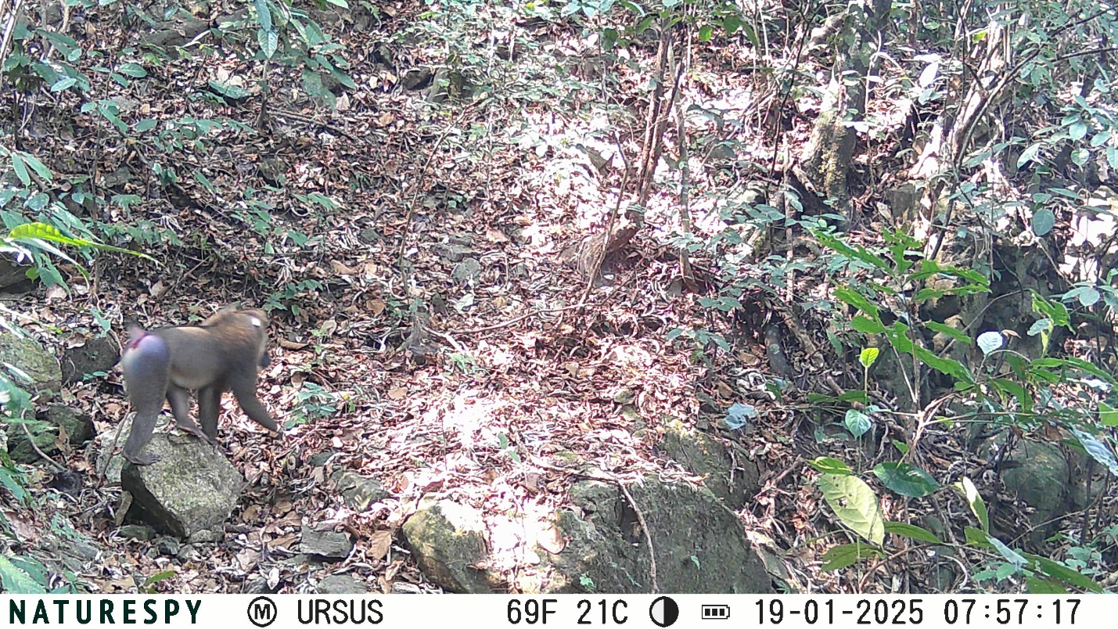
A single individual adult male drill recorded by camera trap

Despite efforts to target Cross River gorillas, no photo nor video evidence of the species was recorded. The absence is likely due to the species cryptic behaviour, low population density, historical hunting pressure and forest degradation in the landscape. These findings highlight continuous vulnerability of Cross River gorillas and the need for intensified protection, habitat restoration and long-term monitoring strategies.

Beyond biodiversity data collection, the project achieved strong social and institutional impact. The trained community rangers are now actively engaged in camera trap monitoring and have become recognised as local conservation actors. They are increasingly being used as local support by the Forestry and Wildlife Service and other non-governmental organisations, for bio-monitoring and conservation activities. This integration demonstrates the value of community-led conservation models in building trust, local ownership and sustainability.

Several challenges were encountered during the implementation: camera malfunctions, rising transportation costs that limited field visits, equipment theft and seasonal climate constraints. However, adaptive management was applied to address some of these challenges, this included: community engagement, flexible deployment schedule to enable the project to continue delivering results.

Overall, the project successfully achieved its core objectives of community ranger’s capacity building, wildlife monitoring through camera traps and biodiversity documentation. This project generated a dataset for multiple species in the area and one of the first images of drill. The camera trap data showed that Tofala Hill Wildlife Sanctuary supports a diverse mammalian community dominated by primates. It has established a community-based monitoring framework that links conservation science with local participation. This integrated model provides a strong foundation for long-term conservation of great apes and other wildlife species while reinforcing the critical role of communities in safeguarding biodiversity in Tofala Hill Wildlife Sanctuary.

