Ascentae

Contacts
George Hough
Business Development Executive
George.hough@ascentae.com
+447493 280556

Case Studies

University of Chester

Context
The University of Chester is made up of multiple sites, with the main site in Chester and various buildings dotted around the city. It also has sites around the North-West and beyond, as far as Warrington, Birkenhead and Shrewsbury.
With many different geographical locations – and a lot of students and lecturers moving between them, it was a regular occurrence for lecturers to be travelling to teach the same material at different sites.
Before COVID, the university was exploring ways to deliver lessons once from one location and broadcast it to the other sites at the same time. This would be better for the students and for staff, who would not have to repeat their session.
Initially, the university was looking at a webinar solution suited to a bigger scale. The solution needed to work in lecture theatres so that the students attending in person could be captured and Q&A was enabled between them and the lecturers.
The search for technology to achieve this began in 2020 with a visit to ISE, the world’s leading AV and systems integration exhibition. It was there they discovered Nureva and first met the Ascentae team.

The Challenge
The University of Chester told us it faced two challenges.
Firstly, pre-COVID, they were making heavy use of more traditional video conferencing, with a limited set-up of Skype for Business.
The university wanted to find a single, consistent solution – something easy to set up, easy to use and easy to support. Their research suggested the individual tools were out there, but they could not find an all-embracing single solution.
Secondly, as the university went through the pandemic it began thinking about future approaches to teaching. They wanted Ascentae to help with finding a modern hybrid learning solution.

The University’s Biggest Hybrid Learning Challenges
Like any other education institution, the University of Chester wanted a good compromise between quality, ease of use and price.
Mark Sargison, the university’s AV Development and Support Manager, said the solution needed to overcome some big challenges:
- Allow teaching to be delivered across multiple sites, to improve the teaching and learning experience.
- Enable the university’s AV team to support consistently and, preferably, remotely (to avoid busy journeys between sites).
- Technology which was simple to use and did not require much training as an academic’s main priority is teaching.
- Enhance the students’ learning experience whilst providing value for money.

Mark Sargison said:
“We didn’t want any one single room to dictate teaching too much. We wanted something that could support different teaching styles and different learning styles, to try to keep everyone happy.”
“We wanted something we could put everywhere that would be relatively easy to use but also give us value for money”.

The Decision
AV leaders from University of Chester visited ISE in 2020, visited stands and talked to some exhibitors, including Nureva and the Ascentae team. They evaluated a number of products from different brands and left very impressed by a demo of Nureva’s audio solutions.
Back in the UK two months later, we arranged for the university to have a follow-up online demonstration of Nureva’s HDL soundbar and innovative Microphone Mist™ technology.

Putting Nureva Technology to the Test
Mark Sargison said:
“We tested medium to large spaces, using Teams to capture lectures rather than a bespoke lecture capture system. We wanted to test creating synchronised content with mics regardless of people’s position in the room, with the lecturer miked up, and how the system handled streaming, multiple user cases and sound quality.”
That demo with Ascentae convinced the University of Chester to choose Nureva.

The Choice
The university explored and had demos of audio solutions from other brands. Mark Sargison explained why the university chose Nureva:

“We did consider other systems but we thought it was more complex, more costly and offered less support than Nureva. Another solution just amplified the air conditioning noise, which was awful.
But Nureva, the Nureva HDL system, delivered a perfect demo.
Straight away, we were really impressed with the product and how the technology worked. Initially, I was sceptical about whether the Microphone Mist™ technology would make a difference – but the audio quality was incredibly good.
The HDL system got rid of air conditioning noise in the background within seconds. The recording was so acoustically clear. At one point, a few of the team were standing apart in the room and talking. It was like they were all standing in the same spot because the sound quality on the recording was so consistent.”

The Solution
The University of Chester didn’t rush into things. With advice from Ascentae, the sensible option for them was to begin with a couple of units. This allowed them to test Nureva’s soundbars and mics in real-world teaching – and prove their capability to the rest of the institution before scaling.
The university now has Nureva audio working across 65 rooms across multiple sites.

Living Up to the Promise with Hybrid Learning Technology

Mark Sargison said:
“When you choose a solution you want to be sure you have made the right choice.
We were wondering whether the sound quality would be consistent across all the different rooms we had. Would it be as easy to use for staff as our technicians found it to be? Would we end up having a lot of tech issues and calls for support? Was this ‘Microphone Mist™ going to work across all sites as well as it did in the demos?
Based on how it has performed right from the start, we are very, very happy with Nureva.”
The AV team at University of Chester were happy. But what about lecturers, staff and students?

The Verdict
Mark Sargison said:
“Since we put in the Nureva audio solution, we have not had a lot of feedback – and that’s a very good thing. In our experience, when you hear, it is usually negative feedback, so we take no news as good news. The feedback we have had has all been good.
Students have expectations and staff have expectations, of the room and of the technology. It just has to work to deliver the right experience for everyone, including visiting speakers.”
The University of Chester told Ascentae they needed something that was easily transferable and understandable between its range of users. Something that could be replicated easily, did not require too much training, and was reliable and easy for any member of the AV team to support.

Marks verdict:
“We’re very happy that this solution ticks all those boxes”.

The outcome and future plans
The University of Chester uses Microsoft Teams with Nureva integrated into rooms, via a USB switch on the lectern. Lecturing staff and visiting speakers can also put their laptop on the lectern, plug in a cable and connect to Nureva as a BYOD option.

Ascentae continues to offer support and advice for the university as it expands its hybrid teaching, hybrid learning and asynchronous content creation capabilities.

Mark Sargison said:

“We are very, very happy with Nureva as an audio solution. The core functionality is so solid. It gives us the confidence to build on that, without having to rush. We will work with Ascentae and with Nureva to grow the relationship, and to grow our use of the products.”

Having attended ISE 2023, the university is now looking into the Connect Module 2, room cameras and new Nureva products, like the HDL310 and HDL410, as future upgrades.

Mark added:
“We started to use Aver cameras and are excited about the possibilities to drive the experiences we want to deliver, through integrations between Aver and Nureva solutions”

How User Friendly is Nureva?
The university’s AV team told Ascentae that Nureva’s technology is very easy to install and integrate into its existing setup. Nureva has now become standard in particular rooms and room types.

Mark Sargison said:
“Nureva is very good and it is very positive how little (negative) feedback we have had about this. We know the support from our integration team at Roche AV, Ascentae and Nureva is there but it’s been needed very little. And when we have needed any support it’s been excellent.

The university is moving towards more active learning – it’s the way teaching is going. There is still a place for the traditional lecture, but small group work, flipped classroom and other approaches are seen to be better and more engaging – and more the kind of thing students want.

We want tools that can support different teaching styles and different learning styles. Nureva is helping us to deliver on that.”

Lincoln University
Modernizing historic spaces at the University of Lincoln
Welcome to the University of Lincoln, where attending classes in old newspaper mills or train station repair yards is just part of daily life. Embracing the future of education, Lincoln uses Huddly cameras to transform spaces, both old and new, into dynamic hubs for hybrid learning.


Updating old spaces with new tech
The University of Lincoln is all about making education accessible for its 14,000 students. With flexible learning options, they can study from anywhere and fit education into their days, no matter what stage of life they’re at.
Driving this transformation is the university's small but mighty AV team of four. Led by Senior AV Designer Jason Ramsden, the team designs solutions for Lincoln’s' over 400 spaces and makes sure that everything runs smoothly. "It's all about making things foolproof," says Rachel Lee, Senior AV Specialist. "Our goal is to support students and academics by making everything as easy as possible for them."


Jason Ramsden
The team faces a unique challenge with the campus' mix of modern and historic buildings not designed for teaching, such as the mill and train repair yard. The move to remote learning early on in the pandemic highlighted difficulties such as poor acoustics, irregular room shapes, and obstructive beams, making it hard to teach and learn effectively on video.

A review of the AV equipment showed that not only were many rooms missing essential tools, but the existing equipment fell short. Jason explains: "At that time, teaching and meeting on video often felt unsettling. Blurry video made it difficult for students to follow the class or connect with their classmates remotely. We knew we had to update the technology."

After evaluating their choices, the team landed on Huddly’s cameras. These flexible cameras provide premium video and smart framing for a variety of spaces. They're also Microsoft Teams certified, making them easy to integrate with Lincoln's existing technology.

Hybrid learning in any space
Fast forward to today, Lincoln has fitted dozens of spaces with Huddly cameras, with many more rolling out this year. The Huddly L1 camera, known for its powerful lens and smart framing, is a top choice for boardrooms and large seminar rooms. Compared to traditional PTZ cameras, Rachel points out that it "lets teachers teach, not worry about technology."
For small classrooms and collaboration areas, Lincoln uses Huddly IQ and S1 for their wide-angle lens and intelligent Group Framing. They often pair them with Huddly Canvas for whiteboards. Jason explains, "Our students like traditional whiteboards more than digital ones. With Huddly Canvas, there's no more need to take photos of the content and send them via email."
When setting up the cameras in some of the more unusual or historical spaces on campus, he first thinks about how the user interacts with them. He recommends: "Consider the experience as soon as they enter the room. How do they start the system, adjust the camera, start teaching? Don't let AV be a barrier – use it to enhance the pedagogy of the space."
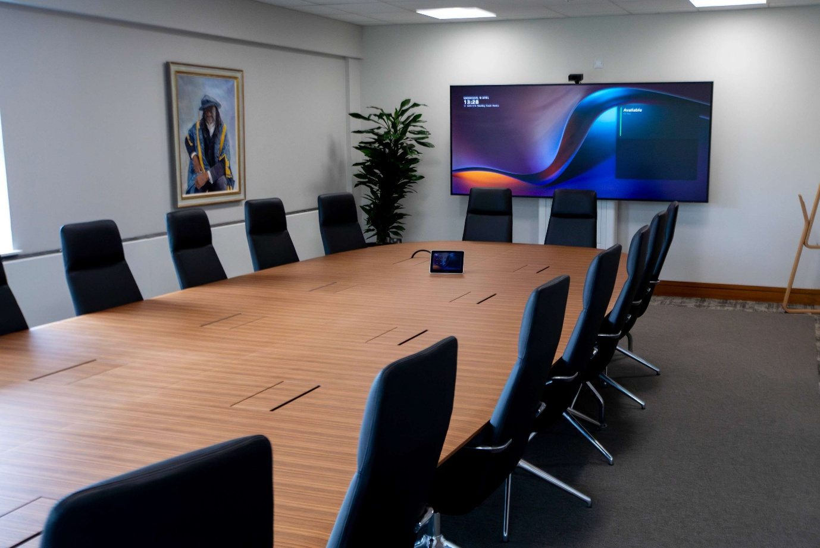
MTR boardroom with Huddly L1.

Technology that works
For Lincoln’s AV team, Huddly cameras have been a game-changer. Rachel says, "With only four of us managing over 400 spaces, we need technology that's easy to use and set up. It's important that stuff just works. We get that with Huddly!"
Jason also highlights ease of use: "Our principle is simple: focus on content, not setup. Anyone should be able to walk into any space on our campus, even for the first time, and be able to deliver what they came to deliver without ever having to read a manual. Huddly makes this happen – a single cable is all you need to start teaching."

"Sharing, connecting, and collaborating should be as easy as swiping through TikTok or Instagram.”
– Jason Ramsden, Senior AV Designer

Meaningful connections
Lincoln is set to expand Huddly's roll-out to over 135 spaces by the end of the summer, including trial runs of AI-directed multi-camera system Huddly Crew in large lecture theaters and the school's video podcast studio.
Jason is excited about where things are going: "AV is shifting from traditional lectures to more engaging, flexible learning. Our team's mission in this is to build community among students, ensuring everyone feels part of the group no matter where they’re joining from."
He adds: "What's really impressed us about Huddly is how their cameras focus on the human element, going beyond basic video to make classes feel engaging and inclusive. It's been incredibly rewarding to see people form meaningful connections without ever meeting face-to-face."
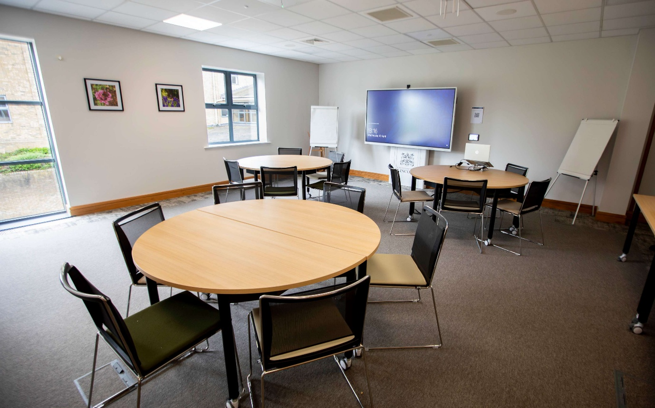
Collaborative space with Huddly IQ.

University of Toledo

Background
The College of Engineering at the University of Toledo partners with another college to offer a distance learning program. The colleges ‘connect’ two classrooms electronically. The instructor may deliver a lecture from either location, share content like slides or video, and all the students are able to communicate and collaborate together in real-time. When the program originated in 2004, students in the remote location could actively participate in classroom discussion with the instructor and other students simply by pressing a button. The button would cue the instructor someone wanted to participate, the microphone would go live, and the video camera would be signalled to focus on that individual.

Problem
Even with regular maintenance, technology like this starts to fail. With its somewhat complex configuration, the equipment racks and cabling were dense and complicated, so much so that it became challenging to find an integrator or programmer that would even work on it. “We knew we needed some kind of control interface and we knew we needed to think about compatibility for the future and how to make that continue to work as technology changed,” Jonathan Rethorn, High Performance Computing Specialist indicated.

Solution
They had identified their functional requirements, and video was part of those requirements, but they were really concerned about over-buying or re-buying when it came to the hardware. “Another hardware-based solution would leave the college in the same situation again in the future—we just didn’t know how long that would be,” said Rethorn. The desire was to go with a software-based solution to allow for future exibility, but they didn’t really know how to accomplish that. The College of Engineering was familiar with Utelogy because it was being used elsewhere at the college, so they approached Utelogy about the possibility of deploying their distance education solution using AV over IP. Utelogy delivered a conceptual design, put together a bid speci-cation and ultimately worked with ProVideo Systems to perform the integration and commissioning of the room. The College of Engineering was able to deploy a solution where the software executes the commands to control the hardware and tell it what to do.

Outcome
The College of Engineering was able to reinstate its real-time audio and visual participation in its distance learning program. “Utelogy made this easy and affordable to do,” said Rethorn. This software-based solution resulted in a savings of more than $40,000 that would have been required to purchase the hardware for control and swap out some other hardware that was no longer compatible. Not only did the solution provide capital savings, it’s also resulted in operational savings as it doesn’t require nearly as many support calls. “We feel the solution has helped us to be on the leading edge and given us a solution for the future. There are some capabilities we don’t have today, like lecture capture, but because we’re using a software solution, we can implement that and other pieces whenever we want,” Rethorn added.

Challenges
- AV equipment complicated, dated and failing
- Lack of future compatibility

Key Results
- Savings of more than $40,000 in hardware
- Operational savings with reduced support calls
- Eliminated the need to over-buy or re-buy hardware

PointGrab: Transforming Hong Kong University's Meeting Room Experience
Introduction In the bustling educational landscape of Hong Kong, a renowned university faced a challenge familiar to many: optimizing the utilization of its meeting rooms. The City University of Hong Kong aims at optimizing shared meeting room resources, improving the effectiveness of the booking system, and enhancing the overall user experience on campus. However, they were facing challenges in making informed decisions and optimizing space efficiency due to the absence of relevant space utilization data.

Challenge
The key challenge stemmed from the lack of reliable data on room occupancy and usage, resulting in meeting rooms being left unoccupied due to “no show” after booking. This led to user frustration and under-utilization of room resources. Adopting a data-driven approach is crucial for effective resource management and planning.

PointGrab's Solution: A Game-Changer
Enter PointGrab's CogniPoint, an innovative deployment leveraging AI-based IoT sensors renowned for their unparalleled accuracy and non-intrusive nature. This integration with the university's room booking and management solution marked the beginning of a transformative journey.
- Unparalleled Accuracy: PointGrab’s occupancy sensors offered a window into real-time room usage with unmatched precision, revealing a clear picture of space utilization.
- Data-Driven Decisions: Armed with granular data, the university's IT and facility teams could now make informed choices about room allocation, design, and booking system enhancements, paving the way for a smarter, more responsive campus.
- Real-Time Alerts and Efficiency: The new data system empowered the university with the ability to react instantly to "no shows" or early meeting conclusions, facilitating automated room reassignments and ensuring optimal scarce space utilization.

The Impact: A Success Story
The deployment of PointGrab CogniPoint brought about a revolution in how the university managed its meeting spaces:
- Increase in Room Utilization: With better data, the university optimized room usage, significantly reducing idle space.
- Boost in Booking System Efficiency: The integration of real-time usage data streamlined the booking process, making it faster and more reliable.

A Testimony to Innovation
"Since using PointGrab, our room utilization has increased significantly, and our faculty and students find booking rooms much easier now," remarked Chris Fung, a member of the university’s IT services. This sentiment echoes the broader impact of PointGrab's technology: transforming real estate into intelligent workspaces.
Conclusion
PointGrab's CogniPoint system, widely used in commercial real estate, is now illustrating how cutting-edge technology can solve age-old problems in space optimization and user satisfaction. The success story at the City University of Hong Kong is a testament to the power of data-driven decisions and the tangible benefits a sensor-data systems bring to educational institutions worldwide.

Useful Links:
Nureva
- https://www.nureva.com/solutions/industries/education?srsltid=AfmBOoqL5XK8X1iEzy3FkgPc8nu3x6zRSMenStriXOJB9iQdTi5xwg-4

Huddly
- https://www.huddly.com/

Utelogy
- https://www.utelogy.com/wp-content/uploads/2025/03/U-of-Toledo-Case-Study-Updated-Sept-2018-1.pdf
- https://www.utelogy.com/

Audiebant
- https://audiebant.co.uk/universities/

Pointgrab
- https://www.pointgrab.com/

