Barry Clark
for new books, repairs & restoration
books@chorlton21.co.uk

Interested in doing some bookbinding?

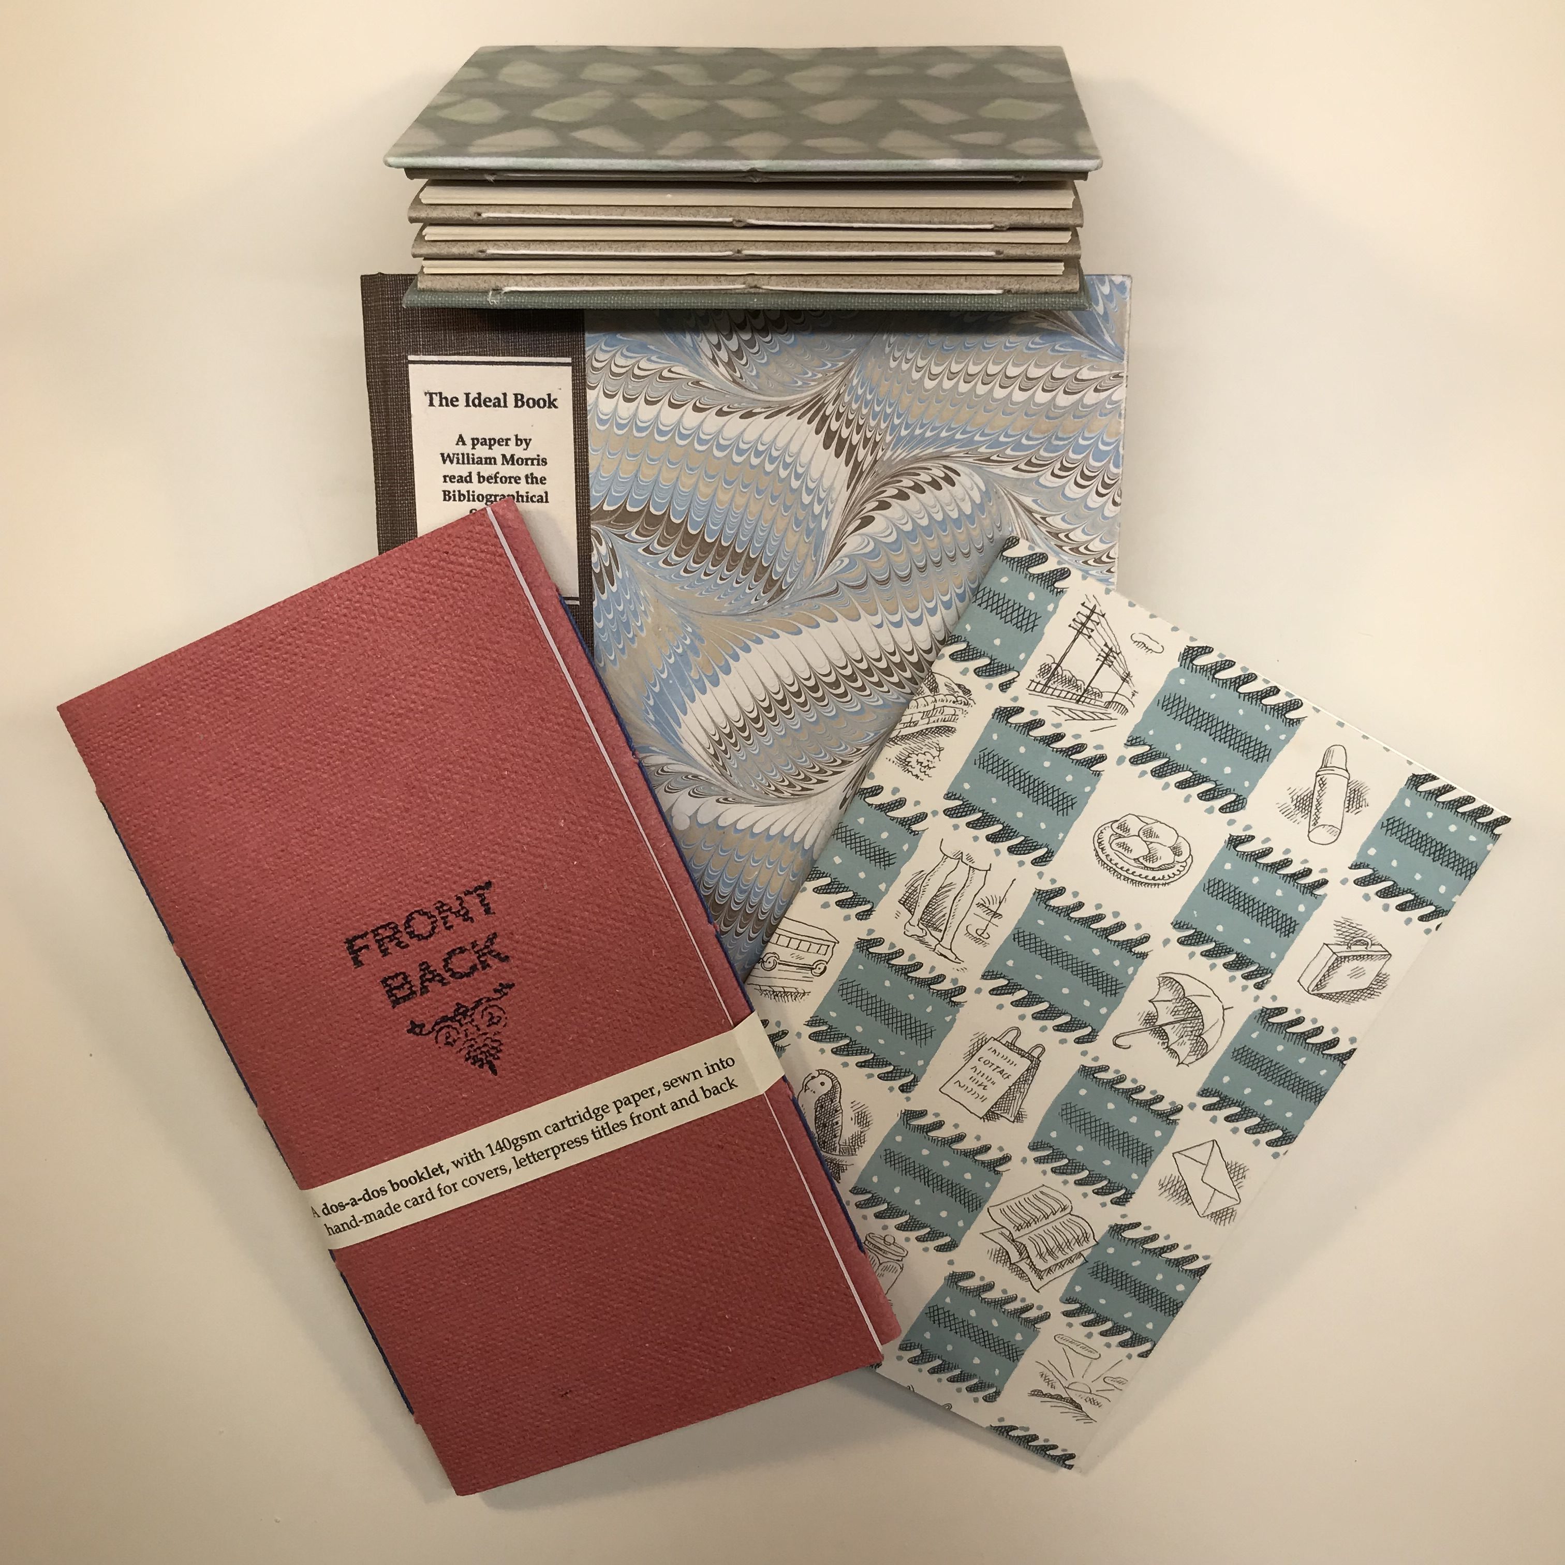
Wednesday 12 February: An Introduction to Bookbinding
[for total beginners, and others not too confident]
In this one-day workshop we will create three finished books: all using the simple but versatile pamphlet stitch. We will make a sewn softback pamphlet with a decorative dustwrapper, a single section hardback notebook with a cloth spine, and a multi-section concertina book. These three projects will introduce you to the essentials of all bookbinding: grain direction, folding and cutting paper, creating book sections, and sewing. And you will have three hand-made books to take home!

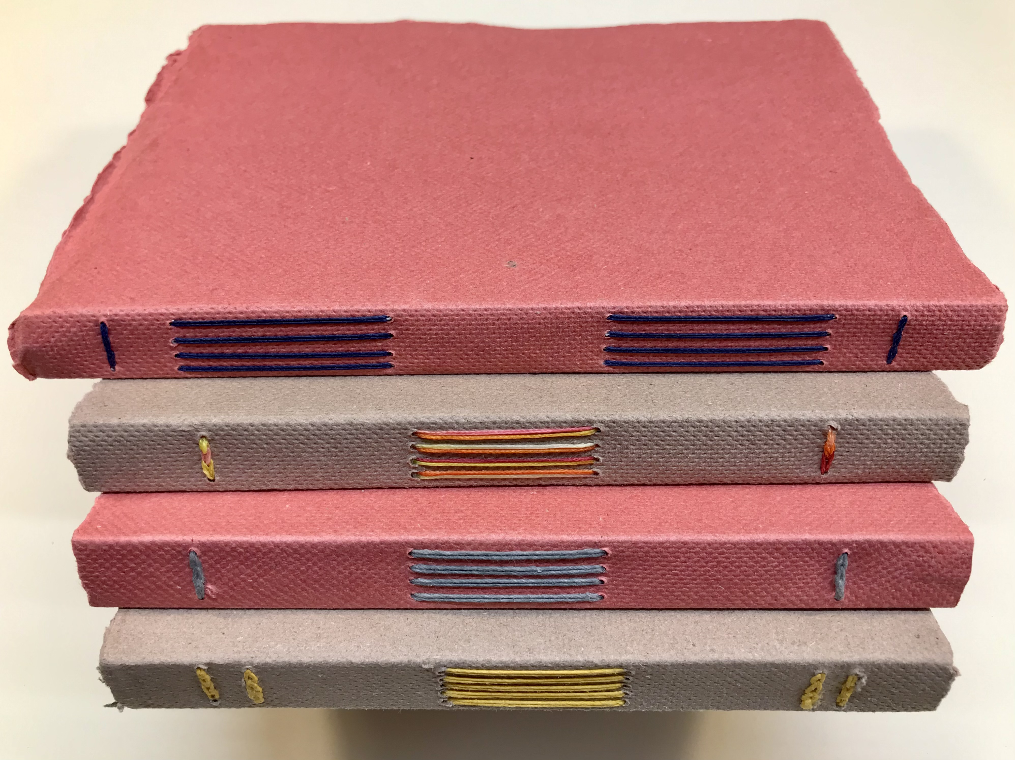

Wednesday 9 April: Creating an Eco Sketchbook
This A5 sketchbook could hardly be greener. The covers are made from Zaansch Bord, a hand-made thick paper made from cotton waste in a wind-driven paper mill in Holland. The pages will be recycled cartridge paper. The book requires no glue as the folded paper sections are sewn direct to the cover with a waxed linen thread, using the long and link stitch - holes are punched into the cover and sewing through the holes creates a binding that is both highly decorative and functional.

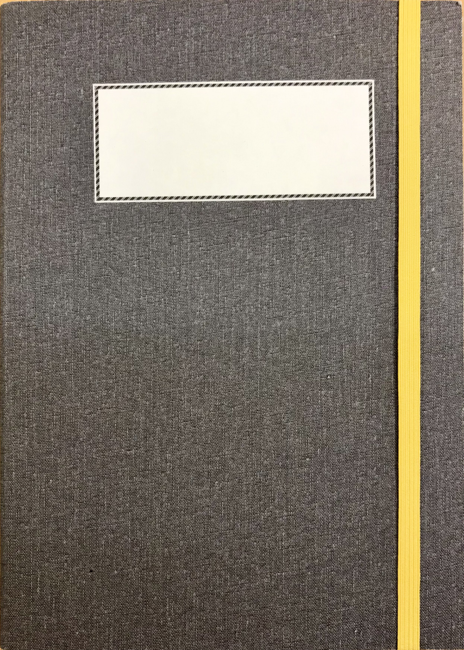
Wednesday 11 June: The A5 Travel Journal
Single sheets have been bound together with adhesive since Victorian times through to the modern paperback . . . and they don’t have to fall apart! It’s even called ‘perfect binding’ in the trade. In this one-day workshop you will make a perfect bound book, with coloured endpapers, strengthened linen cloth covers, and a pocket inside the rear cover for tickets and ephemera, all held together with an elasticated closure. A great journal, home or away.

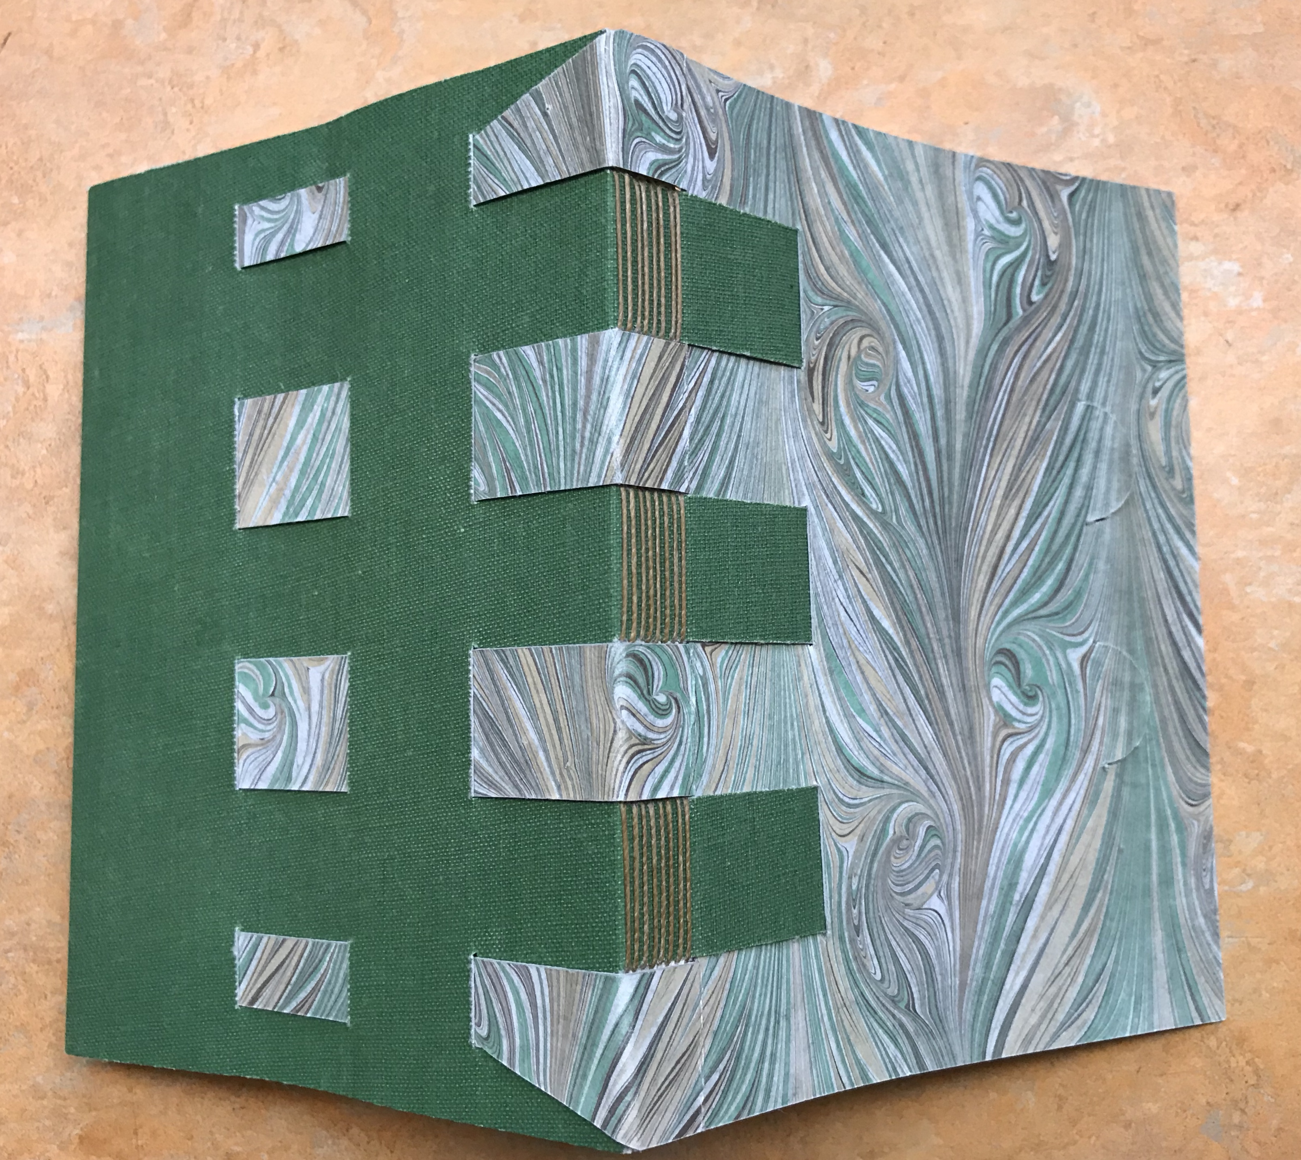

Wednesday 17 September: A crossed structure notebook
We will make an A6 crossed structure notebook - a non-adhesive binding developed by Carmencho Arregui. The book block is sewn directly around the rear cover’s straps which could be card, leather or some other material. We will use reinforced hand-marbled paper for the front cover, with a supported book cloth for the rear. After sewing, the straps of the two covers weave and interlock. The rear cover extends, and folds over the foredge thus protecting the book.
All workshops take place at the Portico library in central Manchester. They run from 10.00-4.00, with tea/coffee on arrival for a prompt start at 10.15am. All materials and tools will be provided. The £80 fee includes the cost of materials, tea/coffee on arrival and a light lunch. Workshops are limited to 12 participants so early booking is advised.

Please go to the Portico website for booking details: https://www.theportico.org.uk or email: Events@theportico.org.uk
The workshops are run in partnership with the Society of Bookbinders, North West and North Wales Region.

Wednesday 12 November: Making a single section hardback book
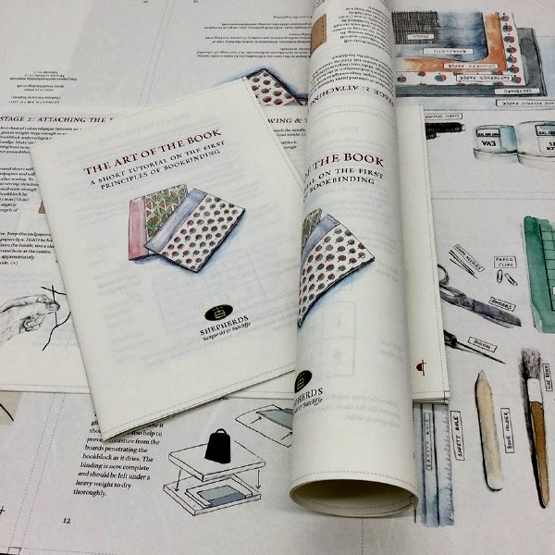
We will make a proper hardback book with a difference! Supplied in the form of a flat sheet, once bound its sixteen printed pages are transformed into your own bookbinding instruction manual for future use. Developed in 2020 by London-based bookbinding suppliers Shepherds Sangorski & Sutcliffe, making the book is itself a tutorial on the essential principles of creating hardback notebooks. Another workshop for total beginners and others not too confident.

