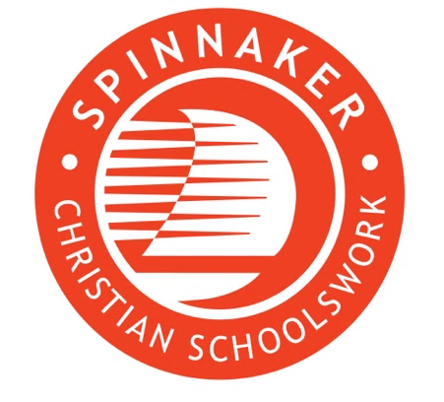  YN  Objective  Changing children’s lives through the discovery of Jesus Christ  Details  £32-35,000 pro-rata depending on experience.  Flexible working hours of approximately 5.5 hours per week.  APPLY  The application pack is on our website:  Join us | Spinnaker Trust  The closing date for applications is 7th March 2025. | FUNDRAISER  SPINNAKER  Spinnaker is a Christian charity dedicated to promoting wonder and learning in primary school children to inspire them to engage with and explore the Christian faith. We do this by creating, delivering and distributing resources for Collective Worship and RE lessons, to support schools and equip schoolsworkers.  Our work is rooted in Christian values, and we rely on the generosity of supporters, churches, and funders to bring our mission to life, developing impactful partnerships with these groups.  OPPORTUNITY  Spinnaker is looking for a dedicated Fundraiser to help our team work towards a more sustainable future. As a Fundraiser, you’ll have the exciting opportunity to:  - Build Connections: Engage with churches, supporters, and funding bodies to secure vital support for our mission.  - Write Impactful Applications: Create compelling funding proposals to trusts, foundations, and corporate sponsors.  - Drive Change: Help develop and execute fundraising campaigns and events that bring lasting impact.  - Make a Difference: Work with a passionate, values-driven team to inspire children and communities through Christian outreach.  WHY WORK WITH US  - Be part of an enthusiastic and passionate team.  - Flexible working hours and the opportunity to work remotely.  - A collaborative work environment where your work and participation is valued.

