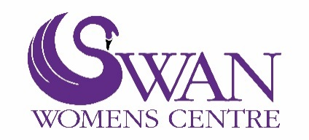
Self-Referral Form
Please note: counselling is not appropriate if you are in crisis.
Personal Details
Full Name
Address
Postcode
Date of Birth (DOB)
Contact Number | Mobile: Landline:
Email Address
Ethnicity
GP Practice
Name of Next of Kin and mobile number
Which service would you like to access?
Adult Counselling  18 years + |  | Volunteering |  | Befriending Service
Teenage Girls Counselling  13 – 19 years |  | Peer Support Group |  | Emotional Support Group  (Counsellor led)
Your Mind Matters  (Mental Health Support for 16 – 25 years) |  | Mental Health Advocacy  (16-25 years) |  | Mental Health  Support Group  (16 – 25years)
Activity/Interest group |  | Legal Advice |  | Other

Please tell us more about what support/help we can give you.

Are you currently being supported by any other agencies?

If so, who is supporting you?

Name:
Organisation:
How are they supporting you?

Do you have any health issues?
If so, please describe what they are and any medication that you are currently taking?

If you are interested in the Befriending Service please return to: vbc@swanwomenscentre.org
If you are interested in Your Mind Matters, Mental Health Services for 16 – 25 year olds please return to: MHP1@swanwomenscentre.org
For all other services including counselling then please return to: cwm@swanwomenscentre.org or contact us as below.

Updated February 2024

