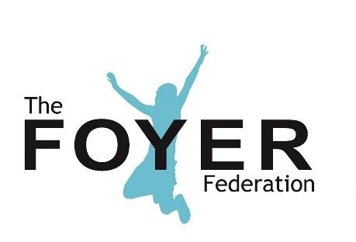

Privacy Policy

Document Type: Internal and External
Last Revision Date: February 2022
Next Revision Date: February 2025
Owner: Chief Executive
Author: Executive Assistant & Company Secretary
Version: 1.0
Status:

This policy has been prepared with reference to the list of requirements for privacy notices published by the Information Commissioner’s Office on this website page: https://ico.org.uk/for-organisations/guide-to-data-protection/privacy-notices-transparency-and-control/privacy-notices-under-the-eu-general-data-protection-regulation/ (as at 1 May 2018)

This Privacy Policy applies to information The Foyer Federation collects about individuals who interact with our organisation. It explains what personal information we collect and how we use it.
If you have any comments or questions about this notice, feel free to contact us at inbox@foyer.net

1. Personal data that we process
The following table explains the types of data we collect and the legal basis, under current data protection legislation, on which this data is processed.
Purpose | Data (key elements) | Basis
Enquiring about our organisation and its work | Name, email, message | Legitimate interests - it is necessary for us to read and store your message so that we can respond in the way that you would expect.
Subscribing to email updates about our work | Name, email | Consent - you have given your active consent.
Making a donation | Name, email, address, payment information | Legitimate interests - this information is necessary for us to fulfill your intention of donating money and your expectation of receiving a confirmation message.
Signing up as a member | Name, email | Contract - by paying your membership fees you have entered into a contractual relationship with us as set out in our membership terms and conditions.
Website functionality | Website activity collected through cookies | Legitimate interests  - it is necessary for us to store a small amount of information, usually through cookies, to deliver functionality that you would expect, such as remembering the contents of your order before you have fully completed the process.

2. How we use your data
We will only use your data in a manner that is appropriate considering the basis on which that data was collected, as set out in the table at the top of this policy.
For example, we may use your personal information to:
- reply to enquiries you send to us;
- handle donations or other transactions that you initiate;
- where you have specifically agreed to this, send you marketing communications by email relating to our work which we think may be of interest to you.

3. When we share your data
We will only pass your data to third parties in the following circumstances:
- you have provided your explicit consent for us to pass data to a named third party;
- we are using a third party purely for the purposes of processing data on our behalf and we have in place a data processing agreement with that third party that fulfils our legal obligations in relation to the use of third party data processors; or
- we are required by law to share your data.
In addition, we will only pass data to third parties outside of the EU where appropriate safeguards are in place as defined by Article 46 of the General Data Protection Regulation.

4. How long we keep your data
We take the principles of data minimisation and removal seriously and have internal policies in place to ensure that we only ever ask for the minimum amount of data for the associated purpose and delete that data promptly once it is no longer required.
Where data is collected on the basis of consent, we will seek renewal of consent at least every three years.

5. Rights you have over your data
You have a range of rights over your data, which include the following:
- Where data processing is based on consent, you may revoke this consent at any time and we will make it as easy as possible for you to do this (for example by putting ‘unsubscribe’ links at the bottom of all our marketing emails).
- You have the right to ask for rectification and/or deletion of your information.
- You have the right of access to your information.
- You have the right to lodge a complaint with the Information Commissioner if you feel your rights have been infringed.
A full summary of your legal rights over your data can be found on the Information Commissioner’s website here: https://ico.org.uk/
If you would like to access the rights listed above, or any other legal rights you have over your data under current legislation, please get in touch with us.
Please note that relying on some of these rights, such as the right to deleting your data, will make it impossible for us to continue to deliver some services to you. However, where possible we will always try to allow the maximum access to your rights while continuing to deliver as many services to you as possible.

6. Cookies & usage tracking
A cookie is a small file of letters and numbers that is downloaded on to your computer when you visit a website. Cookies are used by many websites and can do a number of things, e.g. remembering your preferences, recording what you have put in your shopping basket, and counting the number of people looking at a website.
Where cookies are used to collect personal data, we list these purposes in section 1 above, along with other personal data that we collect. However, we also use some cookies that do not collect personal information but that do help us collect anonymous information about how people use our website. We use Google Analytics for this purpose. Google Analytics generates statistical and other information about website usage by means of cookies, which are stored on users' computers. The information collected by Google Analytics about usage of our website is not personally identifiable. The data is collected anonymously, stored by Google and used by us to create reports about website usage. Google's privacy policy is available at http://www.google.com/privacypolicy.html.

7. Modifications
We may modify this Privacy Policy from time to time and will publish the most current version on our website. If a modification meaningfully reduces your rights, we'll notify people whose personal data we hold and is affected.
Log of changes to document

Version | Date | Page | Change | Approver

