VC Venta – Go-Ride
Report for AGM 2022 – Thursday 24 November

Thank you
I would like to thank all the volunteers who gave up their time to ensure that Go-Ride continues to provide a fun, enjoyable coaching series for all the young cyclists that attend each Sunday afternoon.
Malcolm Cross; Toby Leyland; Start Gilmour; Raf Izak; Steve Swift; Paul Barker; Andy Watkins; Leah Burton; Marianna Koperdanova; and Marium Zain.

Go-Ride Sessions
We ran an (almost) full Go-Ride series this year at the Park & Ride, consisting of 6 sessions in each of Spring, Summer and Autumn. Unfortunately, due to travellers on the site we lost three sessions completely however, we were able to rearrange a fourth interrupted session.
We offered a total of 45 spaces for each series to ensure that we kept within the BC limits for each of the available coaches. Overall, we had a total of 125 riders registered across the three series:
- Spring 45
- Summer 40
- Autumn 40
As a development for this year, we ran a Go-Ride Racing event for the final session in the Spring and Autumn series. This introduced racing for the first time to many riders with the opportunity to pin a number on, take part in two races, and win certificates and medals.
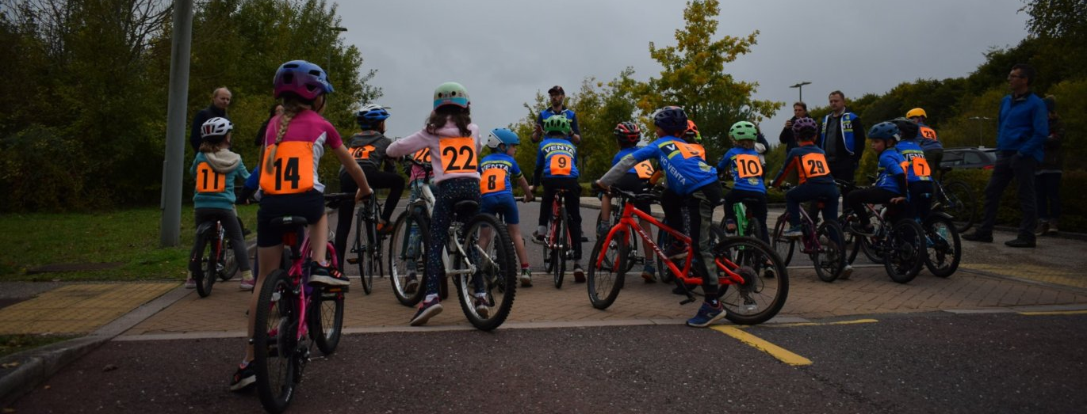

Looking forward to 2022
There are four key areas of focus for next year:
Coaches – To maintain and enhance the fantastic offer the club has to the community we are always on the lookout for more qualified BC coaches. This year Andy Watkins achieved his Level 1 qualification and Marianna Koperdanova is registered for her Level 1 course, and we hope to call on Amy, Vanda, Brenda and Tina as well to really add to the coaching numbers!
Session Structure and Content. We will be developing the session plans to support the new (and old) coaches delivering Go-Ride. This will ensure we have a consistent set of achievable and progressive content that is fun, enjoyable, offers challenge, and is engaging for the young cyclists.
Links to the Club’s racing offer. We will continue to develop the Go-Ride Racing sessions, building on the experience of the two we ran this year to encourage all Go-Ride riders to have a go. For those that want more racing, we will continue the work with Stuart and Toby to develop the connection between Go-Ride and racing, and ensure that those that want to race have a clear pathway within the club.
Finding an alternative venue. With so many of the sessions lost this year we will be stepping up the search for an alternative Go-Ride location, either permanently or for those occasions we are unable to use the Park & Ride.

Richard Sambrook Smith
VC Venta – Head of Go-Ride

