Arts and Crafts
Widcombe Christmas Market
Akiko Carder thebeadgardens@gmail.com Instagram @thebeadgardens
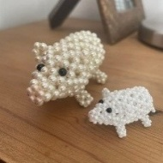
Handmade jewellery with Swarovski Crystal beads and Czech glass beads.

Annie Hastings annie@ahastings.com
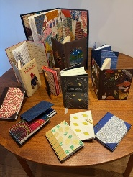
Handbound books in leather and cloth – children’s books, music, notebooks

Rebecca Collett rebeccacollett@icloud.com
@rebeccacollett
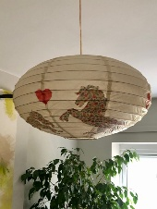
One of a kind, eye-catching, hand decorated and painted Japanese style paper lanterns by BEX COLLETT
Hang them anywhere! Hook a solar bulb inside the shade.
Hang up with a push pin or hook, from a beam or ribbon, inside or outside (weather permitting!)
Or easily attach to the wire of a main light source.

Benedict Hastings actspeaklearn@gmail.com
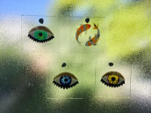
Trapped Light is the brainchild of Ben Hastings, whose work as a shadow puppeteer got him interested in painting glass. Each decoration is hand-painted and completely unique, and can be hung on windows, alcoves, or anywhere with plenty of light. Some pieces are rich in detail, some are bold and colourful. All of them play with light beautifully and would make a one-of-a-kind gift.
Bridget Baker bridgetjbaker@gmail.com
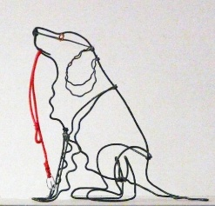
Using galvanised wire, I make any vertebrate animal - fish, amphibians, reptiles, birds and mammal which stand about 7 - 12cm tall. Flying birds can have up to 30cm wingspan. The animals are then painted with enamel.

Catherine Lannin www.herbalharmony.co.uk
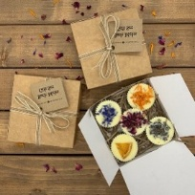
Handmade Soaps, Skincare & Bath products. Natural Cold Process Soaps, Felted Soaps, Skincare, and Shampoo bars all handmade by Catherine Lannin in her garden studio in Bradford on Avon.

Cathy Biggs www.limelightlimited.com
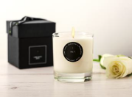
Award-winning candles and reed diffusers. 100% natural plant wax, sustainably sourced, GMO and palm-oil free.

Elisabeth Boss elisabethboss@aol.com
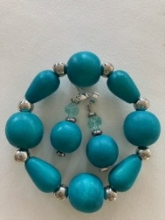.
Handmade modern craft jewellery made with recycled materials

Charlotte Farmer charlottefarmer@btopenworld.com
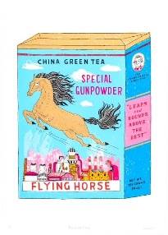
Brightly coloured handmade screen prints and cards mostly featuring grumpy animals and matchboxes

Fiona Wiltshire fioglass@hotmail.com
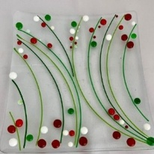
Individually handmade fused glass items , each one is unique.

Gillian Williams gillianwilliams1@btinternet.com
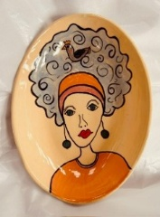
Working from my tiny home studio, I create individually hand-built, highly decorated pottery designed to bring joy and colour to everyday life. My collection includes face plates, Fishy on a Dishy bowls and plates, tiny vases, squiggle vases, brooches, and miniature hanging houses for Christmas trees and festive displays.
Hebe Chant https://hebechant.etsy.com/
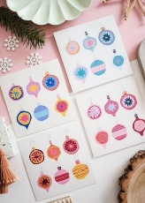
Hebe Designs is an independent illustrated stationery and homeware brand, creating colourful, playful and characterful designs inspired by everyday life, nature and a love of all things creative. From art prints and greeting cards to illustrated gifts, each piece is designed to bring a little joy and personality to your home or to someone special.

Isabell Browell browellinteriors.com ibrowell60@gmail.com
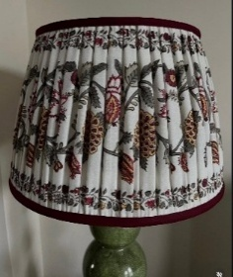
Using carefully selected vintage Indian Saris and handwoven fabrics from Uzbekistan for my hand stitched lampshades I aim to create pieces which are unique and work well with my client's interiors. I also offer a bespoke service for specific interior projects. To compliment my lampshades I have sourced one off hand embroidered Suzani and hand woven Ikat cushions from Uzbekistan

Jane Duffus browellinteriors.com ibrowell60@gmail.com
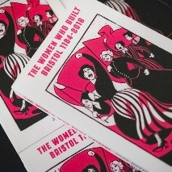
Books about more than 200 amazing but overlooked women from local history.

Jessica Jewett me@jessjewett.com
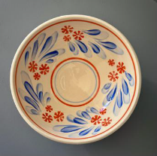
Jess makes beautiful, colourful pottery for use in the home, including mugs, vases, bowls, pots and dishes. They are hand-thrown and hand-decorated with Jess's characteristic colourful and joyful style. She also makes a range of block-printing based wrapping papers which are striking in their colourful patterns, perfect for gifts!

Jill Perry jill@perryspace.uk
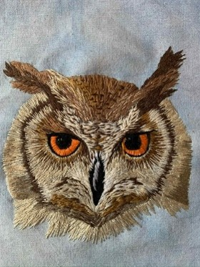
Hand stitched pieces using traditional and contemporary techniques

Jo Slade josladeart@outlook.com
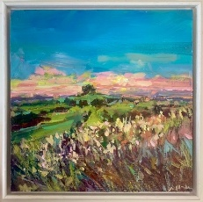
Impressionist landscape paintings inspired by the Bath countryside. Prints, cards, notebooks and calendars available in a range of sizes.

Judith Knight www.folksy.com/shops/nellyandpickles
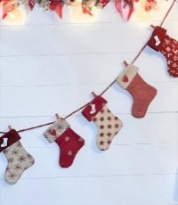
Unique hand crafted felt and fabric home decor and accessories, including wreaths, advent calendars and decorations

Julia Novikova https://unovacraft.co.uk/
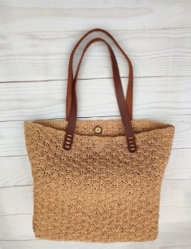
A wide range of beautiful handmade bags, clutches, purses, cases & sleeves, home accessories and much more. Crafted with love and attention to detail, my bags are truly unique. They are practical and stylish, combining fashion and functionality. I use only high-quality materials to make my products, and you will find many eco-friendly options.

Kate McDonell https://www.inkybird.art/
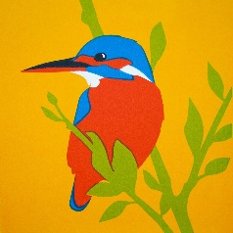
We hand-make beautiful, bright bird screen prints in Bath. We’re inspired by British birds as well as more exotic ones from around the world. Each illustration is full of colour and personality. We sell framed and unframed prints, greetings cards, hand-crafted notebooks, pencil cases and other small gifts.

Laura Jorgensen jorg.laura66@gmail.com
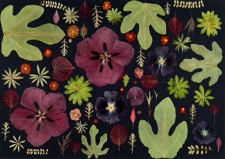
I hand press flowers and leaves to create botanical compositions. My work is then photographed by Bath Photographer Pete Stone and made into fine art prints and greetings cards

Lee Owen leeowendesigns.co.uk
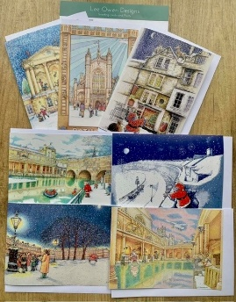
Bath books, Bath Christmas cards, collage originals, cards, mugs, notebooks

Laura Slade charliebrown_ls@hotmail.com
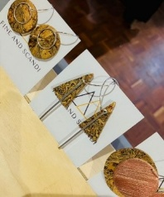
Working with recycled sterling silver, copper, and cork sourced from Portugal, I craft each piece by hand. Clean lines, natural textures, and a Scandinavian calm shape jewellery that feels understated, intentional, and beautifully simple.

Lesley Knight lesleyrknight@yahoo.co.uk
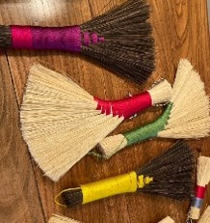
Local brush maker and designer. I use natural fibres and coloured bindings and create beautiful brushes which have a variety of uses in the home, office, workshop or garden. Or enjoyed as a work of art!

Liz Holden White Lizholdenwhite@gmail.com
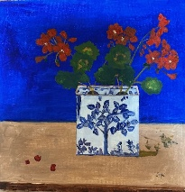
Colourful, original coasters and cards.
Individual painted Christmas cards. A small number of cards in a particular design are made from my original artwork. They are affordable and suitable for a range of occasions. The Christmas cards and some greetings cards are mini original paintings. The coasters are colourful and robust!

Nicola Hyman nicola.hyman7@gmail.com
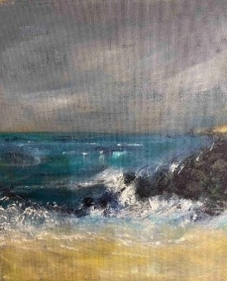
Previously I had a pitch for both my jewellery and painting, but now focus on my painting using oil,acrylic and mixed media to make images inspired by visits to Cornwall and Norway . My aim is to express my feelings rather than produce a photo realistic interpretation

Olivia Cole olivia.cole12@outlook.com
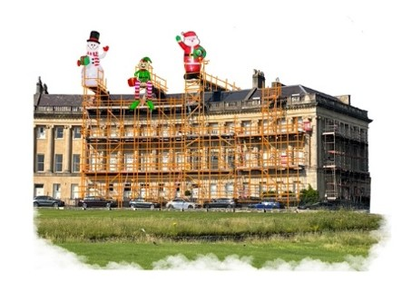
Intrepid Maudie. I am a Bath printmaker. I make Variety of handmade cards and prints, including Lino cuts, screen and digital prints.

Paul Gooch info@pauljgooch.com

Photography and Photobooks that explore Bath's architecture and the transient people that inhabit the city. This year I have broadened my focus to include a second photobook about London.

Piu Bose dpiubose@gmail.com
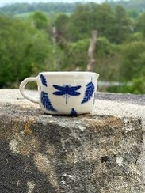
Piu creates hand thrown functional and decorative ceramics along with original cyanotypes, inspired primarily by botanical

Sarah Targett sarahtargett@me.com
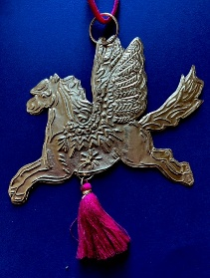
Colourful and contemporary Limited Edition Screenprints, cards and decorations, handmade in Bath at a range of prices.

Sarah Turrell sarahspottery.co.uk
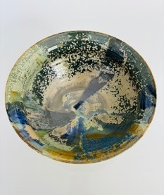
Finely thrown stoneware pottery durable enough for everyday use, plates, mugs, bowls and lots more.

Tanith Capitani ctanith@ymail.com
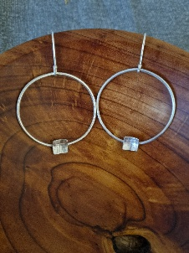
Tanith Capitani Silversmith.
I design and make all my own pieces at my home workshop. I use fully recycled silver and all my pieces are my own designs. My gift boxes are also made from fully recycled materials. I get inspiration from nature and geometrical forms.

Tim Perry https://kestrelpottery.co.uk/
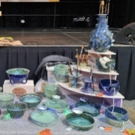
I make small batches of colourful, functional ceramics. Occasionally, I make unique pieces with experimental glazing and decorative techniques.

Tony Hastings tony@ahastings.com
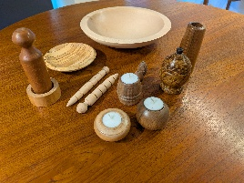
Bowls, candlesticks, light pulls and much more, hand-turned . Much of it from local wood harvested in Bath.

Vikki Yeates www.vikkiyeatesillustration.co.uk
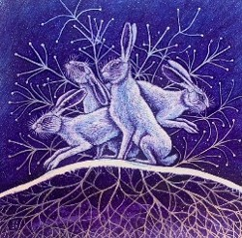
Artwork inspired by British wildlife

Rosemary Le Fèvre rosemary.lefevre@gmail.com
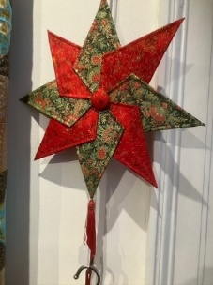
Handmade Quilts, Bags of various sorts and Christmas Items. My work is made from gorgeous high-quality fabric.

Simon Carder simoncarderphotography@gmail.com

Nature and wildlife photography from the local area, UK and around the world from a creative, artistic and abstract perspective.

Vitrific Vitrific@gmail.com
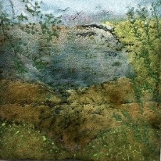
Vitrific is a small co-operative of artists working in vitreous enamel from a workshop in Lyncombe, Bath. The enamelled art we produce includes painted, drawn, stencilled and formed, wall panels and pictures. We also use these enamelling techniques for our range of jewellery and small decorative bowls.
Vitrific offers you something unique, colourful and hand crafted.

Anthony Sheeran sheeranillustration@gmail.com
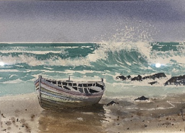

I work in ink and watercolour as well as watercolour of varied subjects.
I am a member of the Society of Architectural Illustrators. My work is primarily watercolour of buildings
and landscape. My work is in the Holburne museum, the Abbey, No 1 the Museum, gallery in Bradford on Avon and
the Stourhead gallery.

Perry Harris uhperry1@gmail.com
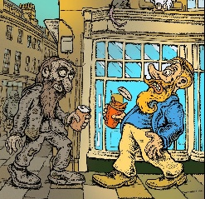

I draw and paint cartoons and watercolours inspired by everyday life in the city of Bath and the beautiful countryside that surrounds it. Selling cards, prints and original paintings and drawings.’

